

SYMPTOTRACKAI: HYBRID RAG BASED SYMPTOM TRACKING AND HEALTH MONITORING SYSTEM
SymptoTrackAI, implemented as the CareLens AI web application: grounded medical information for symptoms described in everyday language, with safety escalation and a private consultation history
A project report submitted in partial fulfilment of the requirements for the award of the degree of
BACHELOR OF TECHNOLOGY
in
COMPUTER SCIENCE AND ENGINEERING
Submitted by
Mariyada Karthika Reddy | 23K91A05E9
Nacharam Akshaya | 23K91A05G6
Madoori Prabath Teja | 23K91A05D6
Pulimadhi Keerthan | 23K91A05K1
Batch C12 (CSE-C)
Under the esteemed guidance of
Dr. Ch. B. Naga Lakshmi
[DESIGNATION]
DEPARTMENT OF COMPUTER SCIENCE AND ENGINEERING
TKR COLLEGE OF ENGINEERING & TECHNOLOGY (AN AUTONOMOUS INSTITUTION)
Medbowli, Meerpet, Balapur, Hyderabad, Telangana - 500 097
Academic year [ACADEMIC YEAR]

CERTIFICATE
This is to certify that the project report entitled "SymptoTrackAI: Hybrid RAG Based Symptom Tracking and Health Monitoring System" is a bonafide record of the work carried out by Mariyada Karthika Reddy (23K91A05E9), Nacharam Akshaya (23K91A05G6), Madoori Prabath Teja (23K91A05D6), Pulimadhi Keerthan (23K91A05K1), in partial fulfilment of the requirements for the award of the degree of Bachelor of Technology in Computer Science and Engineering, during the academic year [ACADEMIC YEAR], under my supervision.

Project Guide | Head of the Department | Principal
Dr. Ch. B. Naga Lakshmi | [HOD NAME] | [PRINCIPAL NAME]
[DESIGNATION] | Department of Computer Science and Engineering | TKR College of Engineering & Technology

External Examiner: [NAME AND SIGNATURE]
Place: [PLACE]
Date: [DATE]

DECLARATION
We hereby declare that the project report entitled "SymptoTrackAI: Hybrid RAG Based Symptom Tracking and Health Monitoring System", submitted to the Department of Computer Science and Engineering, TKR College of Engineering & Technology, in partial fulfilment of the requirements for the award of the degree of Bachelor of Technology in Computer Science and Engineering, is a record of original work carried out by us under the guidance of Dr. Ch. B. Naga Lakshmi, [DESIGNATION]. The results embodied in this report have not been submitted to any other university or institution for the award of any degree or diploma.

Mariyada Karthika Reddy 23K91A05E9
Nacharam Akshaya 23K91A05G6
Madoori Prabath Teja 23K91A05D6
Pulimadhi Keerthan 23K91A05K1

Place: [PLACE]
Date: [DATE]

ACKNOWLEDGEMENT
We express our sincere gratitude to our project guide, Dr. Ch. B. Naga Lakshmi, [DESIGNATION], for valuable guidance, encouragement and constructive suggestions throughout this project.
We thank [HOD NAME], Head of the Department of Computer Science and Engineering, for providing the facilities and support needed to complete this work, and [PRINCIPAL NAME], Principal, TKR College of Engineering & Technology, for the encouragement given to us.
We thank the project coordinators and all faculty and staff members of the department for their help, and our families and friends for their constant support.
We also acknowledge the authors of the base paper, whose framework gave this project its starting point, and the maintainers of the open-source software it depends on (FastAPI, React, Vite, SQLAlchemy, sentence-transformers, FAISS, rank-bm25, Hugging Face Transformers, PyTorch and scikit-learn), together with the authors of the all-MiniLM-L6-v2, ms-marco-MiniLM-L-6-v2 and Flan-T5 models that run inside the system.

Mariyada Karthika Reddy
Nacharam Akshaya
Madoori Prabath Teja
Pulimadhi Keerthan
People with early, minor symptoms often delay seeking care, and a web search for those symptoms tends to return alarming or irrelevant results; a general chatbot, on the other hand, can state unsupported medical claims with confidence. This project presents SymptoTrackAI, implemented as the CareLens AI web application, a local symptom-monitoring assistant that answers only from a curated knowledge base. A symptom description in everyday language is normalised and expanded, then searched in two ways at once: a dense search (all-MiniLM-L6-v2 embeddings in a FAISS index) and a lexical BM25 search. The two score lists are fused with weights 0.65 and 0.35, the 15 best candidates are reranked by a cross-encoder, and the top 5 records form an evidence-based answer that passes a rule-based safety layer. Every consultation is stored privately in SQLite and can be searched, reopened and deleted. The work follows the base paper in using retrieval-augmented generation with a symptom-disease knowledge base and extends it with BM25 fusion, neural reranking, safety escalation and a React interface.
The knowledge base is synthetic: 176 records covering 30 conditions, written by the team and not clinically validated. On 60 everyday-language probes written by the team the shipped pipeline puts the correct condition first in 96.7% of cases (BM25 alone 88.3%; the offline TF-IDF fallback 81.7%); with only two symptoms given it reaches 88.1%, and on leave-one-out verbatim queries 97.2%. Removing the template query expansion raised the probe score to 100.0%, so that stage did not help. The measurement also exposed defects, which are reported and not hidden: with the installed library version the local language model returns its own prompt (30 of 30 answers), the displayed relevance of the best match is always 100%, even for complaints outside the knowledge base, the emergency rules recognised 27 of 40 test descriptions (none of the 12 paraphrased ones), and tracking of symptom trends over time was not built beyond the stored history. A request takes about 0.4 s on a CPU-only PC. The base paper gives no numbers, so no quantitative comparison with it is possible.
Keywords: hybrid retrieval-augmented generation, symptom monitoring, FAISS semantic search, BM25, neural reranking, query expansion, healthcare chatbot, safety escalation, consultation history, FastAPI, React.

TABLE OF CONTENTS
CERTIFICATE i
DECLARATION ii
ACKNOWLEDGEMENT iii
TABLE OF CONTENTS v
LIST OF FIGURES vii
LIST OF TABLES ix
LIST OF ABBREVIATIONS x
CHAPTER 1: INTRODUCTION 1
1.1 Domain and Background 1
1.2 Motivation 1
1.3 Problem Statement 2
1.4 Need for the System 2
1.5 Objectives 2
1.6 Scope of the Work 3
1.7 Contributions 3
1.8 Limitations and Assumptions 4
1.9 Organisation of the Report 4
CHAPTER 2: LITERATURE SURVEY 5
2.1 Overview 5
2.2 Analysis of the Base Paper 5
2.3 Related Work by Theme 6
2.4 Data and Algorithms Used in This Project 8
2.5 Summary of the Surveyed Works 8
2.6 The Batch Literature Survey 8
2.7 Research Gap 9
CHAPTER 3: FEASIBILITY STUDY 10
3.1 Technical Feasibility 10
3.2 Economic Feasibility 10
3.3 Operational Feasibility 11
3.4 Schedule Feasibility 11
3.5 Advantages and Constraints 12
CHAPTER 4: SYSTEM REQUIREMENTS AND ANALYSIS 13
4.1 Existing System and Its Limitations 13
4.2 Proposed System and Its Advantages 13
4.3 Functional Requirements 14
4.4 Non-Functional Requirements 14
4.5 Hardware Requirements 15
4.6 Software Requirements 15
4.7 Data Requirements 15
4.8 User Roles 15
4.9 Constraints and Assumptions 16
4.10 Requirements Against Objectives 16
CHAPTER 5: SYSTEM DESIGN 17
5.1 Design Goals and Architecture 17
5.2 High-Level Workflow 18
5.3 Data Flow Diagrams 20
5.4 UML Diagrams 23
5.5 Database Design 26
5.6 Module Design 27
5.7 User Interface Design 29
5.8 Design Decisions and Their Reasons 30
5.9 Quality Attributes and Design Constraints 31
CHAPTER 6: METHODOLOGY AND SOFTWARE IMPLEMENTATION 33
6.1 Overall Methodology 33
6.2 Knowledge Base and Evaluation Data 34
6.3 Algorithms and the Reasons for Choosing Them 36
6.4 Mathematical Formulation of the Evaluation 39
6.5 Retrieval Configuration 40
6.5 Application Architecture and Implementation 40
6.6 API Design 41
6.7 Security and Error Handling 42
6.8 Installation and Execution 42
CHAPTER 7: SYSTEM TESTING 44
7.1 Testing Strategy 44
7.2 Unit Testing 44
7.3 Integration and Functional Testing 45
7.4 Security Testing 46
7.5 Validation and Edge Cases 47
7.6 Probe Measurements 48
7.7 Performance Testing 51
7.8 User Acceptance 53
7.9 Summary and Limits of the Testing 53
CHAPTER 8: RESULTS AND OUTPUT SCREENS 55
8.1 Experimental set-up 55
8.2 Output screens 56
8.3 Retrieval accuracy of the shipped pipeline 59
8.4 Ablation: what each stage contributes 61
8.5 The displayed relevance score 63
8.6 Generated answer text 64
8.7 Safety layer 64
8.8 Speed 65
8.9 Functional tests 67
8.10 Comparison with the base paper 67
8.11 Sample inputs and outputs, success and failure analysis 68
8.12 Limitations of the evaluation 69
8.13 Objectives against outcomes 69
CHAPTER 9: CONCLUSION 70
9.1 Summary 70
9.2 Objectives achieved and key findings 70
9.3 Applications and known limitations 71
9.4 What the project taught us 71
CHAPTER 10: FUTURE SCOPE 72
10.1 Improvements to what exists 72
10.2 Additional features 72
10.3 Scalability and deployment 73
10.4 Further research 73
REFERENCES 74
APPENDIX A: IMPORTANT CODE 76
A.1 Query expansion (`app/rag/query_expansion.py`) 76
A.2 Hybrid score fusion (`app/rag/hybrid_retriever.py`) 76
A.3 Cross-encoder reranking (`app/rag/reranker.py`) 76
A.4 Safety rules (`app/rag/safety.py`) 77
A.5 Answer generation with fallback (`app/rag/generator.py`) 77
A.6 The chat endpoint (`app/routes/chat.py`) 78
APPENDIX B: INSTALLATION AND USER GUIDE 80
B.1 Requirements 80
B.2 Method A: automatic start (`run.bat`) 80
B.3 Method B: Docker 80
B.4 Method C: manual start (two terminals) 80
B.5 Using the application 81
B.6 Tests and measurement scripts 81
B.7 Configuration 81
B.8 Troubleshooting 82
APPENDIX C: ADDITIONAL SCREENS 82

LIST OF FIGURES
Figure 1: Four-tier architecture of SymptoTrackAI (CareLens AI): React web app, FastAPI application, RAG modules and local data stores. 18
Figure 2: High-level workflow of one symptom analysis (POST /api/chat). 19
Figure 3: Flowchart of the retrieval algorithm: expansion, dual retrieval, fusion, reranking, safety and generation. 20
Figure 4: Decision flow of the safety layer and the answer filter. 20
Figure 5: Context diagram (DFD level 0). 21
Figure 6: DFD level 1: six processes and three data stores. 22
Figure 7: DFD level 2: expansion of the analysis processes into their sub-processes. 23
Figure 8: UML class diagram: ORM classes, schemas, routers and the RAG classes. 24
Figure 9: Sequence diagram of the main flow: one symptom message from the browser to the stored answer. 24
Figure 10: Use-case diagram of the visitor and the registered user. 25
Figure 11: Entity-relationship diagram of the SQLite database and the retrieval stores. 26
Figure 12: Assistant screen with an answer and the recent-consultations panel. 30
Figure 13: History screen with search, safety badges and relevance. 30
Figure 14: Composition of the knowledge base: records per condition and severity labels. 35
Figure 15: Top-1 accuracy of the seven retrieval configurations on verbatim, two-symptom and lay-language queries. 48
Figure 16: The shipped configuration under four protocols: the stored protocol is an upper bound. 49
Figure 17: Raw cross-encoder score of the best record for in-base and out-of-base queries, against the displayed 100%. 50
Figure 18: Safety layer: recall on literal and paraphrased emergencies, and false alarms on ordinary and hard negative texts. 51
Figure 19: Time per pipeline stage and for the whole call, with and without the local generator. 52
Figure 20: HTTP latency of the chat route with the two generator modes. 53
Figure 21: Composition of the knowledge base: records per condition and severity labels (synthetic data). 56
Figure 22: Landing page, light theme: product pitch and entry buttons. 57
Figure 23: Sign-in form; the demo account is created automatically at start-up. 57
Figure 24: Symptom assistant before the first question: example chips and the permanent not-a-diagnosis line. 57
Figure 25: Everyday-language query retrieving Urinary Tract Infection. 57
Figure 26: Answer to "I have high fever, headache and body pain since yesterday" (fallback generator): top condition Influenza; the guidance sentence repeats because several near-identical records matched. 57
Figure 27: Evidence cards of the same answer: symptoms, description, guidance, severity, match bar and red flags; the fifth card is Dengue at 75%. 58
Figure 28: Caution banner (amber) for a message that mentions pregnancy; top record Gastritis. 58
Figure 29: Emergency banner (red) for severe chest pain and difficulty breathing; top record Heart Attack. 58
Figure 30: Failure case: the default Flan-T5 generator returns its prompt as the answer. 58
Figure 31: Consultation history with safety badges and a displayed relevance of 100% in every row. 58
Figure 32: Saved consultation: summary table and stored answer. 58
Figure 33: About page showing the shipped evaluation figures (100%, 245 ms, 176 records) - an upper bound (Section 8.3). 59
Figure 34: The shipped pipeline under four conditions: shipped protocol, leave-one-out, two-symptom queries and lay-language probes. 60
Figure 35: Confusion matrix of the shipped pipeline on the 60 lay-language probes (rows: true condition, columns: first retrieved condition). 61
Figure 36: Top-1 accuracy of the seven retrieval configurations on the verbatim, two-symptom and lay-language query sets. 62
Figure 37: Effect of the HyDE-style expansion: the shipped pipeline with and without it on each query set. 63
Figure 38: Raw cross-encoder score of the top record for in-knowledge-base and out-of-knowledge-base queries, against the constant displayed value of 100%. 64
Figure 39: Emergency detection: recall on literal and paraphrased wording, and false alarms on ordinary and hard-negative texts. 65
Figure 40: Mean time per pipeline stage and totals for the two generator modes. 66
Figure 41: HTTP latency of POST /api/chat with the fallback generator and with the default Flan-T5 generator. 66
Figure 42: Landing page, dark theme. 83
Figure 43: Bottom of the landing page (dark theme). 83
Figure 44: Create-account form (email and a password of 6 to 128 characters). 83
Figure 45: History filtered by the search term "fever": one consultation remains. 83
Figure 46: Confirmation dialog before a consultation is deleted. 83
Figure 47: About page, dark theme. 83
Figure 48: Symptom assistant at phone width (390 pixels). 84
Figure 49: History as cards at phone width. 84
Figure 50: Unknown route: the 404 screen. 84

LIST OF TABLES
Table 1: Abbreviations used in this report x
Table 2: Objectives and their final status 3
Table 3: Chapters of this report 4
Table 4: Base paper compared with this project 6
Table 5: Surveyed works: approach, data, reported result, limitation 8
Table 6: Sources in the batch literature survey 9
Table 7: Technical feasibility checks 10
Table 8: Cost elements 11
Table 9: Phases of the work 11
Table 10: Existing approaches and their limitations 13
Table 11: Functional requirements 14
Table 12: Non-functional requirements 14
Table 13: Hardware 15
Table 14: Software 15
Table 15: Roles 15
Table 16: Objectives and the requirements that serve them 16
Table 17: Tiers, technologies and responsibilities 18
Table 18: Level 1 processes and their data 21
Table 19: Level 2 sub-processes 22
Table 20: Use cases 25
Table 21: Table users 26
Table 22: Table consultations 26
Table 23: Knowledge-base record 27
Table 24: Backend modules 28
Table 25: Data passed between the stages 29
Table 26: Routes and screens 30
Table 27: Design decisions 31
Table 28: Quality attributes 31
Table 29: Knowledge-base facts 34
Table 30: Evaluation query sets 36
Table 31: Retrieval configuration (app/config.py) 40
Table 32: Main software components and versions in the measurement environment 41
Table 33: API endpoints 41
Table 34: Test layers and results 44
Table 35: Automated pytest cases 45
Table 36: Functional checks of the smoke test 45
Table 37: Security probes by group 46
Table 38: Security findings 47
Table 39: Edge cases tried on the chat route and their outcomes 47
Table 40: Top-1 accuracy (%) by retrieval configuration 48
Table 41: Pipeline stage times (milliseconds, 30 queries, warm models) 51
Table 42: HTTP latency of POST /api/chat on 127.0.0.1 (30 requests, milliseconds) 52
Table 43: Summary of results 53
Table 44: Query sets used in the evaluation 56
Table 45: Accuracy of the shipped pipeline (hybrid + cross-encoder) on the five query sets 59
Table 46: Top-1 accuracy by configuration (leave-one-out for S2 and S3) 61
Table 47: Complaints with no matching condition in the knowledge base 63
Table 48: Emergency detection on the probe sets 65
Table 49: Time per pipeline stage (milliseconds, 30 queries, warm models) 66
Table 50: Qualitative comparison with the base paper 67
Table 51: Sample queries and what the pipeline did (captured sessions and logged probes) 68
Table 52: Objectives of the project against what was measured 69
Table 53: Objectives against outcomes 70
Table 54: Scripts used for the tests and the measurements in this report 81
Table 55: Settings read from environment variables 81

LIST OF ABBREVIATIONS
Table 1: Abbreviations used in this report
Abbreviation | Expansion
AI | Artificial Intelligence
API | Application Programming Interface
AUROC | Area Under the Receiver Operating Characteristic curve
BM25 | Best Matching 25 (probabilistic ranking function)
CI | Confidence Interval
CORS | Cross-Origin Resource Sharing
CPU | Central Processing Unit
CRUD | Create, Read, Update, Delete
DFD | Data Flow Diagram
ER | Entity-Relationship
FAISS | Facebook AI Similarity Search
HTTP | Hypertext Transfer Protocol
HyDE | Hypothetical Document Embeddings
JSON | JavaScript Object Notation
JWT | JSON Web Token
LLM | Large Language Model
LOO | Leave-One-Out
ML | Machine Learning
MRR | Mean Reciprocal Rank
NLP | Natural Language Processing
ORM | Object-Relational Mapping
RAG | Retrieval-Augmented Generation
REST | Representational State Transfer
SBERT | Sentence-BERT
SPA | Single-Page Application
SQL | Structured Query Language
TF-IDF | Term Frequency - Inverse Document Frequency
UI | User Interface
UML | Unified Modeling Language

CHAPTER 1: INTRODUCTION
This chapter introduces the domain of the project, the motivation for building SymptoTrackAI, the problem it addresses, the objectives set for it, the scope that was actually delivered, the contributions, and the limitations and assumptions that govern every result reported later. It ends with a map of the rest of the report. The project title is SymptoTrackAI; the web application that implements it carries the name CareLens AI in the code and on screen, and the report uses the two names accordingly.

1.1 Domain and Background
Healthcare informatics is the use of computing to collect, organise and present health information. One of its most visible applications is the symptom checker: a person describes what they feel and receives information about what it might mean and how urgent it is. The idea is attractive because the first step in most illnesses is a question asked at home - is this serious, should I wait, should I see someone - and because access to a clinician is not always quick or convenient.
Conversational language models have made it possible to ask that question in ordinary words. Studies of their medical ability show that large models encode a good deal of clinical knowledge [28], but they also produce fluent text that is wrong, a failure known as hallucination [27], and in health a confident wrong answer can do harm. Retrieval-augmented generation (RAG) [15] addresses this by retrieving passages from a curated source and letting the answer draw only on them. The base paper assigned to the batch [1] applies this idea to symptom monitoring: it retrieves symptom-disease records with FAISS similarity search [17], and it stores each consultation so that a user can review their history.
Retrieval itself has two classic forms. Dense retrieval compares embeddings of the query and the records, so that "stuffy nose" can match "nasal congestion" [16], [18]. Lexical retrieval such as BM25 [19] matches the words themselves and is exact and fast but blind to synonyms. A cross-encoder reranker [21] reads the query and a candidate together and scores them more carefully than either retriever can. SymptoTrackAI combines all three.

1.2 Motivation
• Patients often delay consultation because early symptoms seem minor or access is inconvenient.
• Self-diagnosis through web search produces alarming and frequently wrong conclusions.
• Language models can interpret symptoms described in ordinary language, but ungrounded models hallucinate, which is unacceptable in a health context.
• A health application that must run on an ordinary computer, keep the person's records on that computer and need no paid service is useful to a student team, a small clinic or a classroom.
A further motivation is methodological. The base paper reports its results only as "experimental observations" and shows one example conversation, so its claims cannot be checked. This project therefore treats measurement as part of the work: every number in this report was produced by a script that can be re-run (Chapter 8).

1.3 Problem Statement
• Self-diagnosis through general web search yields inaccurate and frightening results.
• General chatbots answer from public data with no medical grounding or citation.
• Symptoms are recorded as isolated events, so progression over time is never visible.
• An ungrounded health answer can cause real harm if acted upon.
The problem can be stated as follows: given a free-text description of symptoms, return the most relevant medical information from a curated knowledge base, show the records the answer rests on, escalate clearly when the text describes a possible emergency, and keep a private history of consultations - all on a machine without a GPU and without sending the person's text to a third party.

1.4 Need for the System
The need, as the project's problem statement puts it, is a symptom assistant that answers only from a curated medical knowledge base, cites its sources and tracks symptoms over time. Three needs follow. The answer must be grounded, because the cost of an unsupported statement is high. The system must be explicit about what it does not know, because a symptom list cannot establish a diagnosis. And the person's data must stay under their control, because symptom text is sensitive.

1.5 Objectives
Six objectives were set at the start of the project. the table below repeats them and gives the final status; the evidence for each status is in Chapters 7 and 8.
Table 2: Objectives and their final status
No. | Objective | Status | What was delivered
1 | Build a curated medical knowledge base and index it for semantic retrieval. | Achieved, with a synthetic base | 176 records, 30 conditions, FAISS and BM25 indexes; written by the team, not clinically validated
2 | Accept symptoms described in natural language and expand the query to improve recall. | Achieved | Normalisation and a rule-based HyDE-style template; its measured effect is neutral to negative
3 | Implement hybrid retrieval combining dense vector search with neural reranking. | Achieved and measured | Fusion and cross-encoder; top-1 96.7% on 60 everyday-language probes
4 | Generate grounded responses that cite the retrieved source for every statement. | Partly | Answers are built from retrieved records and shown with evidence cards; no per-statement citation
5 | Track reported symptoms over time to reveal progression and trends. | Not achieved beyond storage | Consultations are saved, searchable and deletable; no trend or progression analysis
6 | Evaluate retrieval relevance, answer groundedness and response time. | Partly | Retrieval relevance and response time measured; groundedness checked only structurally

1.6 Scope of the Work
In scope: registration and sign-in; symptom entry in free text; query normalisation and expansion; dense and lexical retrieval over the knowledge base, fusion and reranking; an evidence-based answer with a safety layer; storage, search, review and deletion of consultations per user; a React web interface with light and dark themes; and the scripts that measure the pipeline. Out of scope: diagnosis, prescription or dosage advice, images, voice, clinical validation, multi-language support, and any integration with hospital systems. Chapter 4 gives the requirements and the full scope and limitations appear in Chapter 9.

1.7 Contributions
1. A working implementation of a hybrid RAG symptom assistant that runs on a CPU-only PC: MiniLM embeddings with FAISS, BM25, weighted fusion, a cross-encoder reranker and an evidence-based answer, behind a FastAPI service and a React interface.
2. A fall-back design in which each model-dependent stage has an offline alternative (TF-IDF vectors, hybrid order without reranking, template answer), so the system still answers without model downloads.
3. A rule-based safety layer with ten emergency patterns, a caution list, a permanent disclaimer and an answer filter for medication instructions.
4. A reproducible evaluation (Chapter 8): an ablation of seven retrieval configurations on five query sets, leave-one-out testing, a probe set in everyday language, and measurements of the safety layer and of latency.
5. An honest account of what the evaluation exposed: an inflated shipped metric, a generator that echoes its prompt, a relevance display that hides the model's own signal, and gaps in the safety rules.

1.8 Limitations and Assumptions
The knowledge base is synthetic: it was generated by script from a hand-written table of 30 conditions, so there is only one description and one piece of guidance per condition, shared by all of its records. Accuracy on it says how well the pipeline finds a condition whose wording it has seen, not how well it would help a patient. Probe queries and safety test sentences were written by the authors, who are not clinicians, so they test the software, not clinical accuracy. The assumptions are that users write in English, that the machine has about 15.7 GB of memory for the three models, and that a person who receives an emergency notice will act on it. SymptoTrackAI is information, not medical advice.
For orientation: with the full pipeline the correct condition is first for 97.2% of 176 leave-one-out verbatim queries, 88.1% of 176 queries giving two symptoms, and 96.7% of 60 everyday-language probes (95% interval 88.6-99.1%). These are measured on the synthetic base.

1.9 Organisation of the Report
Table 3: Chapters of this report
Chapter | Title | Content
1 | Introduction | Domain, motivation, problem, objectives, scope, contributions
2 | Literature Survey | Base paper analysis, related work, gap
3 | Feasibility Study | Technical, economic, operational and schedule feasibility
4 | System Requirements and Analysis | Existing and proposed system, requirements, users
5 | System Design | Architecture, DFDs, UML, database, modules, interface
6 | Methodology and Software Implementation | Pipeline, algorithms, API, security, installation
7 | System Testing | Strategy, unit, integration, security, performance
8 | Results and Output Screens | Measurements, screens, comparison, objectives versus outcomes
9 | Conclusion | Summary, findings, known limitations
10 | Future Scope | Improvements and further research

The references and three appendices (important code, installation and user guide, additional screens) follow Chapter 10.

CHAPTER 2: LITERATURE SURVEY

2.1 Overview
This chapter reviews the work on which SymptoTrackAI builds and against which it must be judged. It starts with the base paper assigned to the batch [1], analyses it in detail, and then groups related work by theme: symptom chatbots, retrieval-augmented generation in healthcare, the retrieval and reranking components, and generation and safety. It then describes the data and algorithms that the project itself uses, tabulates the works, lists the sources named in the project's literature survey with an honest note on what could be verified, and ends with the research gap. Numerical results are quoted only where they were read in the paper itself or in a bibliographic record.

2.2 Analysis of the Base Paper
The base paper is "A Hybrid Retrieval-Augmented Generation Framework for Intelligent Symptom Monitoring and Disease Guidance", by U. S. Madhury and M. Ramesh of the Department of Computer Science and Engineering, Ellenki College of Engineering and Technology, Hyderabad, published in the International Journal of Engineering Research and Science and Technology, vol. 22, no. 3, 2026, pp. 702-707 [1]. It presents a framework also named SymptoTrackAI.
Method. A symptom-disease knowledge base - symptom descriptions, disease names and health advice - is organised, de-duplicated and indexed. A transformer the paper calls the "Sequence-NQ transformer" turns both the records and the user's query into embeddings, and FAISS similarity search retrieves the most relevant records. The retrieved text is passed to a retrieval-augmented generation (RAG) step that writes a context-aware reply. A web application adds registration, authentication, a chatbot for symptom analysis and a health log in which queries, predicted advice and timestamps are stored for later review.
Claims. The paper states that "experimental observations" show the hybrid retrieval framework consistently delivers accurate and context-sensitive responses and efficient response time, and that the health log supports continuous monitoring. Its single worked example is a conversation in which constipation and stomach ache, followed by high fever and swollen lymph nodes, lead the chatbot to suggest typhoid. Its conclusion lists future work: a larger knowledge base, multilingual support, multimodal inputs such as clinical reports and images, and cloud deployment.
Strengths. The paper gives a clear, implementable architecture; it chooses retrieval over free generation, which is the right instinct in a medical setting; and it treats persistence of consultations as part of the system, not an afterthought.
Limitations. The paper reports no accuracy figure, no response-time figure, no size or source for the knowledge base, no baseline and no test set, so none of its claims can be reproduced or compared. "Hybrid" in its title refers to combining retrieval with generation; it does not use lexical retrieval, reranking or query expansion. It has no safety mechanism for emergencies, and although it speaks of long-term tracking, it describes storage of past consultations, not analysis of change over time.
Table 4: Base paper compared with this project
Aspect | Base paper | SymptoTrackAI
Retrieval | Embeddings ("Sequence-NQ") + FAISS | MiniLM embeddings + FAISS, BM25, weighted fusion, cross-encoder rerank
Query handling | Query embedded as typed | Normalisation and a rule-based HyDE-style template
Generation | RAG reply | Flan-T5 or deterministic evidence-based answer, plus filter
Safety | Not described | Ten emergency rules, caution list, disclaimer, answer filter
Accounts and history | Registration, login, health log | bcrypt + signed cookie; per-user history with search, detail, delete
Evaluation | Qualitative observations; one example | Ablation on five query sets; 40+30 safety probes; latency; tests
Knowledge base | Symptom-disease dataset, size not stated | 176 synthetic records, 30 conditions

2.3 Related Work by Theme

2.3.1 Symptom and medical chatbots without retrieval
The base paper's own related-work section covers earlier chatbots, and its descriptions are repeated here with their numbers, of which there are none. Divya et al. [7] built an AI chatbot that suggests conditions from described symptoms. Kumar et al. [8] used machine learning and language processing for primary clinical guidance. Hsu and Yu [9] combined machine learning with natural-language understanding and, according to the base paper, understood health conversations better than rule-based chatbots. Babu and Boddu [10] built a BERT-based chatbot for medical queries. Alqaidi et al. [14] integrated a medical chatbot into a network service, and Prathwini and Prathyakshini [12] used text classification to predict diseases from symptoms. These systems predict or classify from learned parameters, so their answers are only as good as the training data and carry no pointer to a source - the weakness that retrieval is meant to repair.

2.3.2 Retrieval-augmented generation in healthcare
Lewis et al. [15] introduced RAG as a way to give a generator access to an external, updatable memory. In medicine, Peri et al. [11] built a chatbot that retrieves from medical books before generating, in order to reduce fabricated answers. Natarajan et al. [13] studied language-model support for medical information retrieval. Son et al. [5] built a RAG chatbot over electronic-medical-record manuals; with 5,931 question-document pairs they fine-tuned two multilingual embedding models and reported retrieval accuracy of 97.6% for BGE-M3 and 89.7% for Multilingual-E5-Large, with query latency under 10 ms. ClinicBot [6] grounds answers in the American Diabetes Association guideline, extracts it into units with provenance, ranks evidence by clinical significance, not text similarity, and shows citations; it is a system demonstration without an accuracy table. Xiong et al. [26] benchmarked RAG components - corpora, retrievers and language models - for medical question answering. Three further RAG chatbots appear in the batch literature survey ([2], [3], [4]); their full texts could not be located, so nothing beyond their titles is claimed here.

2.3.3 Retrieval and reranking components
Dense retrieval [16] represents query and passage as vectors and compares them; Sentence-BERT [18] made such embeddings practical for sentences, and MiniLM [24] distilled a small, fast model that gives the all-MiniLM-L6-v2 embeddings used here. FAISS [17] provides exact and approximate nearest-neighbour search. BM25 [19] remains a strong lexical baseline and is covered in standard texts [31]. Fusion of several rankings is well established; reciprocal rank fusion [25] is one rank-based scheme, and weighted combination of normalised scores, used here, is another. Cross-encoders such as monoBERT [21] read query and candidate together and, trained on MS MARCO [22], give better ordering than the first-stage scores at a higher cost. HyDE [20] asks a language model to write a hypothetical answer document and retrieves with that; this project's version is a fixed text template, not a language-model call, so it borrows the idea but not the mechanism.

2.3.4 Generation and safety
Instruction-tuned models such as Flan-T5 [23] follow prompts at small sizes and are available through the Hugging Face library [29]. Hallucination remains an open problem [27], and while large models encode clinical knowledge [28], the same work stresses the need for human evaluation. This is why the project keeps the answer tied to retrieved records and adds explicit emergency rules rather than trusting a model to recognise danger.

2.4 Data and Algorithms Used in This Project
Data. The base paper's data set is not available or described in enough detail to reuse, and no public symptom-disease base was used. The project's knowledge base is built by scripts/prepare_data.py from a hand-written table: 30 conditions, each with a description, guidance, severity and red flags, and several symptom-subset variants, giving 176 records. Each record has retrieval text of the form "Disease: ... Symptoms: ... Description: ... Guidance: ...". It is labelled synthetic.
Algorithms. The query is lower-cased and tidied, split on commas and conjunctions, and wrapped in a template sentence. The combined text is embedded (384 dimensions, normalised) and searched in a FAISS inner-product index; the same text is tokenised and scored by BM25. Each list is min-max normalised over the union of candidates and fused:
score(d) = 0.65 · norm(sem(d)) + 0.35 · norm(lex(d)) (1)
The 15 best fused candidates are scored by the cross-encoder ms-marco-MiniLM-L-6-v2 and the top 5 are kept. The displayed relevance is the reranker score scaled by min-max over the candidates, which is why its maximum is always 1.00 (Chapter 8).

2.5 Summary of the Surveyed Works
Table 5: Surveyed works: approach, data, reported result, limitation
Work | Approach | Data | Reported result | Limitation
Base paper [1] | Embeddings + FAISS + RAG; web app with history | Symptom-disease base, size not stated | Qualitative only | No numbers; no safety or reranking
Divya et al. [7] | AI self-diagnosis chatbot | Not stated in base paper | Qualitative | No grounding in a source
Hsu, Yu [9] | ML + language understanding chatbot | Not stated in base paper | Better than rule-based (as summarised) | Learned, ungrounded
Peri et al. [11] | RAG over medical books | Medical books | Qualitative in base paper | Chat over text, not symptom triage
Son et al. [5] | RAG over EMR manuals, tuned embeddings | 5,931 question-document pairs | 97.6% / 89.7% retrieval accuracy; < 10 ms | Hospital manuals, not symptoms
ClinicBot [6] | Guideline extraction, evidence priority, citations | ADA Standards of Care 2025 | Demonstration | One disease area; no accuracy table
Xiong et al. [26] | RAG benchmark for medical QA | Medical QA sets | Benchmark and toolkit | Question answering, not symptom entry
Gao et al. [20] | Hypothetical-document query expansion | Retrieval benchmarks | Gains over unsupervised dense retrieval | Needs a language-model call

2.6 The Batch Literature Survey
The project's own literature survey lists five sources. They are reproduced with the extent to which each could be verified.
Table 6: Sources in the batch literature survey
No. | Source | Verification
1 | Base paper, IJERST 2026 [1] | Read in full (PDF); no numbers reported
2 | RAG framework for medical question answering, Iconic Research and Engineering Journals, 2026 [2] | Not found online; title and source only
3 | Book-verified RAG medical chatbot, ICICV 2026 [3] | Not found online; title and source only
4 | Healthcare chatbot with RAG, Int. J. Pharmacy with Medical Sciences, 2026 [4] | Not found online; title and source only
5 | RAG-based EMR chatbot, Healthcare Informatics Research, 2025 [5] | Verified on the journal page: 5,931 pairs, 97.6% / 89.7%, < 10 ms

Strengths of the literature as a whole: retrieval-grounded answering is well motivated and increasingly benchmarked, and the retrieval building blocks are mature and openly available. Its limitations: symptom-oriented RAG work reports little quantitative evidence, often on private or unspecified data; safety escalation is rarely evaluated; and the cost of running these systems on ordinary hardware is seldom measured.

2.7 Research Gap
The base paper establishes a hybrid RAG framework for symptom monitoring. The gap addressed here is adding longitudinal symptom tracking and personalised health insight on top of that retrieval pipeline. The survey shows four concrete gaps around it:
1. Evidence. The base paper's claims are untested; there is no baseline, test set or latency figure to compare against.
2. Retrieval quality. Combining dense and lexical retrieval with a neural reranker is standard elsewhere but is absent from the symptom-monitoring framework, and nobody had measured what each stage adds.
3. Safety. Emergency recognition and medication-instruction filtering are not described, although the domain demands them.
4. Tracking. Longitudinal tracking is promised but not realised: the base paper stores consultations and stops there.
This project closes the first three gaps in part - by building the stages, measuring them and reporting what failed - and delivers only the storage half of the fourth, which is stated as an unmet objective in Chapters 1, 8 and 9.

CHAPTER 3: FEASIBILITY STUDY
The feasibility of SymptoTrackAI was settled partly by analysis and partly by building the system and measuring it. Where a question could not be settled with the data available to the team, the entry says so.

3.1 Technical Feasibility
The technical risks were whether a retrieval pipeline with three neural models could run on an ordinary computer without a GPU, whether it would answer fast enough to feel interactive, and whether every part could be built from free software. The development machine is a desktop with a 12th Gen Intel Core i5-12500 (6 cores / 12 threads), no GPU and 15.7 GB of RAM, running Windows 11.
Table 7: Technical feasibility checks
Question | Measurement | Verdict
Can all models run on a CPU? | Embedding model, cross-encoder and Flan-T5-small load and run under Python 3.11.9 and torch 2.14.1+cpu on the machine above | Feasible
Is retrieval fast enough? | FAISS search 0.19 ms, BM25 2.46 ms, query embedding 93 ms (mean over 30 queries); the cross-encoder over 15 candidates is the slowest stage at 555 ms | Feasible
Is the whole request interactive? | POST /api/chat over HTTP: mean 403 ms with the evidence-based answer, 766 ms with the Flan-T5 generator (p95 1077 ms) | Feasible
Does it work offline? | TF-IDF vectors, hybrid order and a template answer replace the three models; top-1 on everyday-language probes falls to 81.7% from 96.7% | Feasible with lower quality
Is the generator useful? | With transformers 5.20.2 the local generator returned its prompt in 30 of 30 answers | Not feasible as installed
Can accounts and history be built simply? | SQLAlchemy and SQLite, bcrypt, signed cookies; automated tests pass | Feasible

The generator row is a finding, not a plan: it was discovered while measuring and is discussed in Chapter 8. The system remains usable because the evidence-based answer does not need the model.

3.2 Economic Feasibility
The project needs no purchased software or paid service. Every component is open source, the models are downloaded once and then run locally, and symptom text is never sent to a third party, so there is no per-query fee. The hardware is an ordinary desktop already owned by the team; no GPU is needed.
Table 8: Cost elements
Element | Cost | Note
Languages, frameworks, libraries | No licence fee | Python, FastAPI, SQLAlchemy, React, Vite, FAISS, rank-bm25, scikit-learn, PyTorch, Transformers
Models | No licence fee | all-MiniLM-L6-v2, ms-marco-MiniLM-L-6-v2, Flan-T5-small, downloaded once
Hosting and database | None | Runs on the user's own machine; SQLite file
Hardware | Existing PC | About 4 GB free disk for models and dependencies (HOW_TO_RUN.md)
Per-query cost | None | No external API is called for symptom data
Effort | Student time | Four students over one academic project cycle; not priced

The principal hidden cost is validation: a real deployment would need clinicians to review the knowledge base, which this project did not have and did not cost.

3.3 Operational Feasibility
Operation is simple. A person double-clicks run.bat, which creates the Python environment, installs dependencies, prepares the knowledge base and starts the backend and the web interface; a Docker route is also provided. Users need only a browser. They register or use the demo account, type symptoms and read the answer. Day-to-day upkeep is limited to updating the knowledge-base table and rebuilding the index with two scripts. The risk is behavioural: a reader may over-trust a confident-looking answer, so the interface repeats that the result is not a diagnosis and shows an emergency notice when the rules fire.

3.4 Schedule Feasibility
The work was organised in five phases. The dates in the table are the file dates of the repository; the project calendar itself was not recorded.
Table 9: Phases of the work
Phase | Work | Evidence
1. Study | Base paper, literature survey, objectives | Batch documents 2 to 6
2. Backend and pipeline | Knowledge base, indexes, retrieval, safety, accounts, history API, tests | app/, scripts/, tests/ (first complete version dated 10 Sep 2026)
3. Web interface | React and Vite interface replacing the server-rendered pages | frontend/ (22 Oct 2026)
4. Measurement | Ablation, probes, safety and latency scripts | scripts/measure_metrics.py, docs/metrics/
5. Documentation | Diagrams, decks, report, paper | docs/, batch documents

3.5 Advantages and Constraints
• Advantages: answers come only from retrieved records; the system is private and free to run; each model-dependent stage has an offline fallback; every consultation is traceable to evidence cards.
• Constraints: the knowledge base is synthetic (176 records); no clinical review; English only; one cross-encoder call per query dominates the time; the installed generator does not work; no longitudinal analysis.

CHAPTER 4: SYSTEM REQUIREMENTS AND ANALYSIS
This chapter describes the situation the system replaces, the system that was built, and the requirements that it was built against. Each requirement has an identifier that the testing and results chapters refer to.

4.1 Existing System and Its Limitations
Today a person with a symptom typically uses a web search engine, a symptom-checker website or a general chatbot, and sometimes the system described in the base paper's literature.
Table 10: Existing approaches and their limitations
Approach | Limitation
General web search | Returns generic, alarming or unrelated pages; no memory of earlier symptoms; no link between a person's description and one source
General chatbot | Answers from broad public training data, can hallucinate, gives no source for a statement, and sends the text to an external service
Learned medical chatbots (Section 2.3.1) | Predict from trained parameters; answers are not tied to a retrievable record
Base-paper framework | Embedding retrieval and stored history, but no lexical retrieval, reranking, safety escalation or reported measurements [1]
Paper or phone notes | Symptoms recorded as isolated events; progression is never visible

4.2 Proposed System and Its Advantages
SymptoTrackAI, implemented as CareLens AI, is a local web application. A user signs in, describes symptoms in everyday language and receives the matching medical information together with the records it rests on, a relevance indicator, an emergency or caution notice where the rules apply, and a standing disclaimer. Each consultation is stored in the user's private history.
• Grounded: the answer is assembled from the retrieved records, with evidence cards for each.
• Robust retrieval: dense and lexical search, fusion and reranking; 96.7% top-1 on 60 everyday-language probes on the synthetic base.
• Safe by design: ten emergency rules, six caution keywords, a permanent disclaimer and a filter for medication instructions - with the known gaps reported in Chapter 8.
• Private: local models, local SQLite, per-user history isolation, deletion supported.
• Degrades gracefully: each model has an offline alternative.

4.3 Functional Requirements
Table 11: Functional requirements
ID | Requirement | Where implemented
FR-1 | A visitor can register with an email and a password of 6 to 128 characters; a duplicate email is refused | routes/auth.py
FR-2 | A user can sign in and out; the session is a signed cookie valid for 24 hours | routes/auth.py, auth.py
FR-3 | The user can submit symptom text of 3 to 2,000 characters | schemas.py, routes/chat.py
FR-4 | The system normalises the text and builds an expanded query | rag/query_expansion.py
FR-5 | The system retrieves 15 candidates by dense and lexical search, fuses them and reranks to 5 | rag/pipeline.py and its stores
FR-6 | Each answer lists evidence cards: record id, symptoms, description, guidance, severity, red flags, relevance | routes/chat.py
FR-7 | An answer is generated from the evidence (Flan-T5 or deterministic fallback) and filtered for medication instructions | rag/generator.py, rag/safety.py
FR-8 | The system flags emergency or caution wording and always shows a disclaimer | rag/safety.py
FR-9 | Every consultation is stored with query, answer, evidence, score, flag and time | models.py, routes/chat.py
FR-10 | The user can list (latest 200) and search their consultations | routes/history.py
FR-11 | The user can open one consultation in detail | routes/history.py
FR-12 | The user can delete a consultation, after a confirmation | routes/history.py, frontend
FR-13 | A user cannot read or delete another user's consultation (404) | routes/history.py
FR-14 | An About page shows the pipeline and the evaluation file with its caveat | routes/about.py, About page
FR-15 | The interface supports light and dark themes and phone-width screens | frontend/
FR-16 | A demo account exists so the product can be explored | demo.py

4.4 Non-Functional Requirements
Table 12: Non-functional requirements
ID | Requirement | How it is met or measured
NFR-1 Performance | A request should finish in about a second on a CPU | Measured: mean 403 ms (fallback answer), 766 ms (Flan-T5 path)
NFR-2 Privacy | Symptom text stays on the machine | Local models and SQLite; no external call for symptom data
NFR-3 Security | Passwords hashed, sessions signed, histories isolated | bcrypt, HS256 JWT in an httponly cookie, per-user queries; tests
NFR-4 Reliability | The system answers when a model is missing | Fallbacks for embeddings, reranking and generation
NFR-5 Safety | Emergencies are flagged; no dosage advice | Rule layer and answer filter; recall measured in Chapter 8
NFR-6 Usability | Plain language, examples, clear errors | React interface with example prompts, toasts and empty states
NFR-7 Portability | Runs on Windows 10/11 with one command | run.bat; Docker option; ports in .env
NFR-8 Maintainability | Settings and data are replaceable | Environment-variable settings; knowledge base built by script

4.5 Hardware Requirements
Table 13: Hardware
Item | Tested configuration
Processor | 12th Gen Intel Core i5-12500 (6 cores / 12 threads), no GPU
Memory | 15.7 GB RAM
Graphics | None needed; all models run on the CPU
Disk | About 4 GB free for dependencies and downloaded models
Network | Needed once to download models and packages; not needed afterwards

4.6 Software Requirements
Table 14: Software
Layer | Software and version
Operating system | Windows 11 Pro (tested); Linux and macOS with the manual steps
Language | Python 3.11.9; Node.js 18 or newer (24.19 used)
Backend | FastAPI 0.159.1, Uvicorn, SQLAlchemy 2.1.6 (SQLite), Pydantic 2, bcrypt, PyJWT
Retrieval | sentence-transformers 6.2.0, FAISS 1.15.1 (CPU), rank-bm25, scikit-learn 1.9.1
Models | sentence-transformers/all-MiniLM-L6-v2; cross-encoder/ms-marco-MiniLM-L-6-v2; google/flan-t5-small
Deep learning | torch 2.14.1+cpu, transformers 5.20.2
Frontend | React 19, Vite 8, react-router 7, Recharts 3; Chrome, Edge or Firefox
Test and measurement | pytest, matplotlib, Playwright (screens)

4.7 Data Requirements
Three kinds of data are handled. The knowledge base is a table of 176 records with identifier, condition, symptoms, description, guidance, severity, red flags and source. The user data are an account (email and password hash) and a list of consultations. The index files hold the embedding vectors and the BM25 corpus. The knowledge base is regenerated by prepare_data.py and the indexes by build_index.py.

4.8 User Roles
The product has one role in the running system, the registered user, whose data are isolated from all others. A demo account is a normal user. The people around the product have other roles:
Table 15: Roles
Role | Goal | Main screens or tools
Visitor | See what the product does and create an account | Landing, Register, Sign in
Registered user | Describe symptoms, read information, review and delete history | Symptom assistant, History, About
Maintainer | Edit the knowledge base, rebuild indexes, run tests | scripts/, tests/, .env

4.9 Constraints and Assumptions
The knowledge base is synthetic and English; the system gives information and not diagnosis; the cross-encoder dominates response time; the secret key has a development default that must be changed before any real deployment; and there is a single SQLite file and no administrator role. Users are assumed to write in English and to act on an emergency notice.

4.10 Requirements Against Objectives
Table 16: Objectives and the requirements that serve them
Objective | Requirements
1. Curated knowledge base indexed for retrieval | FR-5, Section 4.7
2. Natural-language symptoms with query expansion | FR-3, FR-4
3. Hybrid retrieval with neural reranking | FR-5, NFR-1
4. Grounded responses citing the retrieved source | FR-6, FR-7
5. Track symptoms over time | FR-9, FR-10, FR-11 (storage only; no trend requirement was implemented)
6. Evaluate relevance, groundedness and response time | NFR-1, NFR-5; Chapters 7 and 8

CHAPTER 5: SYSTEM DESIGN
This chapter turns the requirements of Chapter 4 into a design. It gives the architecture, the workflow of one symptom analysis, the data flow diagrams, the UML models, the database, the module design, the interface design and the reasons for the main design decisions. The project is named SymptoTrackAI; it is implemented as a web application called CareLens AI, which is the name that appears in the code and on every screen, and the two names are used for the same system. Every diagram was drawn from the code in the repository (app/, scripts/ and frontend/) and each is listed again with a short explanation in the block-diagram document.

5.1 Design Goals and Architecture
Five goals shaped the design. The first is local-first operation: symptoms are health data, so nothing is sent to an external service. The embedding model, the reranker and the generator run on the machine, and the consultations are stored in a local SQLite file. The second is answers grounded in retrieved text: the user is shown the knowledge-base records that the answer was built from, so that the basis of every answer can be inspected. The third is graceful degradation: if a model cannot be loaded the system still answers, using a simpler method, and the label on the answer says which method produced it. The fourth is safety first: a rule layer that is independent of the retrieval models raises an emergency or caution notice, and a permanent disclaimer states that the output is not a diagnosis. The fifth is simplicity of operation: one launcher, one configuration file, one database file.
The architecture has four tiers over a set of local stores. The presentation tier is a React single-page application served by the Vite development server on port 5412. It has eight routes and a thin client module, lib/api.js, which calls the API through fetch and turns every failure into a message that is safe to show. The application tier is a FastAPI service on port 8412; its routers (auth, chat, history, about and the legacy pages) are mounted in app/main.py. It validates input with Pydantic, opens a database session per request, calls the RAG tier and converts errors into JSON responses. The RAG tier, app/rag, holds the working classes; a single object, the Pipeline, orchestrates them for one query. The data tier is SQLite for the users and their consultations, a processed knowledge base in CSV and JSON, a FAISS index with its record list, a BM25 corpus file, and the Hugging Face cache that holds the three model weights.
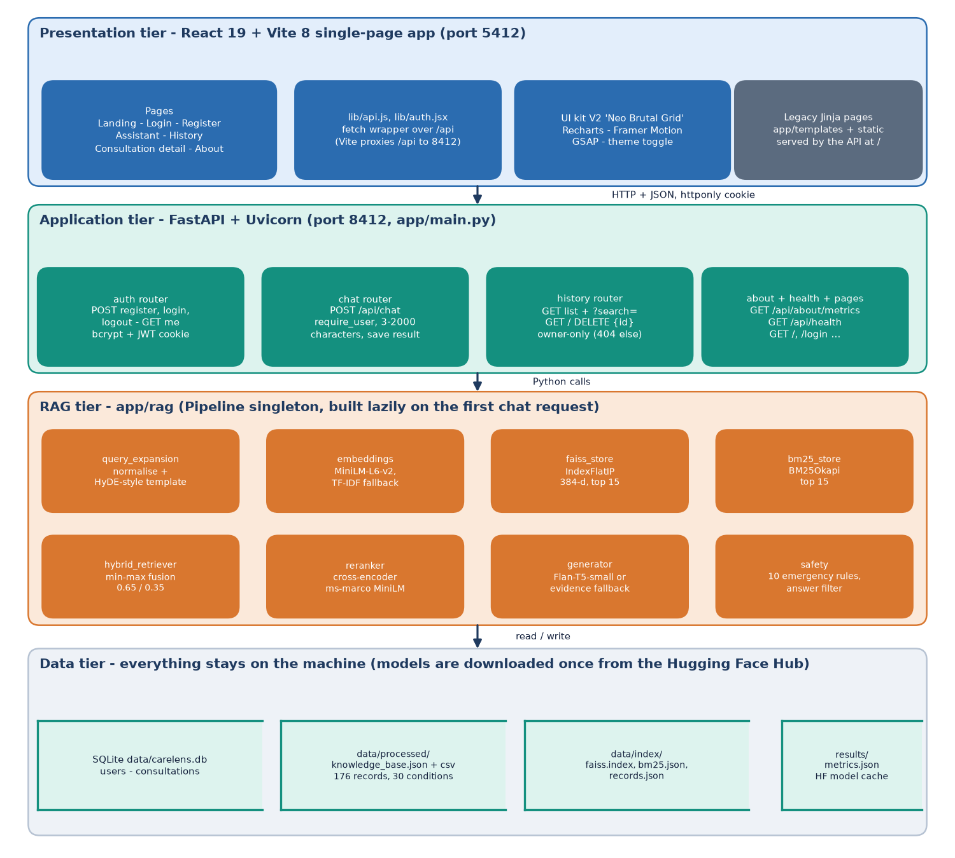
Figure 1: Four-tier architecture of SymptoTrackAI (CareLens AI): React web app, FastAPI application, RAG modules and local data stores.
No external service is used at run time. After the models have been downloaded once, the whole system works offline: if the embedding model cannot be loaded the retrieval uses TF-IDF vectors, if the reranker cannot be loaded the hybrid order is used, and if the generator cannot be loaded an evidence-based answer is composed from the retrieved records. The backend still serves the original server-rendered pages (templates/ and static/, written before the React interface) at the root of the API; they are not the product front door and are not described further.
Table 17: Tiers, technologies and responsibilities
Tier | Technology | Responsibility
Presentation | React 19, React Router 7, Vite 8, Recharts, Framer Motion, GSAP | Landing, sign-in, assistant, history, detail and about pages; theme; loading, empty and error states
Application | FastAPI, Uvicorn, Pydantic v2, SQLAlchemy 2, PyJWT, bcrypt | Routes, input validation, authentication, per-user queries, error handling
RAG | sentence-transformers, FAISS, rank-bm25, Transformers, scikit-learn | Query expansion, embeddings, dense and lexical search, fusion, reranking, generation, safety rules
Data | SQLite, CSV, JSON, FAISS index file, Hugging Face cache | Users, consultations, knowledge base, indexes, model weights

5.2 High-Level Workflow
The workflow of the system is the workflow of one POST /api/chat request. It runs through a fixed sequence of stages. The route checks the sign-in cookie and the length of the message; the Pipeline normalises the text and builds a short hypothetical description from it; the combined text is embedded; FAISS returns the fifteen nearest records and BM25 the fifteen best lexical matches; the two score lists are normalised and fused; the cross-encoder rescores the fused candidates and the best five are kept; a separate rule layer checks the original message for emergency wording; the generator produces the answer text; the answer filter removes listed medication phrases; and the consultation is stored and returned to the interface, which shows the answer, the safety banner and one evidence card per retrieved record.
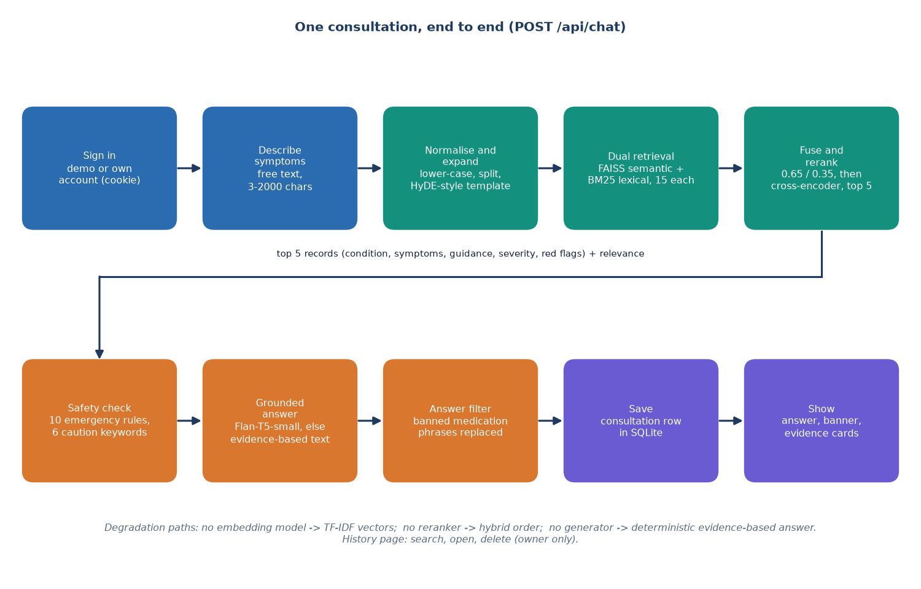
Figure 2: High-level workflow of one symptom analysis (POST /api/chat).
There are three degradation paths. If the sentence-transformer cannot be loaded, the embedding backend switches to a 384-feature TF-IDF vectoriser fitted on the knowledge base. If the cross-encoder cannot be loaded, the hybrid score is used as the rerank score. If the generator cannot be loaded, or fails on a query, Generator.generate returns the deterministic evidence-based answer and labels it evidence-fallback. If the knowledge base or the index is missing the route returns 503 with a message that names the missing file. In all cases the other stages are unaffected.
Offline, the knowledge base is prepared by scripts/prepare_data.py, which writes data/processed/knowledge_base.csv and .json; scripts/build_index.py embeds every record, writes the FAISS index and the BM25 corpus into data/index/, and scripts/seed_demo.py creates the demo account. run.bat runs the three scripts when their outputs are missing. The Pipeline also rebuilds the index itself on first use if the files are absent.
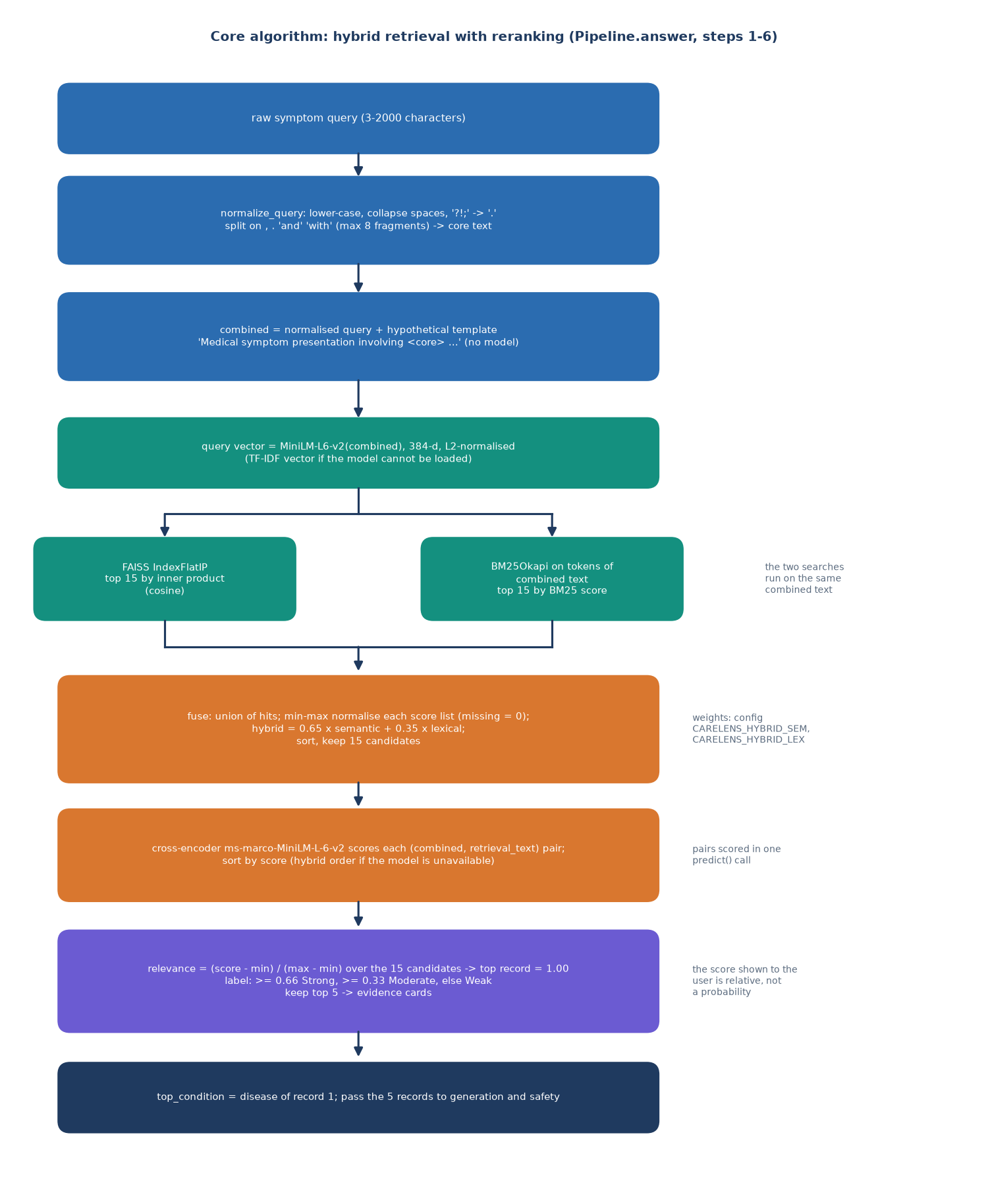
Figure 3: Flowchart of the retrieval algorithm: expansion, dual retrieval, fusion, reranking, safety and generation.
The flowchart above shows the retrieval algorithm at the level of decisions: where the pipeline branches on the availability of a model, and where the safety layer and the answer filter are applied. The decision flow of the safety layer alone is shown below.
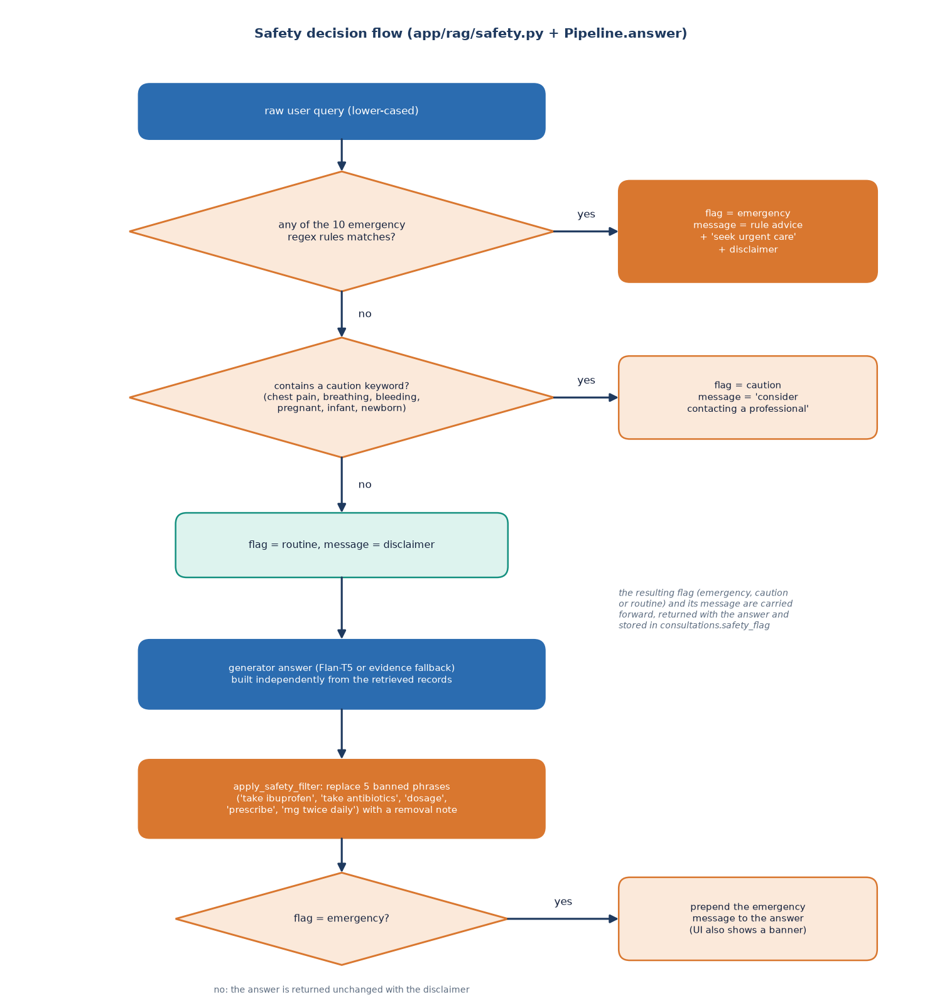
Figure 4: Decision flow of the safety layer and the answer filter.

5.3 Data Flow Diagrams

5.3.1 Level 0: context
At the context level the system is one process with two neighbours. The user sends registration and sign-in details, symptom descriptions, history searches and deletion requests, and receives the grounded answer, the evidence cards, the safety notice, the stored history and the evaluation figures. The Hugging Face Hub is contacted only on the first run, to download the embedding, reranker and generator weights into the local cache; after that no external system exchanges data with the application.
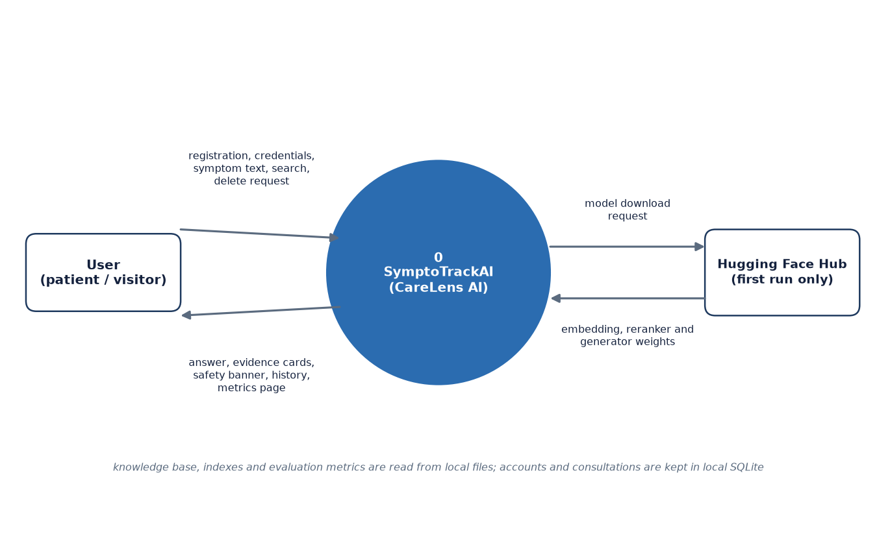
Figure 5: Context diagram (DFD level 0).

5.3.2 Level 1: main processes
Level 1 divides the system into seven processes and four stores. Process 1.0 guards the processes that act on a user's data (2.0, 4.0 and 5.0). The developer appears as a second actor because process 7.0, which builds the knowledge base and the indexes, is run once from the scripts before the application is used. The table gives the data that enter and leave each process.
Table 18: Level 1 processes and their data
No. | Process | Inputs | Outputs | Stores
1.0 | Authenticate user | E-mail, password, session cookie | Session cookie, user id, validation errors | D1 (read, write)
2.0 | Retrieve evidence | Symptom text | Top-5 records with relevance | D2 (read)
3.0 | Generate and screen answer | Original text, top-5 records | Answer text, safety flag and message, evidence cards | -
4.0 | Store consultation | Result of 3.0, user id | New consultation row | D3 (write)
5.0 | Manage history | Search text, consultation id, delete request, user id | History list, detail, deletion result | D3 (read, delete)
6.0 | Report metrics | Metrics request | Stored metrics and knowledge-base size | D4 (read), D2 (size)
7.0 | Build knowledge base and index | Condition table in prepare_data.py | Knowledge-base files, FAISS and BM25 indexes | D2 (write)

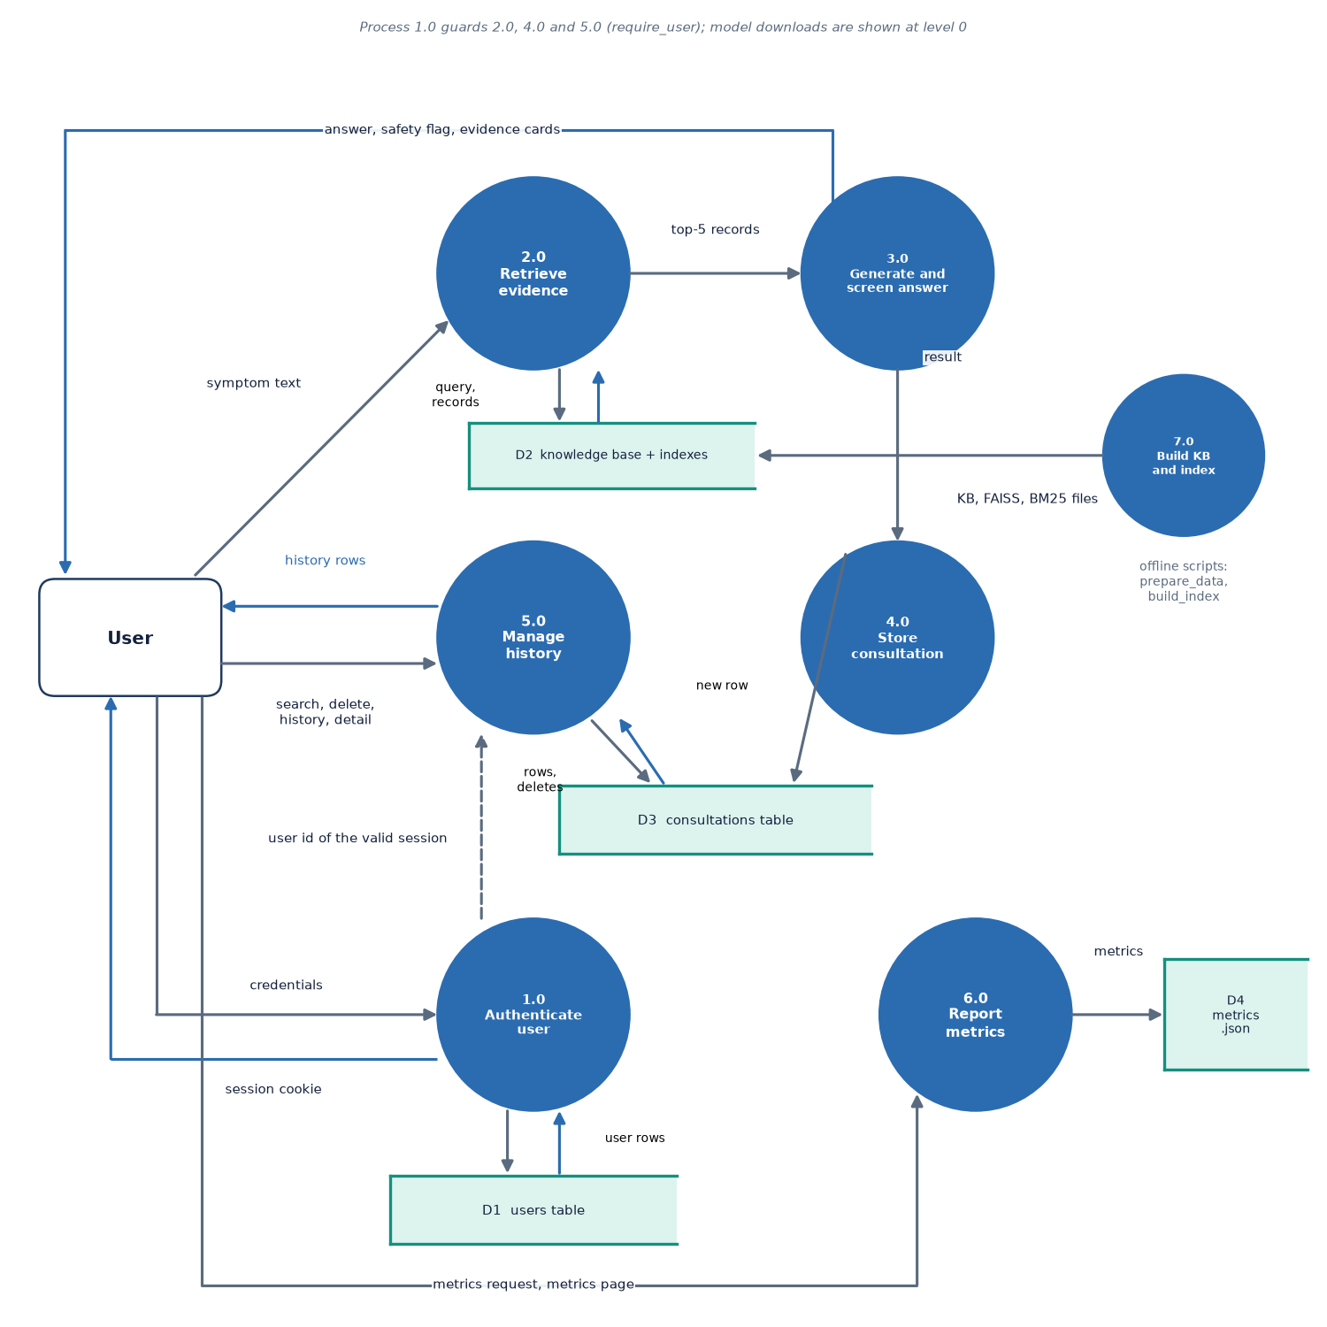
Figure 6: DFD level 1: six processes and three data stores.
The stores are D1, the users table; D2, the knowledge base with its FAISS and BM25 indexes; D3, the consultations table; and D4, the stored metrics file results/metrics.json. Process 5.0 also serves the history search, the detail view and the deletion, all of which are restricted to the signed-in user's own rows.

5.3.3 Level 2: the analysis processes
Level 2 expands processes 2.0 and 3.0 into the steps of Pipeline.answer. Each step takes the output of the previous one; the original message is passed unchanged to the safety check.
Table 19: Level 2 sub-processes
No. | Sub-process | Module and function | Data read
2.1 | Normalise and expand | query_expansion.normalize_query, expand_query_hyde | Symptom text
2.2 | Embed query | embeddings.EmbeddingBackend.encode | all-MiniLM-L6-v2 weights
2.3 | Semantic search | faiss_store.FaissStore.search | data/index/faiss.index
2.4 | Lexical search | bm25_store.BM25Store.search | data/index/bm25.json
2.5 | Fuse (0.65 / 0.35) | hybrid_retriever.fuse | Two lists of 15 hits
2.6 | Cross-encoder rerank | reranker.Reranker.rerank | Cross-encoder weights
3.1 | Grounded answer | generator.Generator.generate | Flan-T5 weights, or the fallback
3.2 | Safety check and filter | safety.check_safety, apply_safety_filter | Original text; answer text

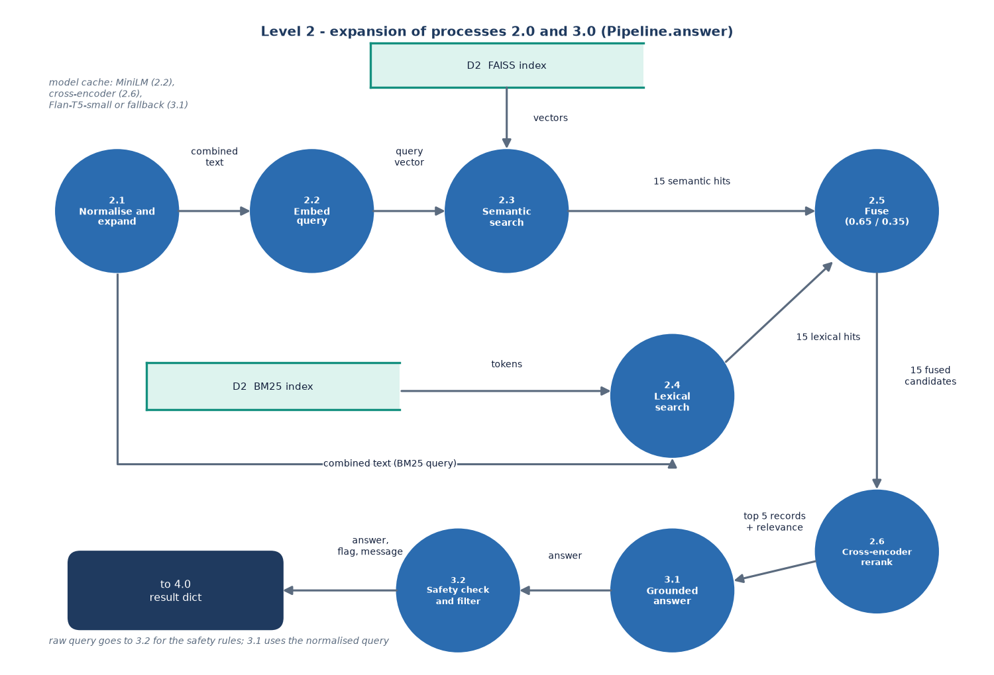
Figure 7: DFD level 2: expansion of the analysis processes into their sub-processes.

5.4 UML Diagrams

5.4.1 Class diagram
The class diagram shows the classes of the system. Two are persistent: User and Consultation, the SQLAlchemy classes that map to the two tables, joined by a one-to-many relationship with cascade delete. The Pydantic schemas (RegisterRequest, LoginRequest, ChatRequest, EvidenceItem, ChatResponse) state the limits of every input and the shape of the output. The routers are thin: each function validates, calls one collaborator and returns a dictionary. The Pipeline owns one object of each RAG class: EmbeddingBackend, FaissStore, BM25Store, Reranker and Generator. Safety is a module of two functions rather than a class, and hybrid_retriever is a module with the single function fuse.
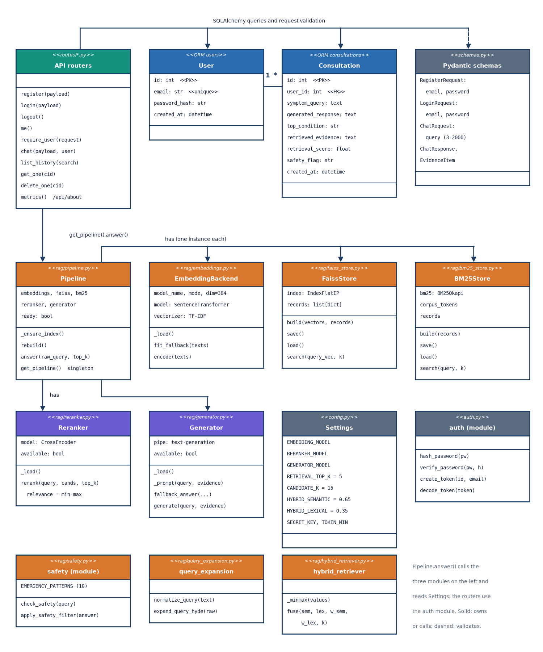
Figure 8: UML class diagram: ORM classes, schemas, routers and the RAG classes.

5.4.2 Sequence diagram
The sequence diagram follows one symptom message. The browser posts the text to /api/chat; the route resolves the user from the cookie, calls Pipeline.answer and then stores a Consultation row before it returns the response. Inside the Pipeline the order of calls is expansion, embedding, FAISS, BM25, fusion, reranking, safety check, generation and filtering. The interface then adds the answer to the conversation, shows a confirmation toast and reloads the list of recent consultations.
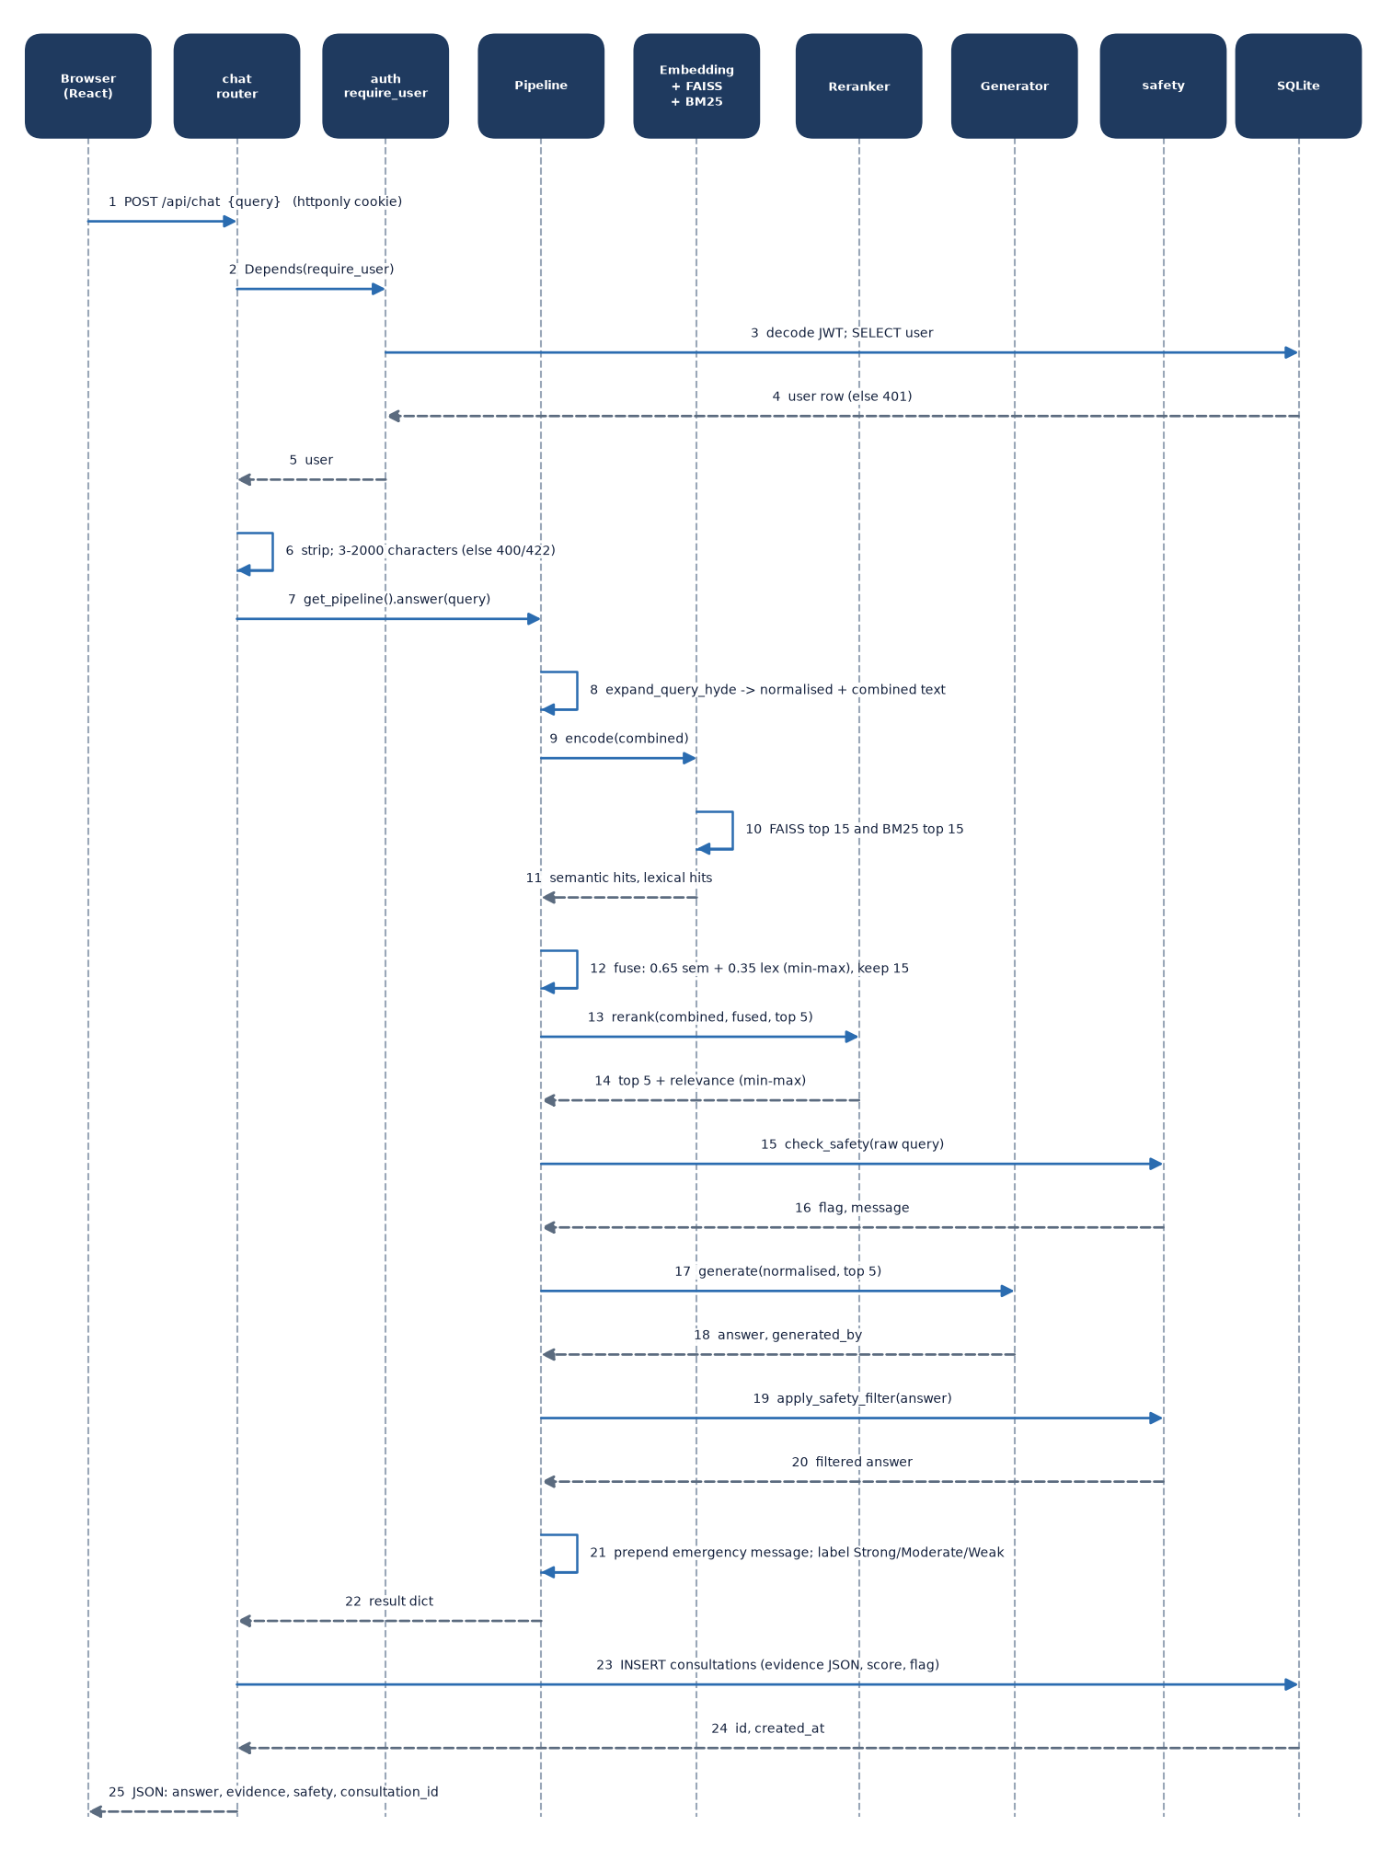
Figure 9: Sequence diagram of the main flow: one symptom message from the browser to the stored answer.

5.4.3 Use-case diagram
Two human actors use the system. A visitor who is not signed in can open the landing page, register and sign in with an own or the demo account. A registered user can in addition describe symptoms, read the grounded answer and its evidence cards, see the emergency or caution banner (part of reading the answer), see the recent consultations, search the history, open a consultation, delete it, view the About page with the measured metrics, and sign out or switch the theme. The local models (MiniLM, the reranker and Flan-T5) take part as a system actor in reading the answer. Every use case from UC4 onwards needs a valid session cookie. The table below lists the use cases with their pre-conditions.
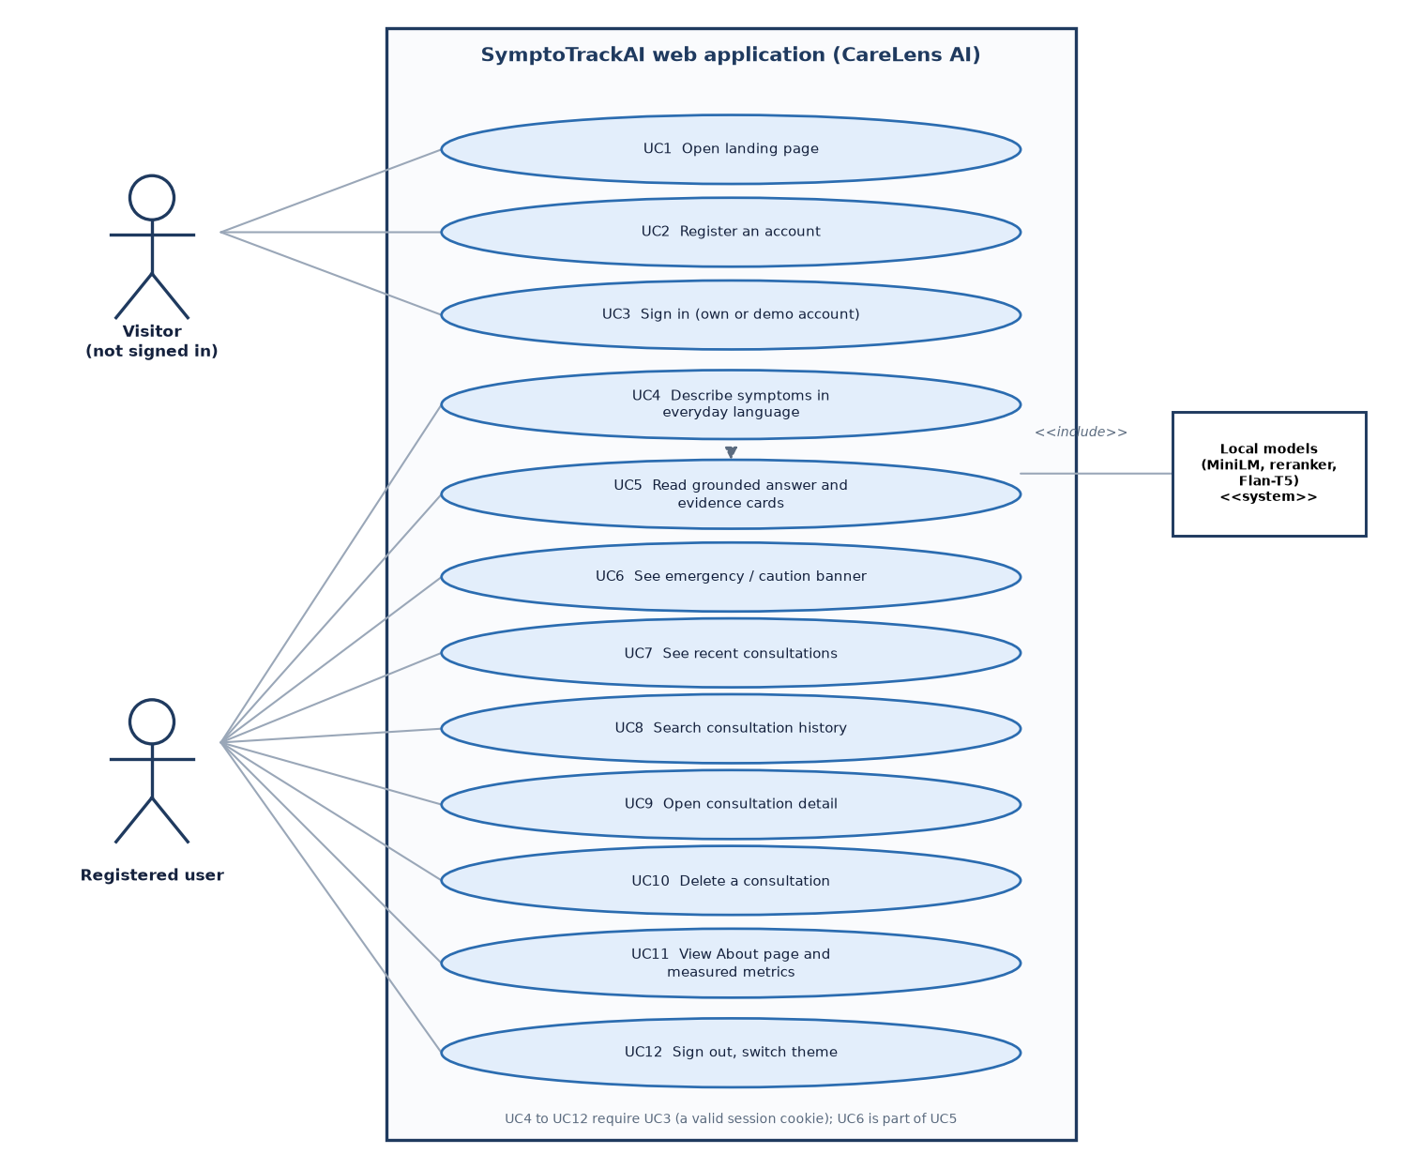
Figure 10: Use-case diagram of the visitor and the registered user.
Table 20: Use cases
No. | Use case | Actor | Pre-condition | Main result
UC1 | Open landing page | Visitor | - | Product pitch and links to register or the demo login
UC2 | Register an account | Visitor | E-mail not yet used; password of 6 to 128 characters | Account created and signed in
UC3 | Sign in (own or demo account) | Visitor | Account exists | Session cookie set; redirect to the assistant
UC4 | Describe symptoms in everyday language | User | Signed in; 3 to 2000 characters | Consultation saved
UC5 | Read grounded answer and evidence cards | User | UC4 completed | Answer text and five evidence cards
UC6 | See emergency or caution banner | User | Message matches a rule | Red or amber banner at the top of the answer
UC7 | See recent consultations | User | Signed in | Last five consultations beside the chat
UC8 | Search consultation history | User | Signed in | Own consultations (latest 200), filtered by symptom or condition
UC9 | Open consultation detail | User | Consultation belongs to the user | Stored question, answer and evidence
UC10 | Delete a consultation | User | Confirmation accepted | Row removed
UC11 | View About page and measured metrics | User | Signed in or not | Pipeline description and the stored evaluation figures
UC12 | Sign out, switch theme | User | Signed in | Cookie cleared; theme stored in the browser

5.5 Database Design
The application database is a single SQLite file, data/carelens.db, accessed through SQLAlchemy. It has two tables created by init_db at start-up. SQLite was chosen because it needs no server, stores all data in one file that the user can see and delete, and is sufficient for one machine and a few accounts. The knowledge base and its indexes are not in the database: they are read-only files that are loaded into memory by the Pipeline.
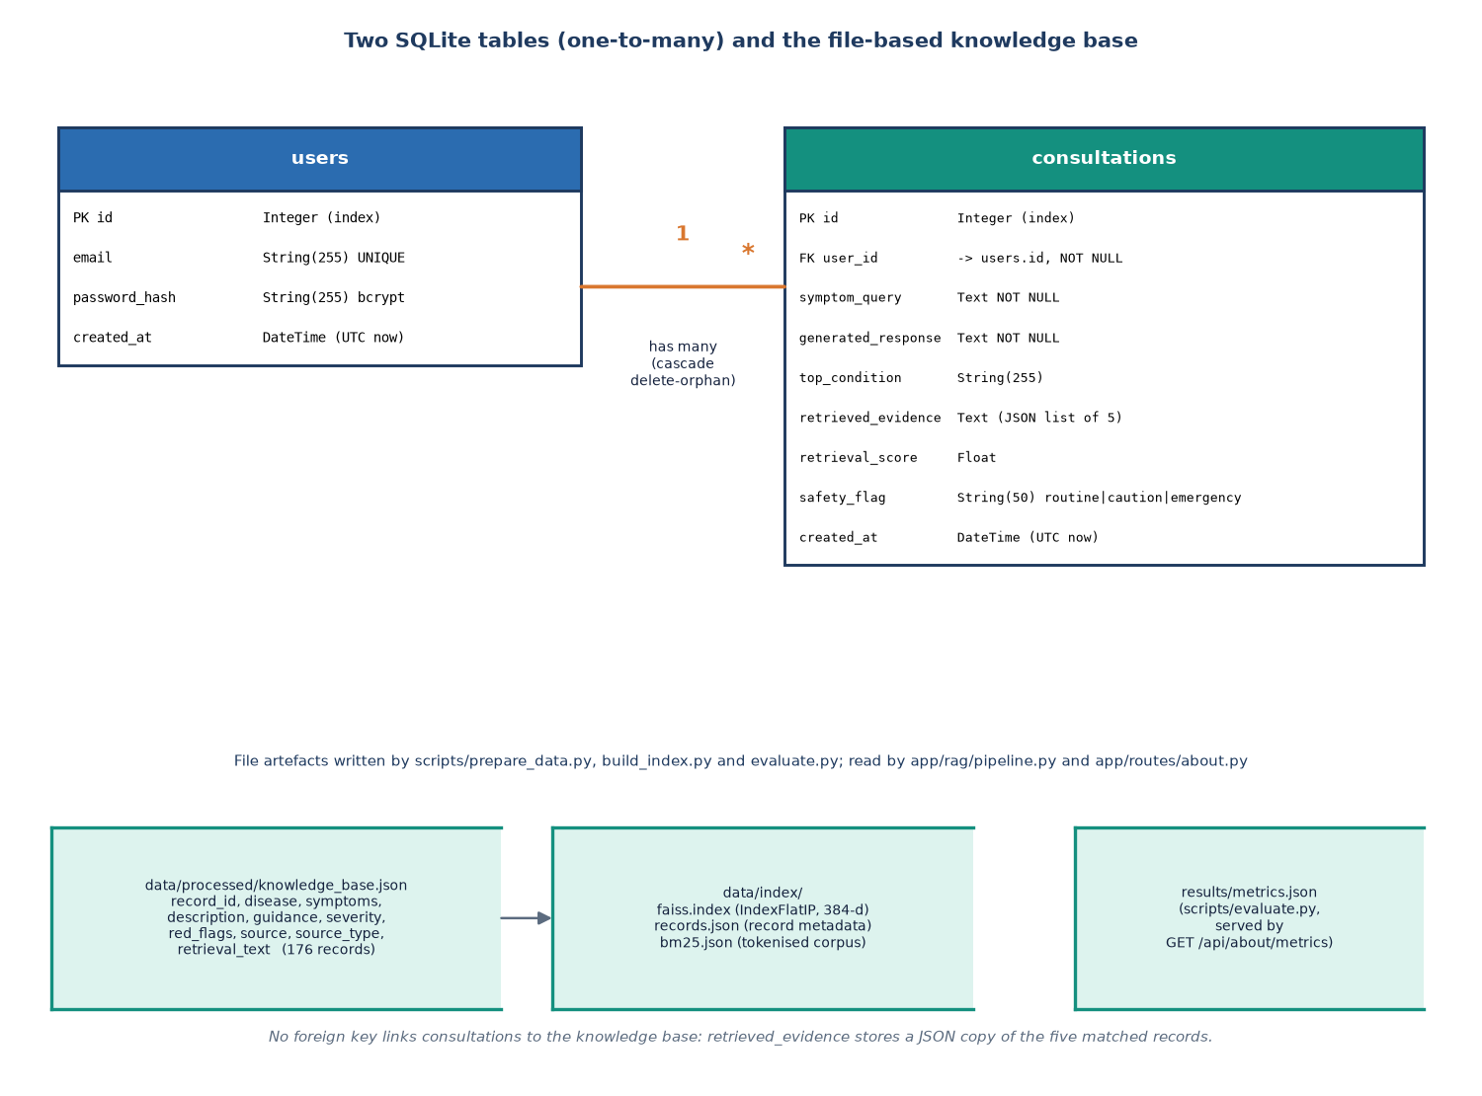
Figure 11: Entity-relationship diagram of the SQLite database and the retrieval stores.
Table 21: Table users
Column | Type | Constraint | Meaning
id | Integer | Primary key, indexed | User identifier
email | String(255) | Unique, indexed, not null | Sign-in name, stored in lower case
password_hash | String(255) | Not null | bcrypt hash of the password
created_at | DateTime | Default: current UTC time | Registration time

Table 22: Table consultations
Column | Type | Constraint | Meaning
id | Integer | Primary key, indexed | Consultation identifier
user_id | Integer | Foreign key to users.id, indexed, not null | Owner; every query filters on it
symptom_query | Text | Not null | The message as typed (3 to 2000 characters)
generated_response | Text | Not null | Answer text, with the emergency notice prepended when flagged
top_condition | String(255) | Default empty | Condition of the best-ranked record
retrieved_evidence | Text | Default '[]' | JSON list of the five evidence records with relevance
retrieval_score | Float | Default 0.0 | Displayed relevance of the best record (0 to 1)
safety_flag | String(50) | Default 'routine' | routine, caution or emergency
created_at | DateTime | Default: current UTC time | Time of the consultation

One user has many consultations (relationship with cascade 'all, delete-orphan'). The evidence is kept as a JSON string in one column rather than in a third table: a consultation is written once and read whole, so a join would add complexity without a benefit, and the stored evidence stays exactly as it was shown even if the knowledge base is rebuilt later. The cost is that the evidence cannot be queried with SQL; the history search is therefore done in Python on the latest 200 rows, over the question text and the top condition only.
The knowledge base is held in data/processed/knowledge_base.json and .csv with ten fields per record.
Table 23: Knowledge-base record
Field | Content
record_id | REC-0001 and so on
disease | Condition name
symptoms | Comma-separated, lower-case symptom list of this record
description | One-sentence description (shared by all records of a condition)
guidance | Self-care and when-to-seek-care text (shared by condition)
severity | low, moderate, high or emergency
red_flags | Warning signs that call for urgent care
source, source_type | Provenance label; every record carries source_type = synthetic
retrieval_text | 'Disease: ... Symptoms: ... Description: ... Guidance: ...' - the text that is embedded and indexed

5.6 Module Design
The backend has 800 non-blank lines of Python in 24 files; the React interface has 2820 lines of JavaScript and JSX. The table lists every backend module with its one responsibility.
Table 24: Backend modules
Module | Responsibility | Main interface
main.py | Creates the app, mounts the static files and routers, creates tables and the demo user at start-up, health route | app, GET /api/health
config.py | All settings, each overridable by a CARELENS_* environment variable | settings
database.py | Engine, session factory, init_db | get_db, init_db
models.py | ORM classes User and Consultation | User, Consultation
schemas.py | Pydantic request and response models with length limits | ChatRequest and others
auth.py | bcrypt hashing and JWT creation and decoding | hash_password, verify_password, create_token, decode_token
demo.py | Creates the demo account if missing | ensure_demo_user
routes/auth.py | Register, login, logout, me; require_user dependency (cookie or Bearer token) | /api/auth/*
routes/chat.py | Validates, runs the Pipeline, stores the consultation, maps errors to 400, 503 and 500 | POST /api/chat
routes/history.py | List with search, get one, delete; every query filtered by user_id | /api/history
routes/about.py | Serves results/metrics.json with the knowledge-base size | GET /api/about/metrics
routes/pages.py | Legacy server-rendered pages | /, /login, /dashboard ...
rag/pipeline.py | Lazy singleton that loads the models and indexes and runs the whole flow | get_pipeline, Pipeline.answer, rebuild
rag/query_expansion.py | Normalisation and the hypothetical-description template | normalize_query, expand_query_hyde
rag/embeddings.py | Sentence-transformer encoder with a TF-IDF fallback | EmbeddingBackend.encode
rag/faiss_store.py | Flat inner-product index: build, save, load, search | FaissStore
rag/bm25_store.py | BM25 index over the same records | BM25Store
rag/hybrid_retriever.py | Min-max normalised weighted fusion | fuse
rag/reranker.py | Cross-encoder rescoring and relevance normalisation | Reranker.rerank
rag/generator.py | Flan-T5 generation and the evidence-based fallback | Generator.generate
rag/safety.py | Emergency and caution rules, medication-phrase filter | check_safety, apply_safety_filter

Three design points follow from the table. First, the Pipeline is a lazy singleton: the three models take about a minute to load, so they are loaded on the first chat request and reused afterwards, which keeps start-up of the server immediate and the health route always available. Second, each RAG class hides one replaceable choice: swapping the vector store, the encoder or the generator means changing one file. Third, the safety module has no dependency on the retrieval classes, so a failure of any model cannot disable it.

5.6.1 The RAG classes in detail
EmbeddingBackend tries to load the sentence-transformer when it is created and records its mode, 'sentence-transformer' or 'tfidf'. In the first mode encode returns unit-length 384-dimensional vectors. In the second it fits, or re-uses, a TF-IDF vectoriser with at most 384 features and English stop words, pads or truncates the matrix to 384 columns and normalises the rows, so that the rest of the code does not need to know which mode is active. When the index is loaded from disk in TF-IDF mode, the vectoriser is refitted on the stored records.
FaissStore wraps a flat inner-product index. build adds the vectors and saves the index to data/index/faiss.index together with the record list in records.json; load restores both and returns false if either is missing, which makes the Pipeline rebuild; search returns up to k tuples of (score, record, position). BM25Store lower-cases the retrieval text, keeps alphanumeric tokens and builds a BM25Okapi model; it saves the records and the tokenised corpus as JSON so that the model can be rebuilt on load. Both stores index the same record list in the same order, which is what allows the fusion step to match their hits by position.
Reranker loads the cross-encoder when created. rerank scores every (query, retrieval text) pair, sorts by score, rescales the scores of all candidates to the 0 to 1 relevance and returns the best k. If the model is unavailable, or if prediction fails, the hybrid score takes the place of the cross-encoder score. Generator loads a text-to-text pipeline, builds the prompt of Section 6.3.6, and returns a pair of the answer and a label that says which method produced it: the model's name or 'evidence-fallback'. Pipeline creates one of each, ensures that the indexes exist, and exposes answer(raw_query, top_k), which returns one dictionary with the answer, the evidence list, the safety flag and message, the relevance label, the score, the generator label and the expansion that was used.
Table 25: Data passed between the stages
Stage output | Structure
Expansion | {normalized, hypothetical, combined} - three strings
Dense and lexical hits | List of (score, record, position) tuples, at most 15 each
Fused candidate | {idx, record, sem, lex, hybrid} - sorted by the hybrid score, at most 15
Reranked candidate | The fused dictionary plus rerank (raw score) and relevance (0 to 1), at most 5
Evidence item | {record_id, disease, symptoms, description, guidance, severity, red_flags, relevance, hybrid, rerank}; the route removes hybrid and rerank before sending
Safety result | {flag, message} with flag routine, caution or emergency
Pipeline result | {answer, top_condition, evidence, safety_flag, safety_message, relevance_label, retrieval_score, generated_by, expanded}

5.7 User Interface Design
The interface is a React single-page application built on a neo-brutalist component kit (thick borders, a grid background, a lime accent, Archivo Black headings and IBM Plex text). Routes are code-split with lazy loading. Signed-in pages are rendered in a shell with a side navigation that becomes a drawer on narrow screens; the public pages use a top bar. A guard component sends a visitor who is not signed in to the sign-in page and returns them to the page they asked for afterwards, and the sign-in and registration pages redirect a signed-in user to the assistant.
Table 26: Routes and screens
Route | Screen | What it offers
/ | Landing | Product pitch, how it works in steps, facts ticker, links to register or try the demo login
/login, /register | Sign in, Create account | Forms with inline errors and a show-password control
/assistant | Symptom assistant | Chat log, four example chips, text area (Enter sends), safety banners, answer, evidence cards, five recent consultations
/history | Consultations | Search box, sortable table with condition, safety badge, relevance and date, view and delete with confirmation
/history/:id | Consultation detail | Stored question, answer and evidence cards; delete
/about | About and metrics | The seven pipeline stages, the stored evaluation figures and the caveat that they come from synthetic data
* | Not found | Message and link home

Four design rules were applied. Safety is never decorative: an emergency notice is a full-width red alert above the answer, a caution notice is amber, and the line 'Not a diagnosis. In an emergency call your local emergency number' sits permanently under the text box. Evidence is visible: each answer is followed by cards that show the record's typical symptoms, description, guidance, severity badge, 'seek urgent care if' warning signs and a relevance bar, whose tooltip states that it is similarity to a record and not a medical probability. Every state is designed: loading skeletons, empty states, error states with a retry button, toasts for success, and a typing indicator while the answer is computed. Accessibility basics are in place: the conversation is an aria-live log, controls have labels, dialogs trap focus and close with Escape, the theme (light or dark) is stored in the browser, and animations respect the reduced-motion setting.
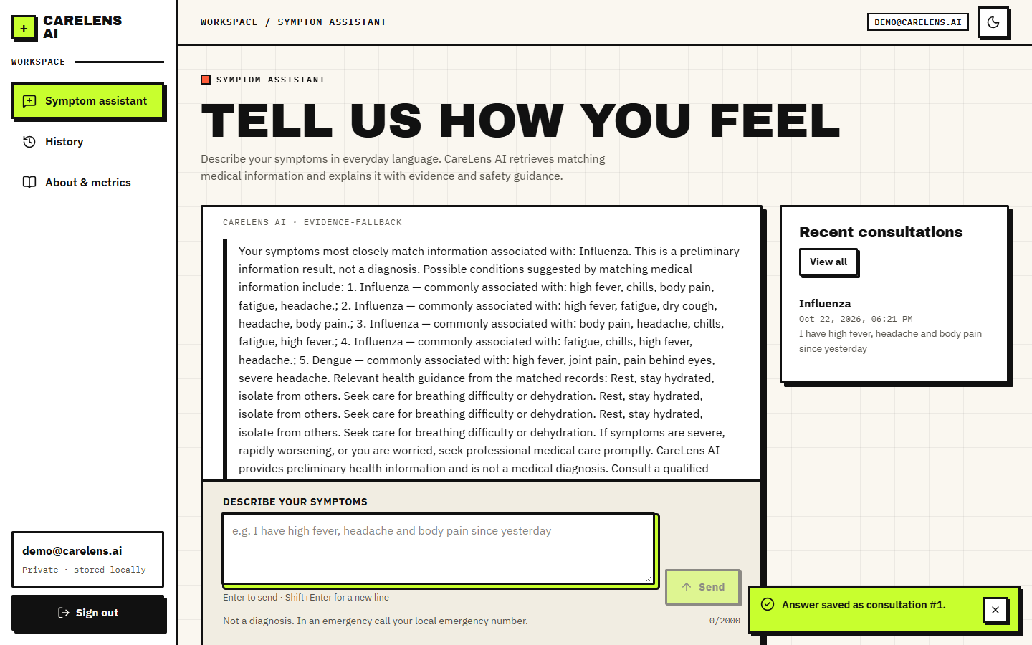  Figure 12: Assistant screen with an answer and the recent-consultations panel. | 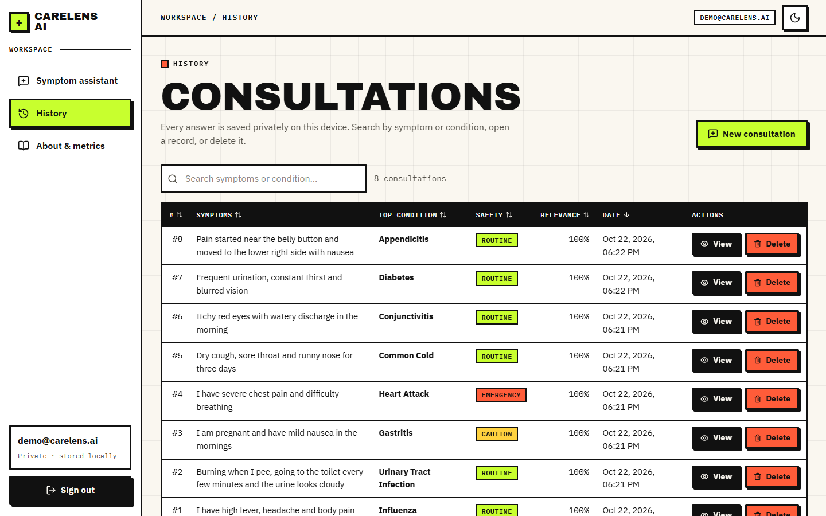  Figure 13: History screen with search, safety badges and relevance.

Screens captured from the running application are shown with their analysis in Chapter 8.

5.8 Design Decisions and Their Reasons
Each decision below was made while the system was built, with the alternative that was not taken and the consequence that has since been observed.
Table 27: Design decisions
Decision | Alternative | Reason | Observed consequence
Run every model locally | Hosted LLM API | Symptom text is health data; no cost, key or internet needed | First request takes about a minute to load models; CPU generation is slow
Hybrid dense + lexical retrieval | Dense only | Symptom words are short and exact; BM25 catches literal matches, the encoder catches paraphrase | Hybrid 90% vs dense 90% on lay probes; BM25 alone 88%
Cross-encoder reranking of 15 candidates | Return the fused order | A cross-encoder reads query and record together and is more precise | Top-1 on lay probes 96.7% vs 90.0%; reranking is the slowest stage
Rule-based HyDE-style template | LLM-written hypothetical document | No second model call and no latency; deterministic | No measured gain: top-1 without it 100.0% on lay probes
Min-max fusion with weights 0.65/0.35 | Reciprocal rank fusion | Keeps score magnitudes; weights are configurable | Weights were not tuned on data
Relevance = min-max of rerank scores | Raw cross-encoder score or probability | Gives the user a simple 0 to 100% bar | The best record is always 100%, even for complaints outside the knowledge base (Chapter 8)
Answer from retrieved records, with a deterministic fallback | Free generation | Nothing may be said that is not in the evidence | Fallback text is repetitive; the local generator path echoes its prompt in the tested environment
Regex safety layer separate from retrieval | Classifier or LLM triage | Transparent, instant, cannot be disabled by a model failure | Misses paraphrased emergencies and fires on negations (Chapter 7)
Evidence stored as JSON text | Separate evidence table | Written once and read whole; keeps what was shown | Not searchable with SQL
JWT in an httponly cookie, Bearer also accepted | Token in local storage | Not readable by page scripts | No Secure flag and a default signing key (Chapter 7)
SQLite | PostgreSQL | Single file, no server | Suited to one machine, not to many users
Vite dev server proxies /api | Cross-origin requests with CORS | Same origin, so the cookie works without CORS configuration | Docker uses nginx for the same purpose

5.9 Quality Attributes and Design Constraints
The design was judged against five quality attributes, each with the measure that was actually used and the constraint that limits it.
Table 28: Quality attributes
Attribute | How the design addresses it | Constraint or open point
Privacy | Local models, local SQLite file, no analytics, no external calls after the first model download, per-user filtering of every query | Data are not encrypted at rest; the signing key is a default value unless changed
Safety | Rule layer independent of retrieval, permanent disclaimer, emergency banner above the answer, medication-phrase filter | Rules are literal; they do not understand paraphrase or negation
Reliability | Three degradation paths; 503 and 500 mapped to readable messages; retry button in the interface | A model that loads but misbehaves (the generator echo) is not detected
Performance | Models loaded once; exact search over a small index; stages timed separately | The cross-encoder on a CPU dominates the response time; no concurrency design
Maintainability | One module per replaceable choice; settings in one file with environment overrides; no global state besides the Pipeline singleton | The test suite is small; behaviour of the safety and history code is mostly covered by the smoke test and probes
Portability | Windows launcher, manual steps for other systems, Docker images for the API and the web server | Tested only on Windows 11

Two constraints shaped many choices. The hardware is an ordinary laptop or desktop without a GPU, which ruled out a large generator and made the small Flan-T5 and the six-layer cross-encoder the practical choices. The knowledge base is small and written by the team, which made an exact flat index sufficient and made the retrieval question easy; a real clinical corpus of thousands of passages would need the structure that the base paper and the ClinicBot system [6] describe, such as sectioned guidelines with provenance, and would justify an approximate index.

CHAPTER 6: METHODOLOGY AND SOFTWARE IMPLEMENTATION

6.1 Overall Methodology
SymptoTrackAI, implemented as the CareLens AI web application, answers a symptom description in everyday language with information retrieved from a medical knowledge base. The methodology follows the retrieval-augmented generation idea [15], in which a language model's answer is conditioned on passages fetched from a document store instead of on its own memory, because ungrounded models can produce fluent but wrong statements [27], which is unacceptable for health information. The base paper [1] applies this idea with FAISS similarity search and a sentence-transformer over a symptom-disease knowledge base, and keeps each consultation for later review. This project keeps that skeleton and extends the retrieval stage in the way the title promises: lexical search is added to dense search, a query-expansion step precedes retrieval, a neural reranker follows it, and a rule-based safety layer surrounds the answer.
The method has seven steps, executed for every message. (1) The text is normalised and a hypothetical description is built around it (query expansion). (2) The combined text is embedded with a sentence-transformer. (3) The embedding is searched in a FAISS index and the same text is searched with BM25, each returning fifteen candidates. (4) The two score lists are min-max normalised and fused with weights 0.65 and 0.35. (5) A cross-encoder rescores the fused candidates and the best five are kept; their scores are rescaled to a 0 to 1 relevance. (6) The original message is checked by a rule layer for emergency or caution wording, a generator composes the answer from the five records, and a filter removes listed medication phrases. (7) The question, answer and evidence are stored for the signed-in user.
The pre-trained models are used as they are. No model was trained or fine-tuned in this project, so there are no training curves, no training and validation split, and no training hyper-parameters; what is tuned by hand is the retrieval configuration (candidate pool, fusion weights, number of records shown). The experimental method is therefore an evaluation of the pipeline: the knowledge base is the retrieval corpus, queries are the test cases, and the correct answer is the condition of the record that the query was written from (Section 6.2.3).

6.2 Knowledge Base and Evaluation Data

6.2.1 Construction of the knowledge base
The knowledge base is built by scripts/prepare_data.py. The script contains a hand-written table of 30 common conditions (for example Common Cold, Influenza, Dengue, Pneumonia, Appendicitis, Stroke and Heart Attack), each with a list of typical symptoms, a one-sentence description, a self-care and when-to-seek-care text, a severity level and a list of red-flag signs. For every condition the script generates up to six records, each a random subset of three to five of its symptoms (the random generator is seeded with 42), and drops records whose condition and symptom list are identical to an earlier one. 180 records were generated and 4 duplicates removed, leaving 176 records. Each record carries the canonical retrieval text 'Disease: ... Symptoms: ... Description: ... Guidance: ...'.
The knowledge base is synthetic. It was written by the project team from general knowledge, was not taken from a clinical source and has not been reviewed by a clinician; every record is labelled source_type = synthetic, and the interface says so on the About page. The same pipeline accepts a downloaded symptom-disease table in the same columns, but no public dataset was used in this work, so no dataset licence applies. Because the description and guidance are shared by all records of a condition, there are only 30 distinct description and guidance pairs in 176 records, and the symptom vocabulary is 97 distinct phrases with 3.98 symptoms per record on average.
Table 29: Knowledge-base facts
Item | Value
Records / conditions | 176 / 30 (4 to 6 records per condition)
Severity labels | low 36, moderate 88, high 28, emergency 24
Symptoms per record | 3.98 on average (range 3 to 5)
Distinct symptom phrases | 97
Distinct description and guidance pairs | 30 (one per condition)
Source | Written by the team; source_type = synthetic; not clinically reviewed
Index | FAISS flat inner-product index, 384 dimensions, plus a BM25 corpus

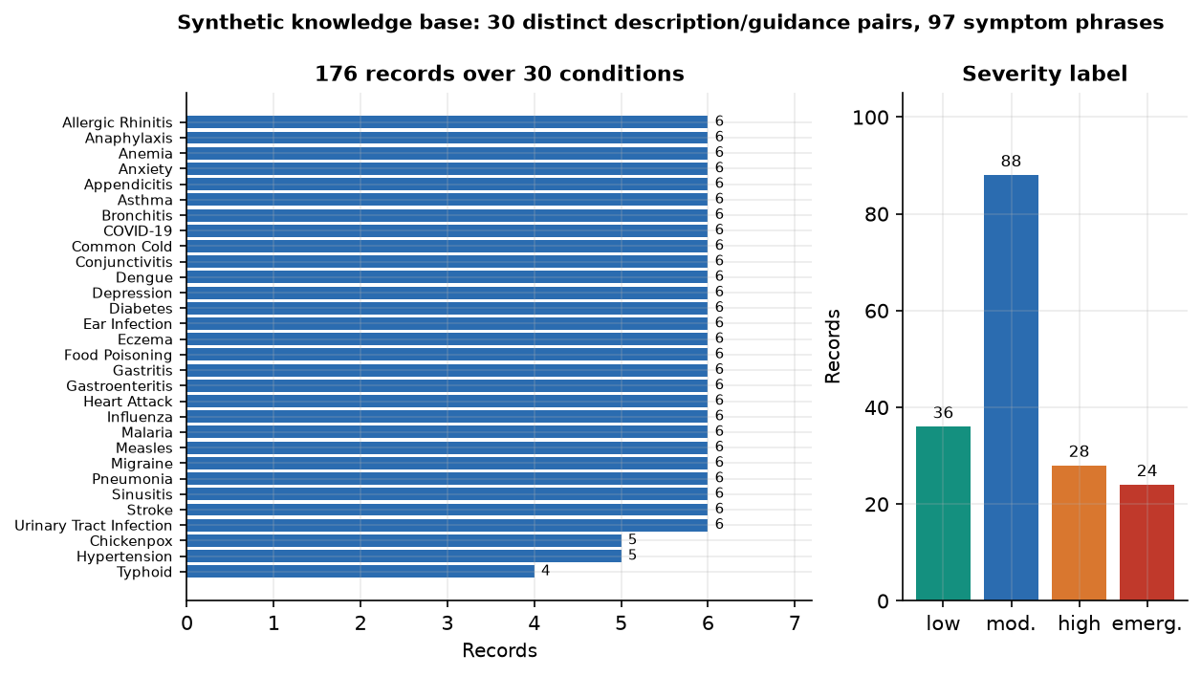
Figure 14: Composition of the knowledge base: records per condition and severity labels.

6.2.2 Preprocessing
Preprocessing happens in two places. When the knowledge base is built, symptom phrases are lower-cased, whitespace is collapsed and repeated symptoms inside a record are removed. At query time normalize_query lower-cases the message, collapses whitespace, turns '?', '!' and ';' into full stops and truncates to 2000 characters. expand_query_hyde then splits the normalised text on commas, full stops, ' and ' and ' with ' into at most eight fragments and builds the hypothetical description. Both functions are quoted below exactly as they are in the code.
def normalize_query(text: str) -> str:
t = (text or "").strip().lower()
t = re.sub(r"\s+", " ", t)
t = re.sub(r"[?!;]+", ".", t)
return t[:2000]

def expand_query_hyde(raw_query: str) -> dict:
"""Return {'normalized': str, 'hypothetical': str, 'combined': str}."""
norm = normalize_query(raw_query)
# Extract mention-like fragments (split on commas/periods/and)
frags = [f.strip() for f in re.split(r"[,.]| and | with ", norm) if f.strip()]
frags = [f for f in frags if len(f) > 1][:8]
core = ", ".join(frags) if frags else norm
hypothetical = (
f"Medical symptom presentation involving {core}. "
"Patient-reported symptoms with possible associated systemic features, "
"onset information and relevant clinical observations for matching medical information."
)
combined = f"{norm} {hypothetical}"
return {"normalized": norm, "hypothetical": hypothetical, "combined": combined}

The expansion is a template, not a second language model: it wraps the symptom fragments in a fixed sentence about 'medical symptom presentation'. The idea comes from HyDE [20], where a language model writes a hypothetical answer document and the retriever searches with that document instead of the short question. Writing the document with a model would add a generation step to every query, so the project uses a deterministic stand-in, and the experiments in Chapter 8 test whether it helps.

6.2.3 Evaluation query sets
Because nothing is trained, the evaluation needs only queries with known answers. Four query sets were used; all are small, all are for the bundled synthetic knowledge base, and none was reviewed by a clinician.
Table 30: Evaluation query sets
Set | Queries | How they were made | What they test
S1 | 30 | One random record per condition (the protocol of scripts/evaluate.py, seed 7); the query is 'I have' plus the record's symptoms | Wiring. Shipped protocol leaves the record in the index; leave-one-out removes it
S2 | 176 | Every record in turn, same wording, record removed from the index | Retrieval from sibling records
S3 | 176 | Every record in turn, two randomly chosen symptoms only (seed 11), record removed | Short, ambiguous queries
S4 | 60 | Two everyday-language descriptions per condition written by the authors (scripts/probe_data.py) | Paraphrase and word choice not in the knowledge base

For each query the system's answer is the condition of its top-ranked record, and it is counted correct when it equals the condition the query was written for. Two further probe sets test parts of the system other than retrieval: 15 complaints that no condition in the knowledge base covers, and 40 emergency descriptions with 30 non-emergency texts for the safety rules (Chapter 7).

6.3 Algorithms and the Reasons for Choosing Them

6.3.1 Dense retrieval: sentence embeddings and FAISS
Symptom descriptions are matched to records by meaning, so that 'my chest feels tight' can retrieve a record that says 'chest tightness'. The encoder is all-MiniLM-L6-v2, a six-layer Sentence-BERT model [18] built on the compact MiniLM transformer [24] that maps a text to a 384-dimensional unit vector. It was chosen because it is small (about 22 million parameters), fast on a CPU and widely used for semantic search. With unit vectors the inner product equals the cosine similarity, so the index is a FAISS IndexFlatIP [17], an exact search that compares the query with all 176 vectors. For a base of this size an approximate index would add complexity and error for no speed benefit. Dense retrieval follows the dual-encoder approach of dense passage retrieval [16].
sim(q, d) = (q · d) / (‖q‖ ‖d‖) = q · d for unit vectors q and d (2)

6.3.2 Lexical retrieval: BM25
Symptom words are short and exact, and a dense model can blur them. BM25 [19], a probabilistic extension of TF-IDF [31], rewards records that contain the query's words, weights rare words more and normalises for record length. The implementation is rank_bm25's BM25Okapi with its default constants (k1 = 1.5, b = 0.75) over lower-case alphanumeric tokens of the retrieval text.
BM25(q, d) = Σ over terms t in q of IDF(t) · f(t,d)·(k1 + 1) / ( f(t,d) + k1·(1 − b + b·|d| / avgdl) ) (3)

6.3.3 Score fusion
The two retrievers return scores on different scales (cosine values between about 0 and 1, BM25 values that are unbounded), so each list is rescaled to the interval from 0 to 1 by min-max normalisation before the weighted sum. A record that only one retriever returned receives the score 0 from the other. The weights are 0.65 for the dense score and 0.35 for the lexical score; they are the project's initial choice and were not tuned. Rank-based fusion [25] is an alternative that needs no weights; it was not tried.
ŝ(i) = (s(i) − min s) / (max s − min s) h(i) = 0.65 · ŝ_dense(i) + 0.35 · ŝ_lex(i) (4)
def fuse(sem_hits, lex_hits, w_sem: float = 0.65, w_lex: float = 0.35, k: int = 15):
"""sem_hits / lex_hits: list of (score, record, idx). Returns ranked list of dicts."""
sem_scores = {idx: s for s, _, idx in sem_hits}
lex_scores = {idx: s for s, _, idx in lex_hits}
rec_by_idx = {}
for _, r, idx in list(sem_hits) + list(lex_hits):
rec_by_idx[idx] = r
all_idx = list(rec_by_idx.keys())
sv = _minmax([sem_scores.get(i, 0.0) for i in all_idx])
lv = _minmax([lex_scores.get(i, 0.0) for i in all_idx])
fused = []
for i, a, b in zip(all_idx, sv, lv):
fused.append({"idx": i, "record": rec_by_idx[i],
"sem": sem_scores.get(i, 0.0), "lex": lex_scores.get(i, 0.0),
"hybrid": w_sem * a + w_lex * b})
fused.sort(key=lambda d: d["hybrid"], reverse=True)
return fused[:k]

6.3.4 Reranking with a cross-encoder
A bi-encoder embeds the query and the record separately, so it cannot see how the two words interact. A cross-encoder reads them together and outputs one relevance score, which is more precise but too slow to run on the whole base [21]. The standard design, used here, is to let the cheap retrievers pick fifteen candidates and let the cross-encoder reorder them. The model is cross-encoder/ms-marco-MiniLM-L-6-v2, trained on the MS MARCO passage-ranking data [22]; it is a general web-search reranker and has not been adapted to medical text. It scores fifteen (query, record text) pairs per request, and the best five are returned.

6.3.5 Relevance display
To give the user a simple bar, the cross-encoder scores of the candidates are rescaled by min-max to the interval from 0 to 1 and shown as a percentage; 0.66 and above is labelled 'Strong match', 0.33 and above 'Moderate match' and anything lower 'Weak match'. The code is quoted below. Because the rescaling uses the minimum and maximum of the same list, the best candidate always receives exactly 1.0, whatever the raw scores were; the display therefore says how a record compares with the other candidates of the same query and nothing about how well the query is covered by the knowledge base. Chapter 8 measures the consequence.
ρ(i) = (r(i) − min r) / (max r − min r), r(i) = CrossEncoder(q, d_i); label = Strong if ρ ≥ 0.66, Moderate if ρ ≥ 0.33, else Weak (5)
def rerank(self, query: str, candidates: list[dict], top_k: int = 5):
if not candidates:
return []
if self.available and self.model is not None:
try:
pairs = [(query, c["record"].get("retrieval_text", "")) for c in candidates]
scores = self.model.predict(pairs)
for c, s in zip(candidates, scores):
c["rerank"] = float(s)
candidates = sorted(candidates, key=lambda d: d["rerank"], reverse=True)
except Exception as e:
print(f"[reranker] predict failed: {e}")
for c in candidates:
c["rerank"] = float(c.get("hybrid", 0.0))
else:
for c in candidates:
c["rerank"] = float(c.get("hybrid", 0.0))
# normalize rerank to 0..1 for display
vals = [c["rerank"] for c in candidates]
lo, hi = min(vals), max(vals)
for c in candidates:
c["relevance"] = 1.0 if hi - lo < 1e-9 else (c["rerank"] - lo) / (hi - lo)
return candidates[:top_k]

6.3.6 Grounded generation and its fallback
The generator receives the normalised message and the five records as numbered context and is instructed to answer only from that context, avoid a definitive diagnosis, avoid prescribing medication and mention uncertainty. The model is Flan-T5-small, an instruction-tuned encoder-decoder with about 77 million parameters [23], run on the CPU with greedy decoding and at most 220 new tokens; a small model was chosen so that the system runs on an ordinary laptop. After generation, the text 'You have ' is replaced by a neutral phrase and a sentence stating that the output is not a diagnosis is appended if it is missing.
If the model cannot be loaded or fails, fallback_answer composes the answer deterministically: it names the condition of the best record, lists the five records with their symptoms, concatenates the guidance texts of the first three, and ends with the warning and the disclaimer. Every condition and every symptom in this text comes from a retrieved record, so it cannot state anything outside the evidence; the price is that it is repetitive. In the tested environment the model path did not produce an answer: the installed Transformers 5.20 no longer provides the text2text-generation task, the loader falls back to text-generation, and for a T5 model that task returns the prompt unchanged. In 30 of 30 test queries the 'answer' was the instruction and the retrieved context, labelled with the generator's name (Chapter 8 shows the screen). The fallback path is the one that gives a usable answer.
def generate(self, query: str, evidence: list[dict]) -> tuple[str, str]:
"""Returns (answer, generated_by)."""
if self.available and self.pipe is not None:
try:
out = self.pipe(self._prompt(query, evidence), max_new_tokens=220, do_sample=False)
text = out[0]["generated_text"].strip() if out else ""
if not text:
raise RuntimeError("empty generation")
# safety post-check: strip any definitive-diagnosis phrasing
text = text.replace("You have ", "Information most closely associated with ")
if "not a diagnosis" not in text.lower():
text += " This information is not a diagnosis; consult a qualified healthcare professional."
return text, f"local-generator:{self.model_name}"
except Exception as e:
print(f"[generator] generation failed: {e}")
return self.fallback_answer(query, evidence), "evidence-fallback"

6.3.7 Safety rules
The safety layer is a list of ten regular expressions, each with a one-sentence advice: severe chest pain or chest pressure, difficulty breathing, severe bleeding, loss of consciousness, stroke-like signs, severe allergic reaction, self-harm, sudden severe neurological symptoms, seizures and severe abdominal pain. A match returns the flag 'emergency' with an urgent-care message that includes the disclaimer. If none matches, six keywords (chest pain, breathing, bleeding, pregnant, infant, newborn) return 'caution'; otherwise the flag is 'routine'. The rules look at the user's message, not at the retrieved records, so they work even when retrieval fails. They are literal patterns: they do not understand negation, history or paraphrase (Chapter 7 measures this). The answer filter then replaces five phrases (take ibuprofen, take antibiotics, dosage, prescribe, mg twice daily) with a marker.
def check_safety(query: str) -> dict:
q = (query or "").lower()
for pattern, advice in EMERGENCY_PATTERNS:
if re.search(pattern, q):
return {
"flag": "emergency",
"message": (f"Emergency safety notice: {advice} Please seek urgent/emergency medical care "
"right away (local emergency number or nearest emergency department). " + DISCLAIMER)
}
# high-risk single keywords that merit caution banner
cautious = ["chest pain", "breathing", "bleeding", "pregnant", "infant", "newborn"]
if any(k in q for k in cautious):
return {"flag": "caution",
"message": ("Caution: your message mentions potentially serious symptoms. "
"Consider contacting a healthcare professional promptly. " + DISCLAIMER)}
return {"flag": "routine", "message": DISCLAIMER}

6.4 Mathematical Formulation of the Evaluation
For n queries, let rank_i be the position of the first record whose condition equals the correct one in the returned list (infinite if absent). Top-k accuracy is the share of queries with rank_i ≤ k and the mean reciprocal rank at 5 is the mean of 1/rank_i over rank_i ≤ 5 (0 otherwise). Because a condition has four to six records, the first three records often belong to one condition, so Top-3 over records is almost the same as Top-1 and the tables also give the mean number of distinct conditions in the five evidence cards. Since every set is small, Top-1 accuracy is reported with the Wilson score interval [34] at 95% confidence, and the separation of in-base and out-of-base queries by a score is summarised by the area under the ROC curve [30].
Top-k = (1/n) Σ 1[rank_i ≤ k] MRR@5 = (1/n) Σ 1/rank_i (rank_i ≤ 5) (6)
Wilson 95% interval = ( p̂ + z²/2n ± z·√( p̂(1 − p̂)/n + z²/4n² ) ) / ( 1 + z²/n ), z = 1.96 (7)

6.5 Retrieval Configuration
Table 31: Retrieval configuration (app/config.py)
Parameter | Value
Embedding model | sentence-transformers/all-MiniLM-L6-v2
Reranker | cross-encoder/ms-marco-MiniLM-L-6-v2
Generator | google/flan-t5-small
Candidate pool per retriever | 15
Records returned | 5
Fusion weights (dense, lexical) | 0.65, 0.35
Maximum message length | 2000 characters (minimum 3)
Token lifetime | 1440 minutes

6.5 Application Architecture and Implementation
The backend is a FastAPI application served by Uvicorn on port 8412. At start-up it creates the tables and the demo user; it does not load any model. The first call to POST /api/chat creates the Pipeline singleton, which loads the sentence-transformer, the cross-encoder and the generator and the two indexes; in the measurement environment this took about 62 seconds, and later requests reuse the loaded objects. If the index files are missing the Pipeline rebuilds them from the knowledge base before it answers. Every route obtains a database session from the get_db dependency and closes it after the response.
The frontend is a React application served by Vite on port 5412. State is kept in components and in one authentication context; there is no global store. The API client lib/api.js adds credentials to every request, converts network failures and error responses into an ApiError with a readable message, and fires an 'unauthorized' event on a 401 so that an expired session sends the user to the sign-in page. The Vite server proxies every /api path to the backend, so the browser sees one origin and the cookie works without cross-origin configuration; in Docker the same job is done by an nginx container.
Four details of the interface code are worth recording. The authentication context keeps a small hint in browser storage that records whether a session may exist, because the session cookie is httponly and cannot be read by the page; without the hint the application would call /api/auth/me on every first visit and log an expected 401. The assistant page keeps the conversation in component state, aborts an unfinished request when the user leaves the page, and shows a toast with the consultation number when an answer is saved. The history page sends the search text to the server after a delay of 300 ms, so a request is not made for every keystroke, and asks for confirmation before it deletes. Every page sets its own document title, and every list has a loading, an empty and an error state.
Table 32: Main software components and versions in the measurement environment
Component | Version | Used for
Python | 3.11.9 | Backend and scripts
FastAPI / SQLAlchemy | 0.159.1 / 2.1.6 | API and database access
PyTorch (CPU) / Transformers | 2.14.1+cpu / 5.20.2 | Model execution; the Transformers version removed the task the generator needs
sentence-transformers / FAISS | 6.2.0 / 1.15.1 | Embeddings and cross-encoder; vector index
scikit-learn | 1.9.1 | TF-IDF fallback and evaluation metrics
React / Vite | 19 / 8 (package.json) | Single-page application and dev server

6.6 API Design
The API is JSON over HTTP. Errors always have the form {detail: message}; validation errors from Pydantic return 422 with a list of messages that the client joins into one sentence. Sign-in is by an httponly cookie named carelens_token; an Authorization: Bearer header is also accepted, which the tests use.
Table 33: API endpoints
Method and path | Auth | Request | Success response | Errors
GET /api/health | no | - | {status, product} | -
POST /api/auth/register | no | {email, password 6-128} | {email, token} + cookie | 400 e-mail exists; 422
POST /api/auth/login | no | {email, password} | {email, token} + cookie | 401 invalid; 422
POST /api/auth/logout | no | - | {ok}, cookie cleared | -
GET /api/auth/me | cookie | - | {email, id} | 401
POST /api/chat | yes | {query 3-2000} | {answer, top_condition, evidence[5], safety_flag, safety_message, relevance_label, consultation_id, created_at, generated_by} | 400 blank; 401; 422; 503 knowledge base missing; 500
GET /api/history?search= | yes | optional search text | list of up to 200 consultations, newest first | 401
GET /api/history/{id} | yes | - | one consultation | 401; 404 not found or not yours
DELETE /api/history/{id} | yes | - | {ok} | 401; 404
GET /api/about/metrics | no | - | stored metrics + kb_records, kb_conditions, data_source | 404 metrics file missing

A 404 rather than a 403 is returned when a consultation exists but belongs to another user, so that the existence of other users' records is not revealed.

6.7 Security and Error Handling
Passwords are hashed with bcrypt [32] with a random salt before storage, and verification catches malformed hashes and returns false. A successful sign-in creates a JSON Web Token [33] signed with HMAC-SHA256 that holds the user id, the e-mail and an expiry after 1440 minutes, and sets it as an httponly cookie with SameSite=lax. Every history route filters on the user id of the token, and a message is accepted only between 3 and 2000 characters. The chat route separates three failure causes: a missing knowledge base returns 503 with the name of the missing file, any other pipeline error returns 500 with a generic message and prints the detail to the server log, and a failure while saving returns 500 after a rollback. The interface turns each of these into a message in the conversation with a retry button.
Three weaknesses are known and are tested in Chapter 7: the signing key has a built-in default value, 'carelens-local-dev-secret-change-me', that is used unless CARELENS_SECRET_KEY is set; the cookie has no Secure flag, which matters when the application is served over HTTPS; and there is no limit on failed sign-in attempts. The registration route also reveals whether an e-mail is already registered. The application was designed for one machine and is not hardened for a public deployment.

6.8 Installation and Execution
The project runs on Windows with Python 3.10 or newer and Node.js 18 or newer. The simplest way is to double-click run.bat in the project folder. The launcher reads the ports from .env (backend 8412, frontend 5412), creates a virtual environment if there is none, installs the Python requirements, prepares the knowledge base and the index when they are missing, installs the frontend packages, seeds the demo account, opens two server windows (CareLens API and CareLens Web) and opens the browser at http://localhost:5412. The first start downloads the three models from Hugging Face and takes longer; later starts need only the time to load the models at the first message.
• Demo login: demo@carelens.ai / Demo@1234; the account is created automatically and has sample consultations.
• Docker: docker compose up --build builds the React app, runs the API container and an nginx container on the same ports.
• Manual: python -m venv .venv; pip install -r requirements.txt; python scripts/prepare_data.py; python scripts/build_index.py; python scripts/seed_demo.py; python -m uvicorn app.main:app --port 8412; then npm install and npm run dev in frontend/.
• Checks: python -m pytest tests (unit and API tests), python scripts/smoke_test.py (end-to-end through the web port) and python scripts/capture_screens.py (screenshots).
• Offline mode: if a model cannot be downloaded the application falls back to TF-IDF retrieval and evidence-based answers and continues to work.

CHAPTER 7: SYSTEM TESTING

7.1 Testing Strategy
SymptoTrackAI, implemented as the CareLens AI application, was tested in six layers. Single functions (query expansion, fusion, safety rules, password hashing, the generator fallback) are tested in isolation; the API is tested in-process against the real application object with a real retrieval round trip; the whole stack, including the React web server and its proxy, is exercised by a smoke test that drives a running server over HTTP; security and input validation were probed with a script written for this report; the retrieval, relevance and safety components were measured on probe sets; and every screen was walked in a real browser while the screenshots of Chapter 8 were captured. The automated tests live in tests/ (60 non-blank lines) and scripts/smoke_test.py; the probes live in scripts/measure_metrics.py, scripts/measure_security.py and scripts/probe_data.py.
What the tests establish is that the code behaves as designed on the cases tried. They do not establish clinical correctness: the knowledge base is synthetic and no clinician reviewed an answer, so none of the results below says how the system would perform on real patients (Section 7.9).
Table 34: Test layers and results
Layer | What it covers | How | Result
Unit | Query expansion, safety rules and filter, password hashing, fusion, generator fallback | pytest, in-process | 9 of 9 tests pass (Pass)
Integration | Registration, chat, history isolation, validation and a retrieval round trip | pytest with FastAPI TestClient | Included in the 9 tests
Functional (end to end) | Health, proxy, sign-in, chat, emergency, history search, detail, delete, about, registration, logout | scripts/smoke_test.py against the running servers | 22 of 22 checks pass (Pass)
Security and validation | Sessions, tokens, cookie, input bounds, isolation between users | scripts/measure_security.py | 35 of 38 probes pass; 3 findings
Measured probes | Retrieval configurations, relevance display, generator, safety rules, answer filter, latency | scripts/measure_metrics.py | Sections 7.6 and 7.7
Browser walk | Every screen, light and dark, with real answers; console, page and HTTP errors | scripts/capture_docs_screens.py (Playwright, Chrome) | All screens captured; no console error

7.2 Unit Testing
The repository contains 9 pytest functions. They are listed with what each asserts; none is a placeholder. No tests were added to the product for this report.
Table 35: Automated pytest cases
ID | Test function | Input | Assertions | Result
T1 | test_normalize_and_expand | 'I have high fever, headache and body pain' | Normalised text contains 'fever'; hypothetical text contains 'Medical symptom presentation' | Pass
T2 | test_safety_emergency | 'severe chest pain and difficulty breathing'; 'I have a mild headache' | First is flagged 'emergency'; second is 'routine' or 'caution' | Pass
T3 | test_safety_filter_removes_dosage | 'take antibiotics daily' | Output contains 'removed' | Pass
T4 | test_password_hashing | 'Secret123' | Hash differs from the password; correct password verifies; wrong one does not | Pass
T5 | test_hybrid_fuse | Two dense hits and one lexical hit | The record found by both retrievers is ranked first | Pass
T6 | test_generator_fallback | Generator without a model, one evidence record | Answer contains 'not a diagnosis' | Pass
T7 | test_auth_and_history_isolation | Two accounts; user 1 asks 'I have fever and cough' | Chat returns 200; after switching to user 2, the consultation of user 1 gives 404 | Pass
T8 | test_api_validation | 'hi'; a 5000-character message | Both rejected with 400 or 422 | Pass
T9 | test_retrieval_roundtrip | 'high fever, headache and body pain', top 3 | At least one evidence record and a top condition | Pass

The suite ran in 34 seconds, most of it model loading. Two tests (T5, T6) use hand-made inputs and test the logic only; T9 only checks that retrieval returns something, not that it is right, which is why correctness is measured separately in Section 7.6. A weakness of the suite is that T7 and T8 write their test users into the real database file (data/carelens.db), which is why the file is excluded from version control. The suite does not test the safety rules beyond one positive and one negative example, the relevance computation, the history search or the deletion route; those are covered by the smoke test and the probes.

7.3 Integration and Functional Testing
scripts/smoke_test.py needs the backend on its port and the Vite server running. It talks to the application the way the browser does, through the web port and its /api proxy, with a cookie jar, and uses the demo account and one throw-away account. Its checks are grouped below; all of them pass.
Table 36: Functional checks of the smoke test
Group | Checks | Expected | Result
Availability | Backend health on the API port; frontend serves the app; proxy reaches the API | 200 and the expected markers | Pass
Access control | History without sign-in; wrong password | 401 and 401 with 'Invalid' | Pass
Session | Demo login; the cookie is accepted by /api/auth/me | 200 and the demo e-mail | Pass
Chat | A fever query returns an answer and at least one evidence record with the card fields; the safety flag is a valid value | 200; disease, symptoms, description, guidance, severity and relevance present | Pass
Emergency | 'severe chest pain and difficulty breathing' | safety_flag = emergency | Pass
Validation | A one-character message | 422 | Pass
History | The new consultation is listed; searching 'fever' returns only matching rows; the detail has its evidence | 200 and the expected rows | Pass
Deletion | Both test consultations are deleted; the deleted one then gives 404 | 200, 200, 404 | Pass
About | The metrics endpoint returns the stored figures and the knowledge-base size | 200 with top1_accuracy and kb_records | Pass
Registration | New account; duplicate e-mail; the new account's history is empty; logout clears the session | 200, 400, empty list, 401 | Pass

The 22 checks pass. The smoke test uses the fallback or the model generator, whichever the backend loaded, and tests only the shape of the answer; it cannot notice that an answer is an echo of its prompt (Section 7.6.3).
The browser itself was exercised by the capture script, which signs in through the real form, sends eight real questions (a routine one, a lay-language one, a caution case, an emergency and four more), opens the history, the search, a consultation and the deletion dialog, switches the theme and loads the pages at phone width. It records console errors, uncaught page errors and failed requests and exits with an error if it sees any; it saw none.

7.4 Security Testing
38 black-box probes were run against the API in-process with a scratch database (scripts/measure_security.py; the full list is in docs/metrics/security.json). They test who can reach what, how tokens are checked, how input is bounded, and whether one user can see another's data. 35 pass and 3 fail; the failures are real weaknesses and are listed rather than hidden.
Table 37: Security probes by group
Group | Probes passed | Examples of what was checked
Accounts and sessions | 10 of 12 | No access without sign-in; httponly and SameSite cookie; duplicate e-mail 400; password of 5 characters rejected; malformed e-mail rejected; e-mail case-insensitive
Token handling | 6 of 7 | Valid token accepted; altered signature, foreign key, expired and unsigned (alg none) tokens and a token for a non-existent user all give 401
Input validation | 10 of 10 | Message length bounds 3 and 2000 (2 and 2001 rejected); missing or non-JSON body 422; markup stored verbatim as text; SQL meta-characters in the search harmless; a request for a prescription yields no dosage text
Isolation and storage | 9 of 9 | Another user gets 404 on read and delete and sees an empty list; deletion works; history is closed after logout; stored password is a bcrypt hash

Authentication is sound where it was tested: tokens with a wrong signature, a different key, an expired time or no signature at all are refused, the cookie is not readable by page scripts, other users' consultations answer 404 (not 403), and passwords are stored as bcrypt hashes. The probes also found three weaknesses.
Table 38: Security findings
ID | Probe | Expected | Observed | Result
A5 | Cookie carries the Secure flag | Secure (needed on HTTPS deployments) | Cookie sent without the Secure attribute | Fail
A11 | 15 consecutive wrong passwords (rate limit / lock-out) | 429 or 423 from some attempt | 401 on all 15 attempts; no 423 or 429 | Fail
T6 | Signing key is the built-in default | secret differs from the shipped default | Key equals the value written in app/config.py | Fail

• A5, no Secure flag: the cookie would also be sent over plain HTTP; this matters only if the application is deployed behind HTTPS and would be fixed by setting secure=True for non-local hosts.
• A11, no limit on failed sign-ins: fifteen consecutive wrong passwords were all answered 401; there is no rate limit or lock-out, so a password could be guessed by repetition.
• T6, default signing key: unless CARELENS_SECRET_KEY is set, tokens are signed with the key written in app/config.py, which anyone with the source can use to forge a token. The application is meant for a single local machine, where this is a low risk, but it must be changed for any shared deployment.
Not tested: cross-site request forgery beyond the SameSite setting, denial of service by long-running requests, dependency vulnerabilities, the Docker deployment and transport security. No penetration test by a third party was done.

7.5 Validation and Edge Cases
Table 39: Edge cases tried on the chat route and their outcomes
Input | Expected | Observed
Message of 2 characters | Rejected | 422 (validation error)
Three spaces | Rejected | 400 ('Please describe your symptoms.')
Message of 3 characters | Accepted | 200
Message of 2000 characters | Accepted | 200
Message of 2001 characters | Rejected | 422
Body without a query / not JSON | Rejected | 422 / 422
Markup in the message | Stored as plain text | Returned verbatim; the React interface renders text, not HTML
Complaint outside the knowledge base (15 tried) | Weak or no match | All 15 still returned a top record shown as 'Strong match' (Section 7.6.2)
Emergency in paraphrased words (12 tried) | Emergency banner | None of 12 flagged (Section 7.6.4)
Negation or history mentioning an emergency word (10 tried) | No emergency banner | 6 of 10 wrongly flagged

The bounds and malformed-input cases behave as designed. The last three rows are the cases where the design does not hold, and they are the most important test results of this chapter: the system always answers, the displayed relevance does not tell the user when the knowledge base does not cover the complaint, and the safety rules depend on literal wording. Not tried: non-English text, emoji, extremely long single words, queries in a different script, and concurrent requests.

7.6 Probe Measurements

7.6.1 Retrieval accuracy by configuration
The retrieval configurations were compared on the four query sets of Section 6.2.3 (the table gives Top-1 accuracy in per cent, the share of queries whose first record is of the right condition). The shipped protocol column leaves the held-out record in the index and is the protocol of the stored results/metrics.json; the other columns remove it. With 176 records, all sets are small, so the 95% interval of the shipped configuration is wide: 93.5-98.8% on S2, 82.5-92.1% on S3 and 88.6-99.1% on S4.
Table 40: Top-1 accuracy (%) by retrieval configuration
Configuration | S1 shipped protocol (n=30) | S2 verbatim, leave-one-out (n=176) | S3 two symptoms (n=176) | S4 lay language (n=60)
BM25 only (lexical) | 100.0 | 100.0 | 89.8 | 88.3
Dense only (MiniLM + FAISS) | 90.0 | 86.4 | 70.5 | 90.0
Hybrid fusion (0.65/0.35) | 100.0 | 96.6 | 85.8 | 90.0
Hybrid + cross-encoder (shipped) | 100.0 | 97.2 | 88.1 | 96.7
Shipped, without HyDE expansion | 100.0 | 99.4 | 89.8 | 100.0
Dense TF-IDF fallback | 100.0 | 100.0 | 89.2 | 76.7
Hybrid with TF-IDF fallback (offline mode) | 100.0 | 100.0 | 90.3 | 81.7

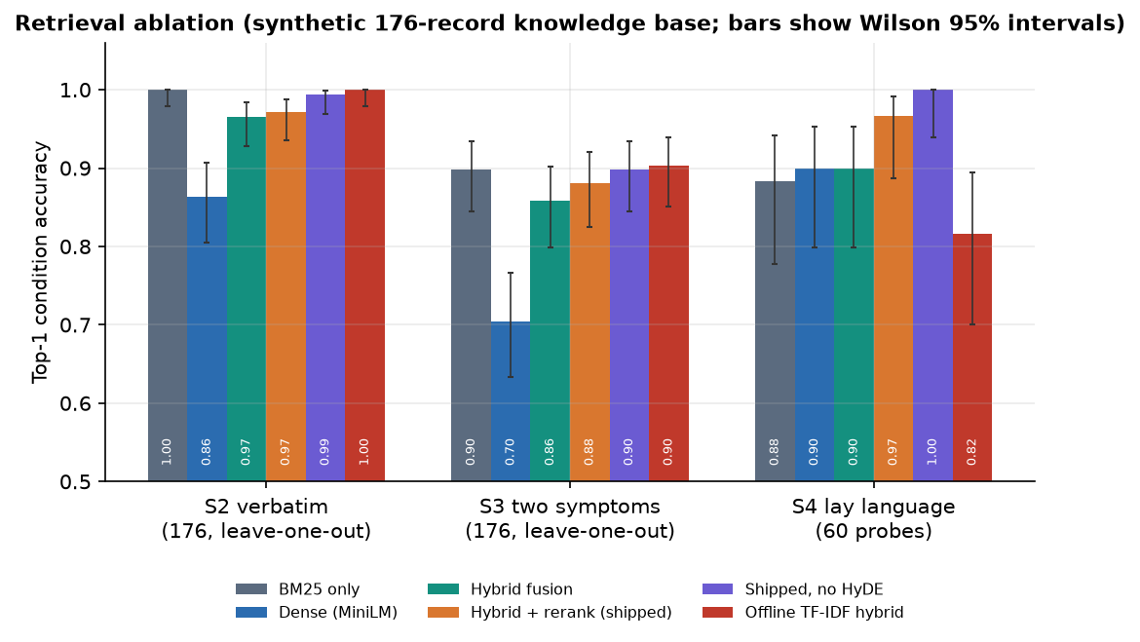
Figure 15: Top-1 accuracy of the seven retrieval configurations on verbatim, two-symptom and lay-language queries.
Four observations follow. First, the stored 100% figure is reproduced only by the shipped protocol, where the answer is in the index; removing the held-out record gives 96.7% on the same 30 queries and the 100% is an upper bound for the wiring, as the About page itself says. Second, lexical search alone is strong on this base (100.0% on verbatim queries, 88.3% on lay queries), because queries and records share words; dense search alone is weaker on verbatim queries (86.4%) than on lay ones (90.0%), so each retriever covers the other's failures. Third, the cross-encoder improves the fused order on lay and two-symptom queries (90.0% to 96.7% and 85.8% to 88.1%). Fourth, the rule-based HyDE-style expansion did not help: without it the shipped configuration scores 100.0% on lay queries and 99.4% on verbatim queries, against 96.7% and 97.2% with it. With n = 60 the difference on lay queries is 2 queries and lies inside the sampling interval, so the honest conclusion is that no benefit was shown. The offline mode (TF-IDF vectors, no reranker) drops to 81.7% on lay queries.
The two lay-language queries missed by the shipped configuration were 'my nose will not stop running and I have a slight cough, nothing serious' (Common Cold returned as Allergic Rhinitis) and 'a slow-rising fever for days, feeling weak, no appetite, abdominal pain' (Typhoid returned as Appendicitis). Both are confusions between conditions that share symptoms in the knowledge base. On two-symptom queries the misses are of the same kind: 'I have congestion and runny nose' retrieves Allergic Rhinitis for Common Cold, and 'I have fever and chills' retrieves Malaria for Pneumonia.
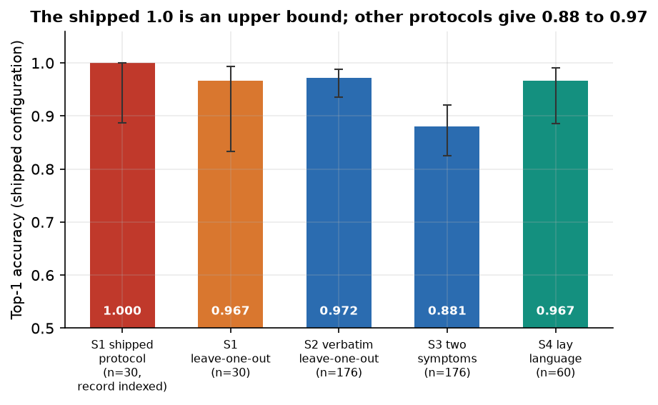
Figure 16: The shipped configuration under four protocols: the stored protocol is an upper bound.

7.6.2 Relevance display
For all 60 lay queries and all 15 complaints outside the knowledge base (for example 'my tooth aches badly when I drink cold water' or 'lower back pain after lifting heavy boxes'), the best record is displayed with relevance 100% and the label 'Strong match'. Through the real pipeline, 15 of 15 out-of-base complaints came out as 'Strong match'. The cause is the min-max rescaling of Section 6.3.5. The raw cross-encoder score, which the interface discards, does separate the two groups: its mean is 2.481 for in-base queries (range -4.52 to 6.494) and -6.336 for out-of-base ones (range -9.116 to -4.766), and the area under the ROC curve for telling them apart is 1.00 (raw hybrid score: 0.93). The information needed for an honest 'no match' exists and is not shown.
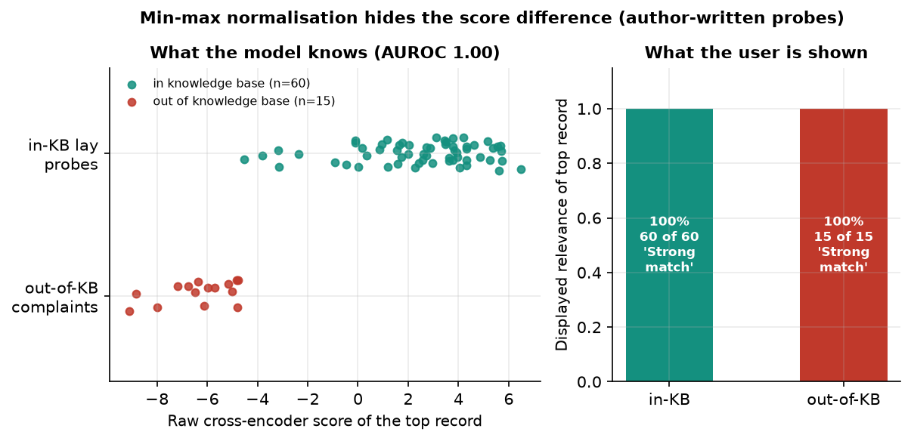
Figure 17: Raw cross-encoder score of the best record for in-base and out-of-base queries, against the displayed 100%.

7.6.3 Generated answers
The local generator was run on 30 queries. In 30 of them (100%) the 'answer' was the instruction and the retrieved context, unchanged, labelled local-generator:google/flan-t5-small. The installed Transformers 5.20.2 no longer provides the task the code requests (unavailable: KeyError), so the code falls back to a task that, for a T5 model, returns its input. The requirements file asks only for transformers 4.38 or newer, so a fresh install picks up the version that breaks it. The deterministic fallback, in contrast, named only conditions among the retrieved records in 30 of 30 answers, which is guaranteed by its construction. Groundedness was not judged by a person or a model: the only check is this structural one, so the objective of grounded, cited answers is met in structure (the evidence cards) and not shown for the generated text.

7.6.4 Safety rules
The emergency layer was tested with 40 emergency descriptions and 30 non-emergency texts written by the team. 28 descriptions used the rules' own wording and 12 used everyday paraphrases ('gasping for air', 'I do not want to live anymore', 'worst stomach pain of my life'). The layer flagged 27 of 28 literal descriptions and 0 of 12 paraphrases; overall recall is 0.675 (95% interval 0.52 to 0.80). The one literal miss was 'lips swollen and cannot breathe', because the rule expects 'swollen lips' first. None of the paraphrases was flagged even as 'caution'. Among the non-emergency texts, all 20 ordinary ones were routine, but 6 of the 10 hard negatives (negation or history, such as 'I do not have difficulty breathing, only a blocked nose' and 'my grandmother had a stroke last year') raised an emergency banner and 4 more raised a caution; precision is 0.82.
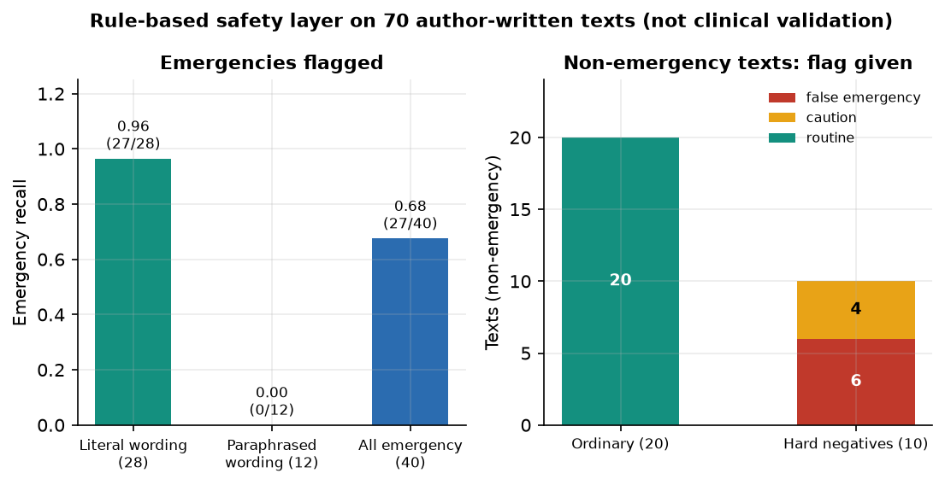
Figure 18: Safety layer: recall on literal and paraphrased emergencies, and false alarms on ordinary and hard negative texts.
The answer filter was tried on 14 sentences with medication instructions. It cleaned 6 of them. Of the ten sentences that contained one of its five listed phrases it cleaned 6: the detection ignores case but the replacement does not, so 'Take ibuprofen every six hours' and 'Dosage: one tablet daily' passed through unchanged; unlisted drugs ('Take paracetamol 500 mg every four hours', 'Take amoxicillin three times a day') were not touched at all. In normal operation the fallback answer is built from knowledge-base guidance that contains no dosages, so the filter rarely has anything to remove; it is not a reliable defence if a generator ever produces dosage text.

7.7 Performance Testing
Performance was measured on one CPU-only PC (12th Gen Intel Core i5-12500 (6 cores / 12 threads), no GPU, 15.7 GB RAM, Windows 11, Python 3.11.9) with the models already loaded, on 30 queries. The first request after start-up must load the models and the indexes, which took about a minute in the measurement script. The table gives the pipeline stages, each timed in its own pass.
Table 41: Pipeline stage times (milliseconds, 30 queries, warm models)
Stage | Mean | Median | 95th percentile
Normalise and expand | 0.03 | 0.03 | 0.05
Embed query (MiniLM) | 92.96 | 56.21 | 269.18
FAISS search | 0.19 | 0.13 | 0.46
BM25 search | 2.46 | 2.13 | 4.19
Fusion | 0.07 | 0.06 | 0.11
Cross-encoder rerank (15 pairs) | 554.66 | 542.57 | 841.96
Safety check | 0.04 | 0.04 | 0.08

The cross-encoder is the dominant stage at 555 ms on average; the embedding costs 93 ms and everything else together under 5 ms. The whole pipeline call takes 484 ms on average (95th percentile 697 ms) with the evidence-based answer and 979 ms (1376 ms) when the local generator is called; the model adds about 808 ms to produce, and here to return, its echo.
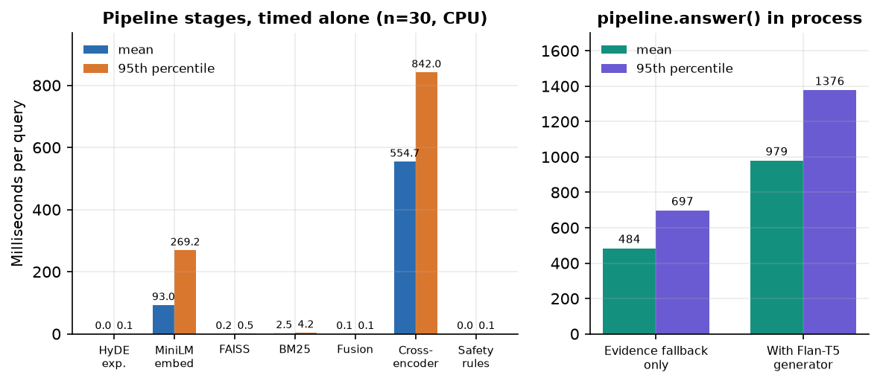
Figure 19: Time per pipeline stage and for the whole call, with and without the local generator.
Table 42: HTTP latency of POST /api/chat on 127.0.0.1 (30 requests, milliseconds)
Generator | Mean | Median | 95th percentile | Maximum | First request
Evidence-based fallback | 403 | 397 | 569 | 606 | 340
Flan-T5-small (default) | 766 | 737 | 1077 | 1283 | 580

Through the HTTP layer a question is answered in about 0.4 s with the fallback and 0.8 s with the local generator. Other routes are quick: health about 8 ms, listing the history about 32 ms, and sign-in about 249 ms, which is the deliberate cost of bcrypt. The measurements used 127.0.0.1 because the name localhost adds about two seconds per call on this machine through an IPv6 fallback; the browser, which goes through the Vite proxy, was not timed. Throughput under many simultaneous users was not tested: the pipeline holds one set of models in memory and runs on the CPU, so concurrent requests would queue.
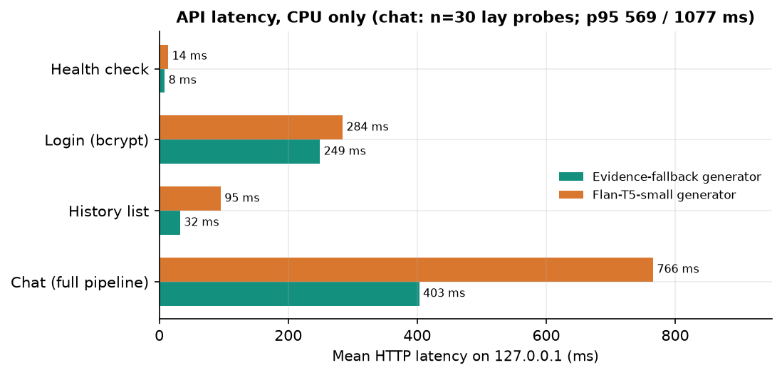
Figure 20: HTTP latency of the chat route with the two generator modes.

7.8 User Acceptance
No formal user acceptance test was carried out. No patient, clinician or other outside user used the application, and no usability or comprehension measure was collected. What exists is the team's own walk-through: the demo account was used to try the main flow, and the capture script confirmed that every page loads without a console error at desktop and phone width. A user study with the intended public, and a review of the answers by a clinician, are the two evaluations that would matter most and are listed as future work.

7.9 Summary and Limits of the Testing
Table 43: Summary of results
Area | Result
Automated tests | 9 of 9 pytest and 22 of 22 smoke checks pass
Security probes | 35 of 38 pass; three weaknesses (no Secure flag, no sign-in rate limit, default signing key)
Retrieval, lay-language probes | Top-1 96.7% for the shipped configuration (n = 60, interval 88.6-99.1%)
Retrieval, two-symptom queries | Top-1 88.1% (n = 176)
Relevance display | Top record always 100%; 15 of 15 out-of-base complaints shown as 'Strong match'
Local generator | 30 of 30 answers are an echo of the prompt; fallback answers are structurally grounded
Emergency rules | Recall 0.68; paraphrases 0 of 12; 6 of 10 hard negatives falsely flagged
Latency (HTTP, CPU) | About 0.4 s per question with the fallback, 0.8 s with the local generator

The testing has clear limits. The knowledge base is synthetic and its records of one condition are near-duplicates, so retrieval accuracy on it is easy and says little about a real medical corpus. All probe sets are small and were written by the same team that wrote the system; the lay-language queries were not reviewed by a clinician; the emergency probes are examples, not a clinical test. The 95% intervals are wide. Groundedness was checked only structurally. No load, concurrency, accessibility-audit, long-run or clinical testing was done, and no user study. Results were measured once on a single machine and are not repeated runs, although the retrieval experiments are deterministic. The three defects found (prompt echo, always-100% relevance, literal safety rules) are documented rather than fixed in this work.

CHAPTER 8: RESULTS AND OUTPUT SCREENS
This chapter reports what was measured and what the running application shows. Section 8.1 describes the set-up, Section 8.2 presents every output screen, Sections 8.3 to 8.9 give the quantitative results (retrieval accuracy, ablation, the relevance display, generated text, the safety layer, speed and tests), Section 8.10 compares the work with the base paper, and Sections 8.11 to 8.13 give sample output, success and failure analysis, the limits of the evaluation and the outcome against each objective. Where a result is weak it is reported as weak.

8.1 Experimental set-up
All measurements were made on one machine: 12th Gen Intel Core i5-12500 (6 cores / 12 threads), no GPU, 15.7 GB of memory, Windows, Python 3.11.9, PyTorch 2.14.1+cpu, transformers 5.20.2, sentence-transformers 6.2.0, FAISS 1.15.1, scikit-learn 1.9.1, FastAPI 0.159.1. No GPU was used. The three models are sentence-transformers/all-MiniLM-L6-v2, cross-encoder/ms-marco-MiniLM-L-6-v2 and google/flan-t5-small; retrieval takes a candidate pool of 15 records, fuses semantic and lexical scores with weights 0.65 and 0.35, and keeps the top 5 after reranking.
Data. The knowledge base holds 176 records for 30 conditions (3.98 symptoms per record, a vocabulary of 97 symptom phrases). It is synthetic: scripts/prepare_data.py writes 30 hand-typed condition entries with up to six random symptom subsets each, and all records of a condition share one description and one guidance text (only 30 distinct description-guidance pairs exist). No public dataset and no clinical review were involved, so every accuracy below measures how well the pipeline finds the right entry in this small table, not how well it recognises disease.
Figure 21: Composition of the knowledge base: records per condition and severity labels (synthetic data).
Query sets. Five query sets were used, because the choice of set changes the picture a great deal.
Table 44: Query sets used in the evaluation
Set | Queries | How they were made | Held-out handling
S1 shipped protocol | 30 | I have + the symptom list of one random record per condition (the protocol of scripts/evaluate.py, seed 7) | Held-out record remains in the index
S1 leave-one-out | 30 | The same 30 queries | Held-out record removed from both retrievers
S2 | 176 | Every record's own symptom list | Leave-one-out
S3 | 176 | Two random symptoms of each record (I have a and b) | Leave-one-out
S4 | 60 | Two everyday-language descriptions per condition written by the authors (not copied from the knowledge base) | Not needed

The S4 queries, 15 out-of-knowledge-base complaints, 40 emergency descriptions and 30 non-emergency texts were written by the project team, not by clinicians; they are small probe sets that exercise the pipeline and should be read as such. Accuracy is the share of queries whose first retrieved record belongs to the right condition (top-1); intervals are 95% Wilson intervals [34]. Top-3 and Top-5 count the first three or five retrieved records; MRR@5 is the mean reciprocal rank of the first correct record.

8.2 Output screens
The principal screens captured from the running application are shown here (Chrome, 1440 by 900 pixels, backend on port 8412, React frontend on port 5412, demo account, real queries through the real pipeline); the other captures (dark theme, registration, search, delete dialog, phone width and the 404 page) are in Appendix C. The application is called CareLens AI on screen. The answer, evidence, caution, emergency, history and detail screens were captured with the evidence-based fallback generator active, because the default local generator returns its own prompt in this software environment (Section 8.6); one screen in this section was captured with the default generator and shows that defect.
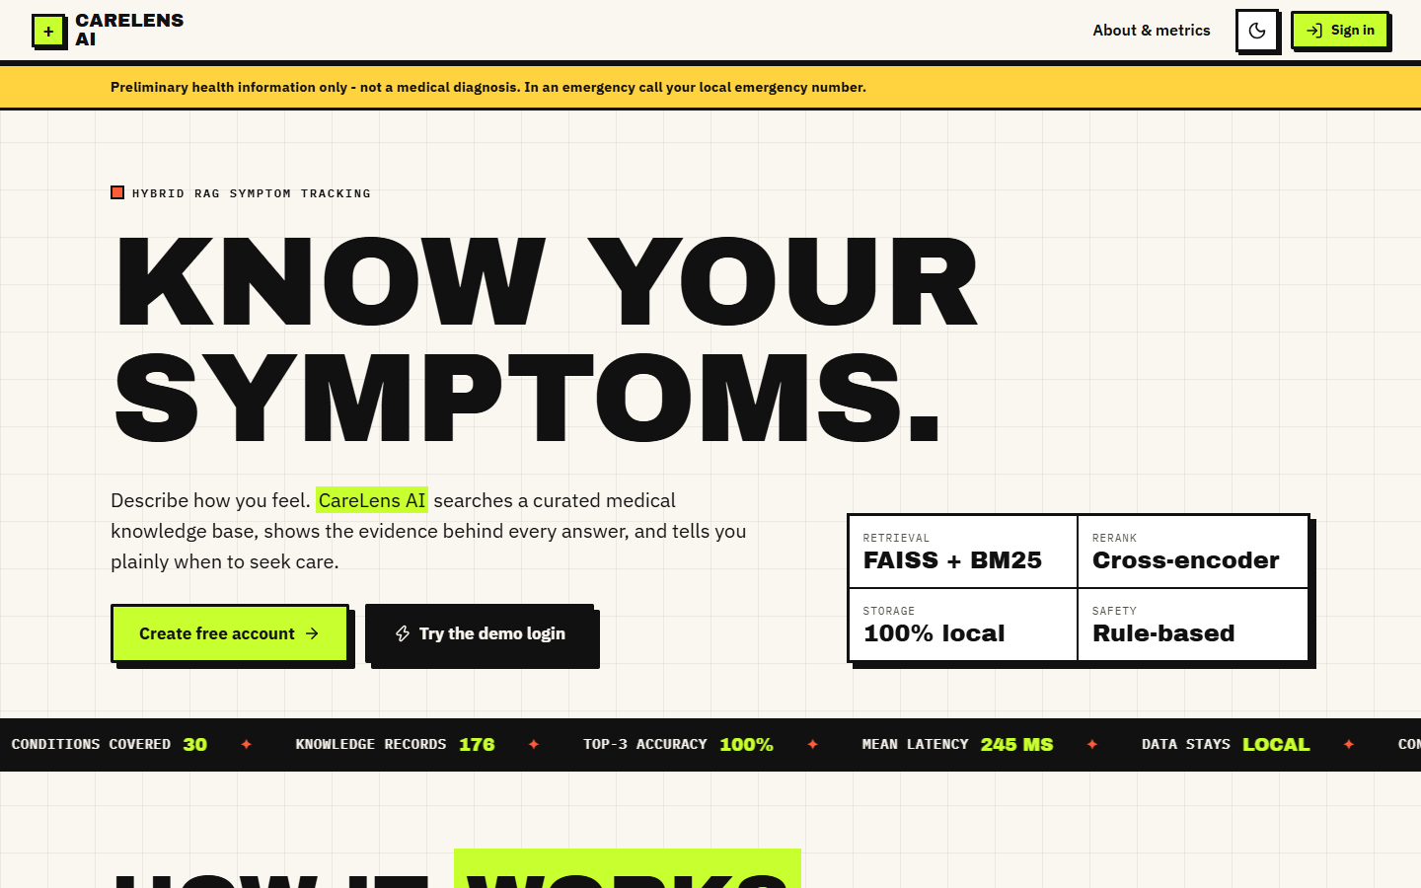  Figure 22: Landing page, light theme: product pitch and entry buttons. | 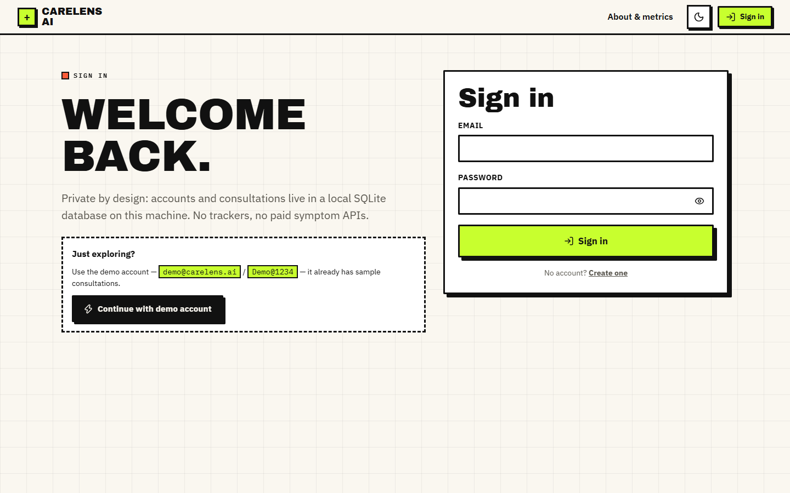  Figure 23: Sign-in form; the demo account is created automatically at start-up.

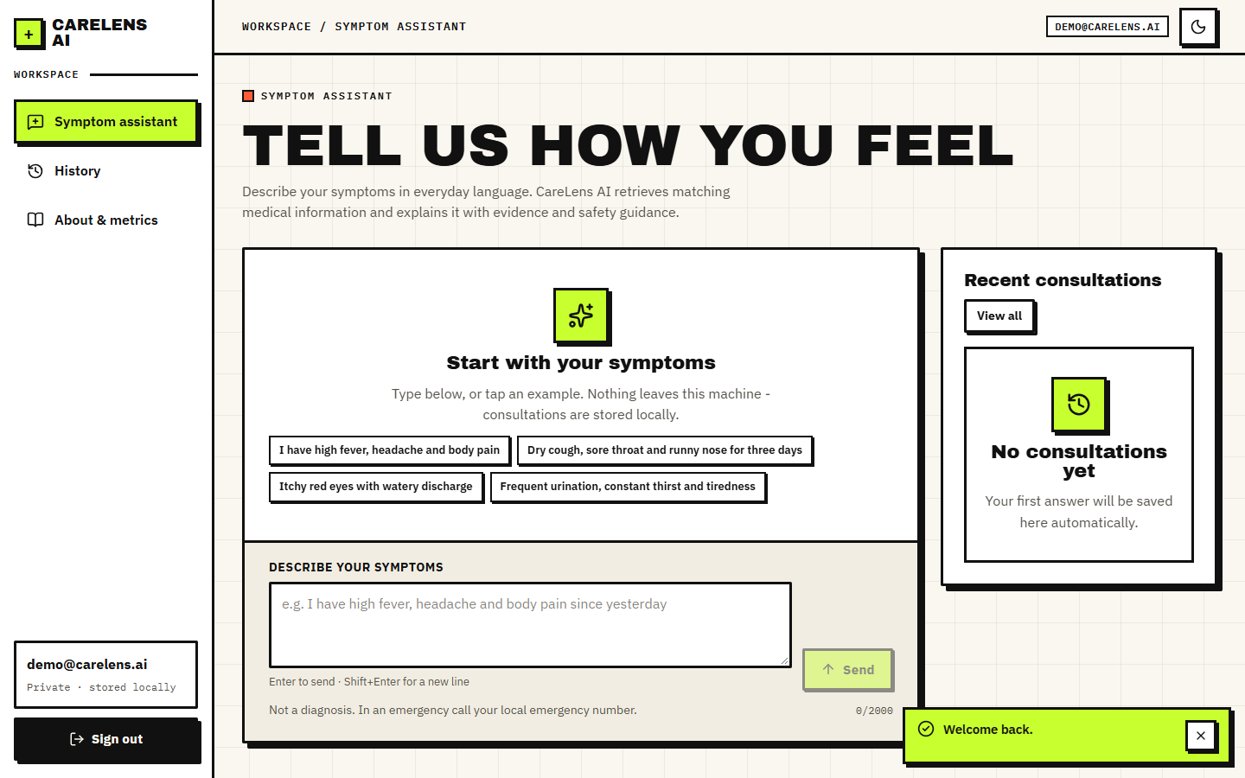  Figure 24: Symptom assistant before the first question: example chips and the permanent not-a-diagnosis line. | 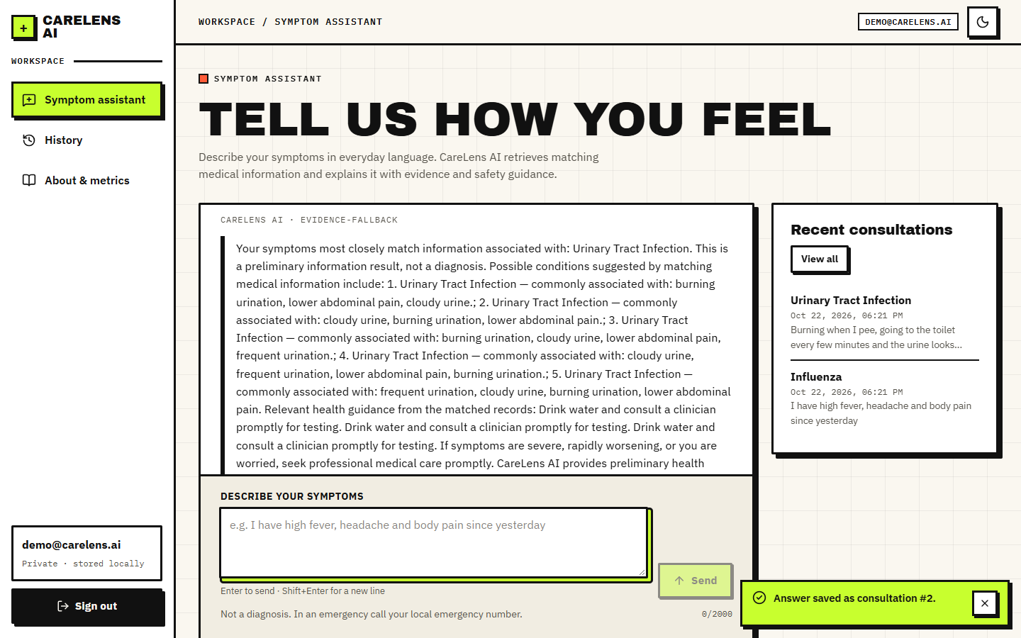  Figure 25: Everyday-language query retrieving Urinary Tract Infection.

Figure 26: Answer to "I have high fever, headache and body pain since yesterday" (fallback generator): top condition Influenza; the guidance sentence repeats because several near-identical records matched.
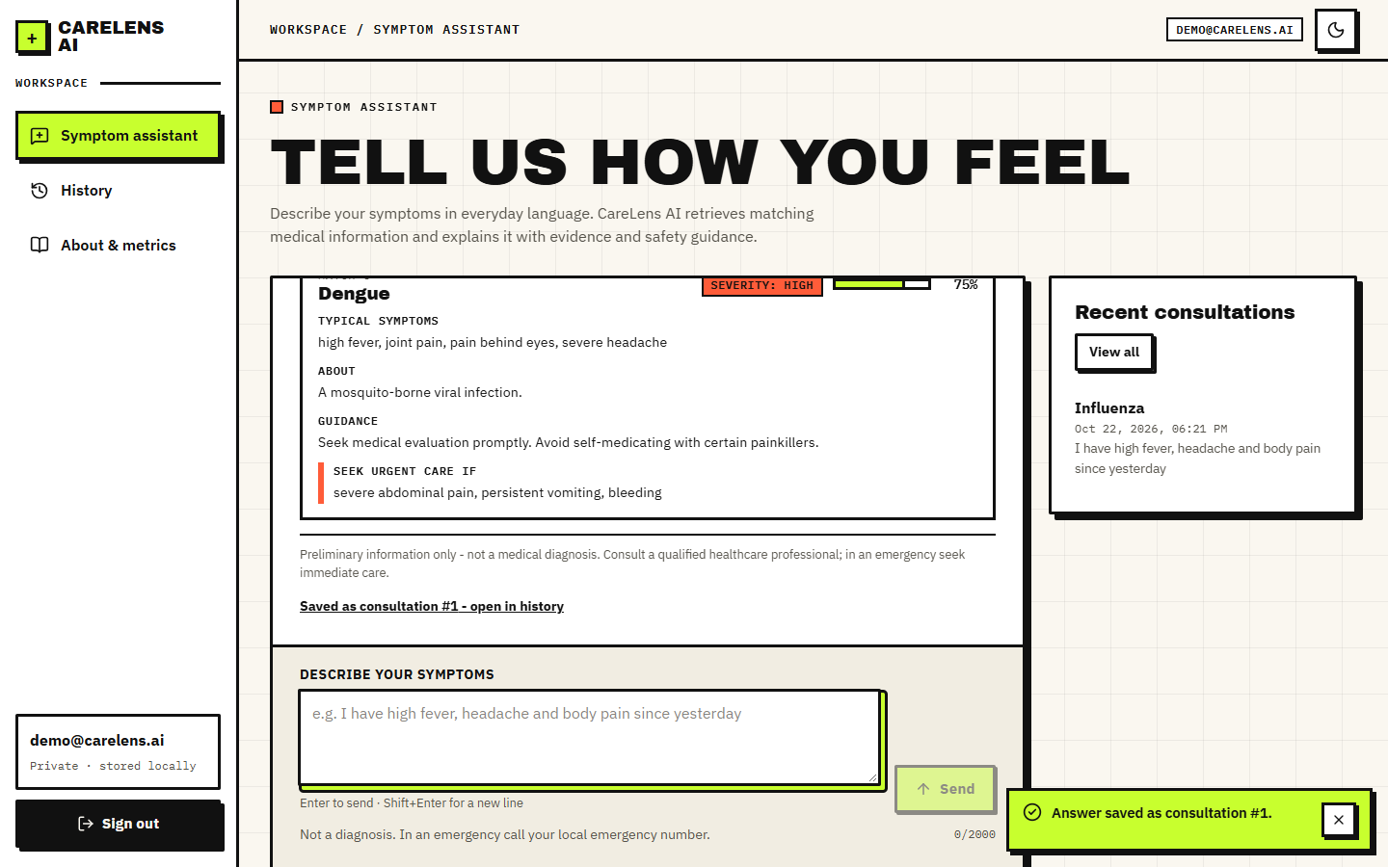  Figure 27: Evidence cards of the same answer: symptoms, description, guidance, severity, match bar and red flags; the fifth card is Dengue at 75%. | 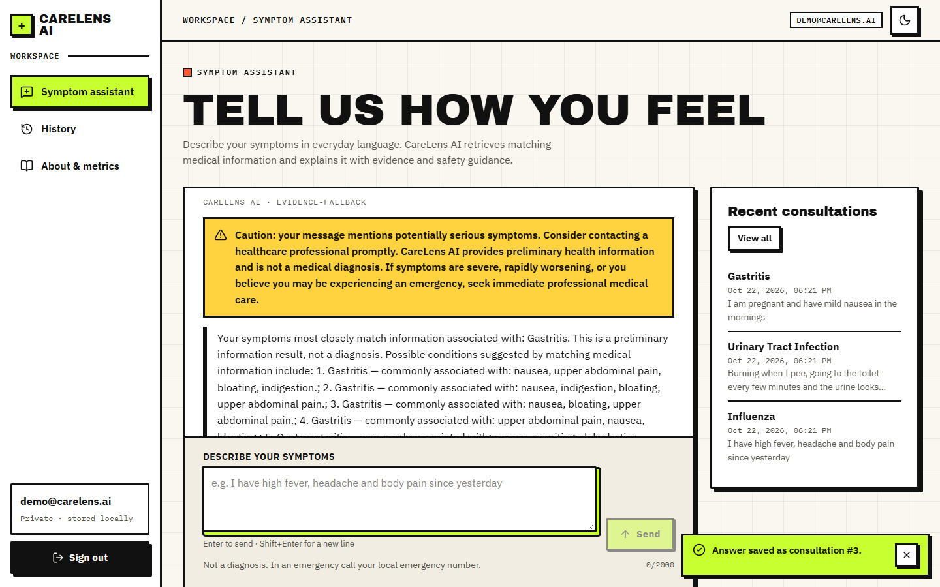  Figure 28: Caution banner (amber) for a message that mentions pregnancy; top record Gastritis.

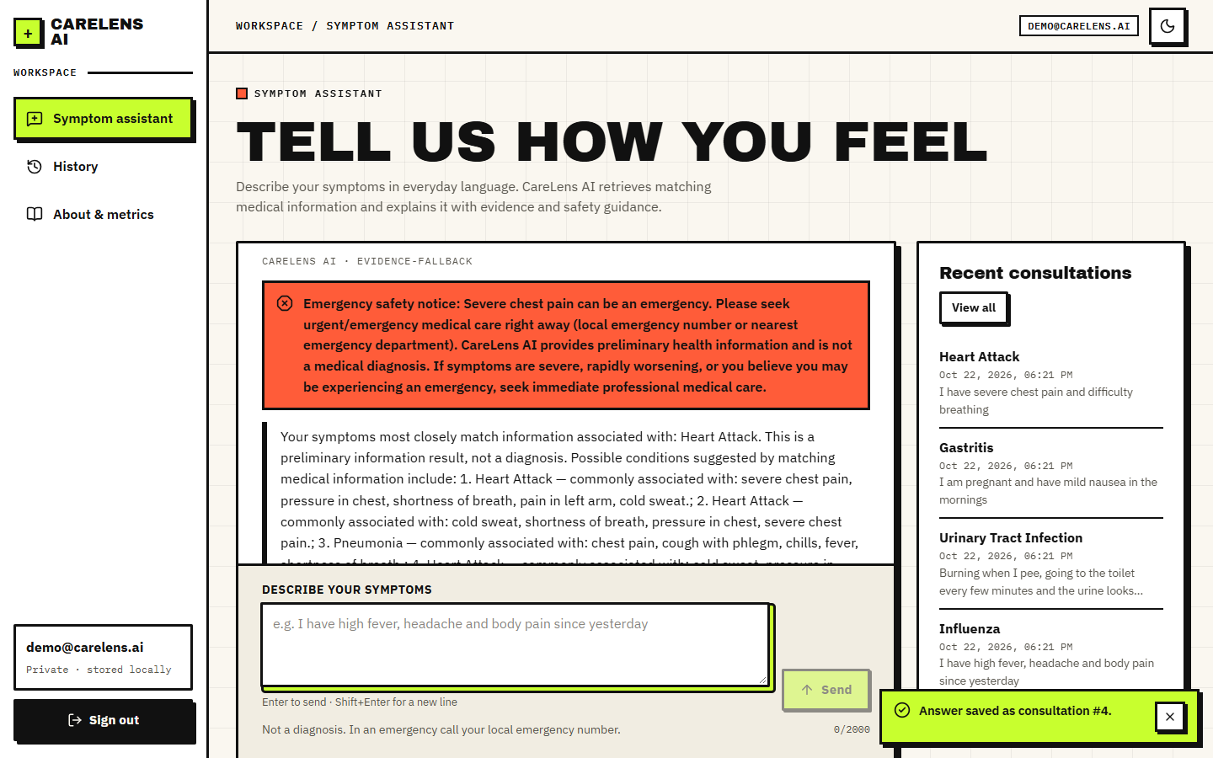  Figure 29: Emergency banner (red) for severe chest pain and difficulty breathing; top record Heart Attack. | 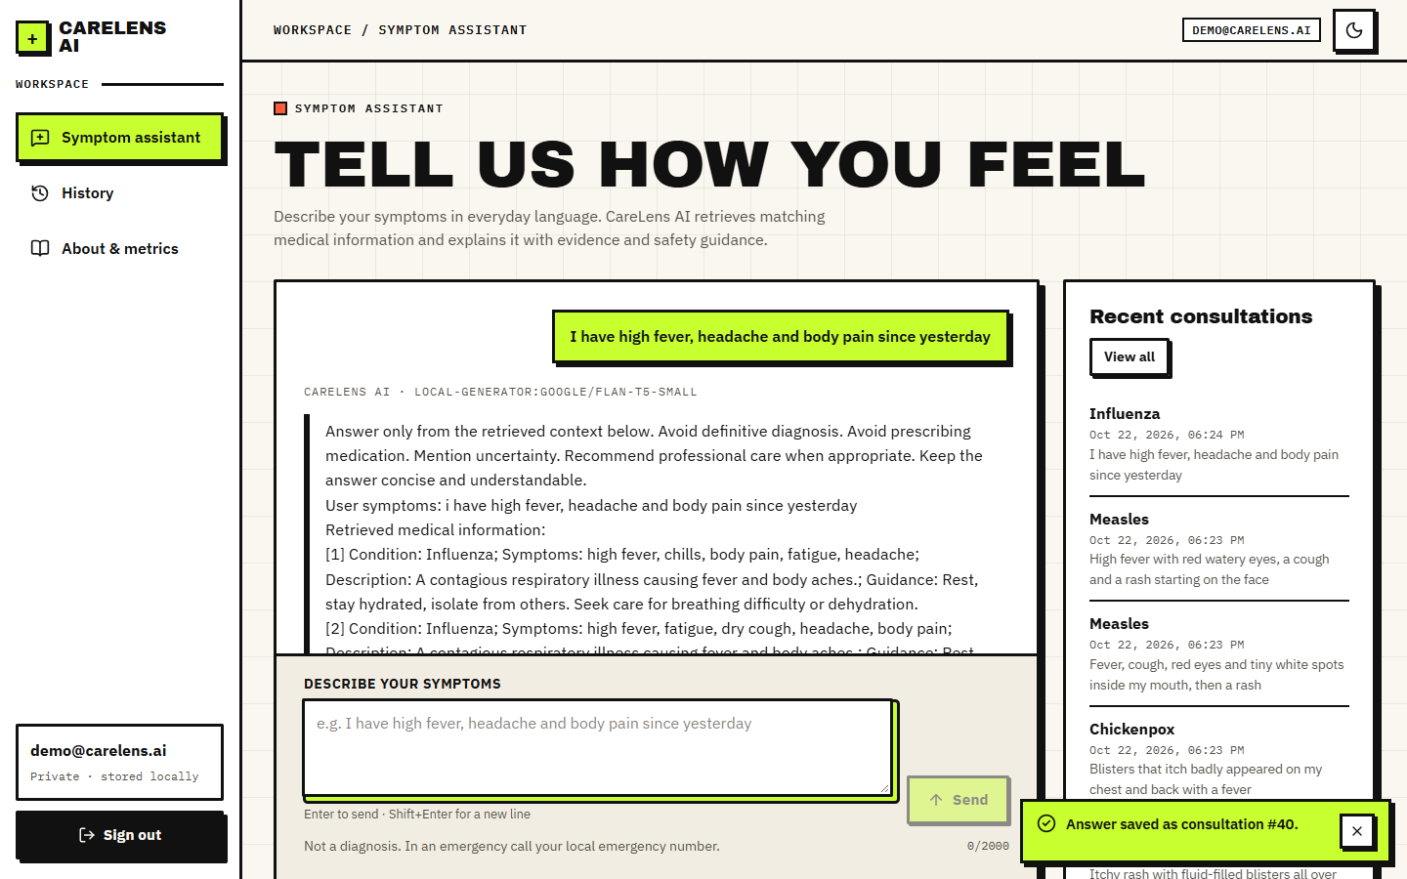  Figure 30: Failure case: the default Flan-T5 generator returns its prompt as the answer.

Figure 31: Consultation history with safety badges and a displayed relevance of 100% in every row. | 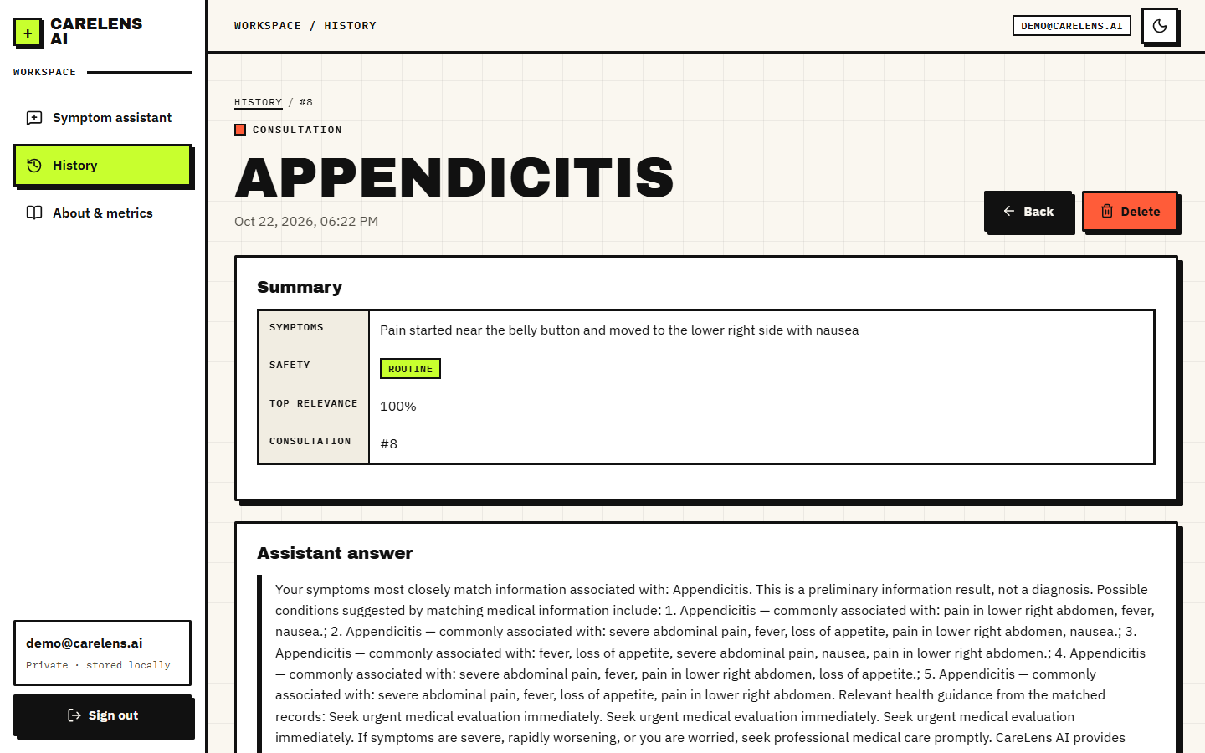  Figure 32: Saved consultation: summary table and stored answer.

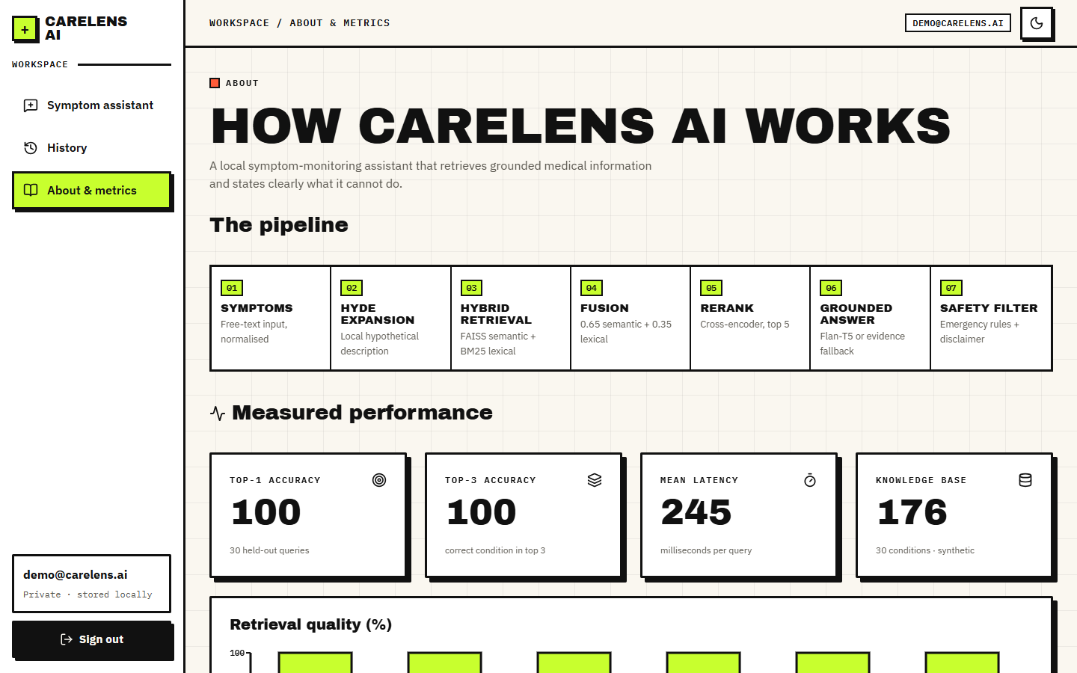
Figure 33: About page showing the shipped evaluation figures (100%, 245 ms, 176 records) - an upper bound (Section 8.3).

8.3 Retrieval accuracy of the shipped pipeline
The shipped configuration is hybrid fusion followed by the cross-encoder, with the HyDE-style expansion on. Table 8.2 gives its accuracy on the five query sets.
Table 45: Accuracy of the shipped pipeline (hybrid + cross-encoder) on the five query sets
Query set | n | Top-1 | 95% CI | Top-3 | Top-5 | MRR@5 | Misses
S1, shipped protocol (held-out record still indexed) | 30 | 100.0% | 88.6-100.0% | 100.0% | 100.0% | 1.000 | 0
S1, leave-one-out | 30 | 96.7% | 83.3-99.4% | 96.7% | 96.7% | 0.967 | 1
S2, every record verbatim, leave-one-out | 176 | 97.2% | 93.5-98.8% | 97.2% | 97.2% | 0.972 | 5
S3, two random symptoms, leave-one-out | 176 | 88.1% | 82.5-92.1% | 88.1% | 92.0% | 0.890 | 21
S4, lay-language probes | 60 | 96.7% | 88.6-99.1% | 98.3% | 98.3% | 0.972 | 2

8.3.1 The shipped 100% is an upper bound
scripts/evaluate.py holds one record per condition out of the test set but leaves it in the index, and its query is that record's own symptom list. Retrieval then finds the record itself, and the About page reports 100% for Top-1, Top-3, precision, recall, F1 and MRR on 30 queries. Reproducing that protocol gives 100.0%; removing the held-out record gives 96.7% on the same queries and 97.2% on all 176 records. The sibling records of the same condition remain in the index, so even leave-one-out is generous; the figure shows how the same pipeline falls as queries become less like the stored text.
Figure 34: The shipped pipeline under four conditions: shipped protocol, leave-one-out, two-symptom queries and lay-language probes.

8.3.2 Failure patterns
On the lay-language probes the pipeline fails 2 times in 60: "My nose will not stop running and I have a slight cough, nothing serious" (true Common Cold, first record Allergic Rhinitis); "A slow-rising fever for days, feeling weak, no appetite, abdominal pain" (true Typhoid, first record Appendicitis). Both are confusions between conditions that share most symptoms. On two-symptom queries it fails 21 times in 176; the logged examples are "I have congestion and runny nose" (Common Cold read as Allergic Rhinitis); "I have headache and fatigue" (Influenza read as Migraine); "I have chills and headache" (Influenza read as Malaria); "I have fever and chills" (Pneumonia read as Malaria). Two symptoms such as headache and fatigue are shared by many conditions, so these misses reflect real ambiguity, and a single ranked answer hides it.
Per condition, the shipped pipeline answered both lay-language probes correctly for 28 of the 30 conditions, and missed at least one for Common Cold (1 of 2), Typhoid (1 of 2). Conditions with a distinctive symptom (a rash with blisters, loss of smell and taste, face droop with slurred speech) are found reliably; conditions that overlap with a close neighbour, such as a common cold and allergic rhinitis, or a prolonged fever and appendicitis, are where the first record can be wrong.
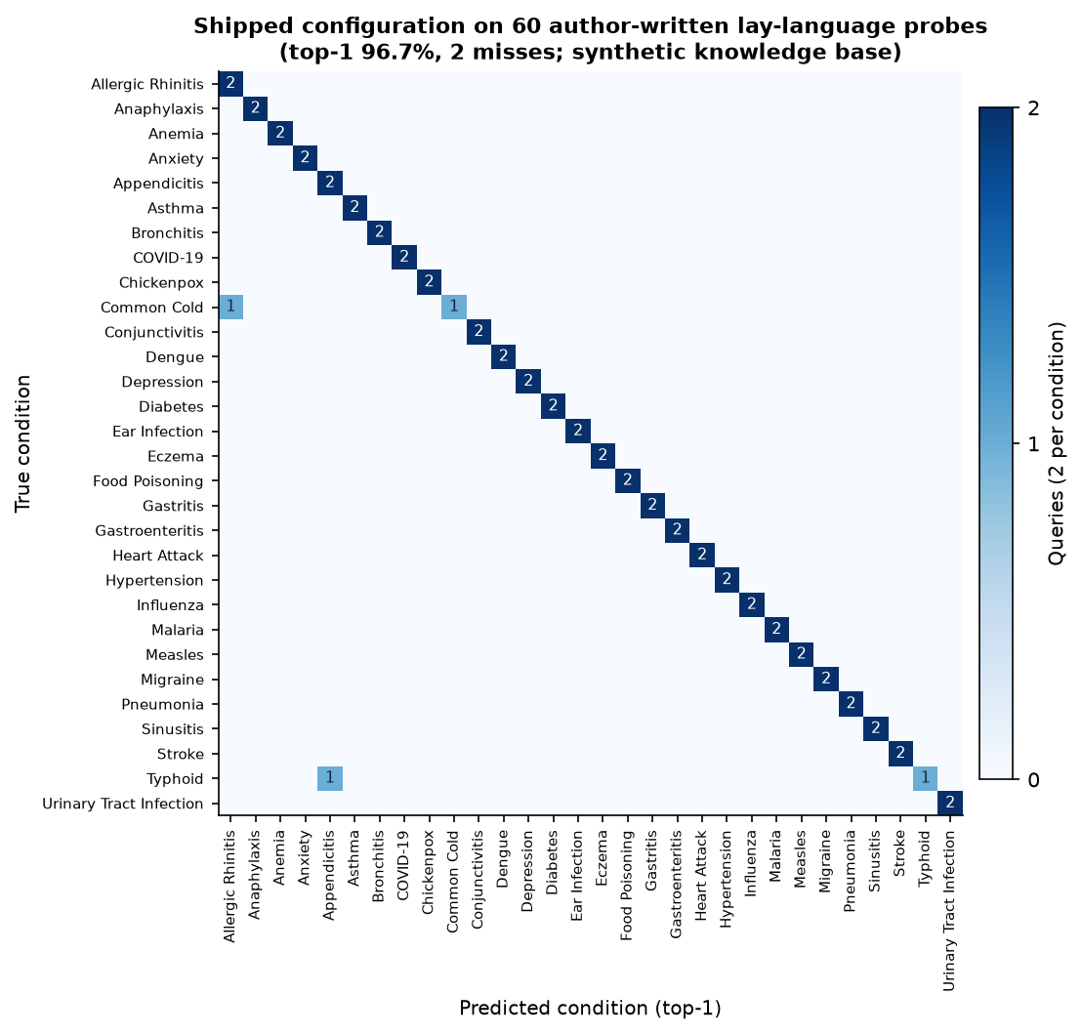
Figure 35: Confusion matrix of the shipped pipeline on the 60 lay-language probes (rows: true condition, columns: first retrieved condition).
The five evidence cards are not five different conditions: the mean number of distinct conditions among the five retrieved records is 1.2 on the lay probes and 1.483 on the two-symptom queries, because each condition owns four to six near-identical records. The "possible conditions" list is therefore not a differential diagnosis.

8.4 Ablation: what each stage contributes
The same query sets were run through seven configurations. The BM25 and dense paths use the same expanded query as the pipeline, so the table isolates retrieval and ranking rather than the interface.
Table 46: Top-1 accuracy by configuration (leave-one-out for S2 and S3)
Configuration | S2 (176) | S3 (176) | S4 (60) | S4 MRR@5
BM25 only (lexical) | 100.0% | 89.8% | 88.3% | 0.883
Dense only (MiniLM + FAISS) | 86.4% | 70.5% | 90.0% | 0.917
Hybrid fusion (0.65/0.35) | 96.6% | 85.8% | 90.0% | 0.908
Hybrid + cross-encoder (shipped) | 97.2% | 88.1% | 96.7% | 0.972
Shipped, without HyDE expansion | 99.4% | 89.8% | 100.0% | 1.000
Dense TF-IDF fallback | 100.0% | 89.2% | 76.7% | 0.779
Hybrid with TF-IDF fallback (offline mode) | 100.0% | 90.3% | 81.7% | 0.823

Figure 36: Top-1 accuracy of the seven retrieval configurations on the verbatim, two-symptom and lay-language query sets.
• Lexical matching is already strong on this data. BM25 alone reaches 100.0% on S2 and 88.3% on S4. The knowledge base was generated from short symptom phrases, so word overlap is a very good signal.
• Dense embeddings alone are weaker on verbatim text (86.4% on S2) but slightly better on lay language (90.0% on S4); fusion gives 96.6% and 90.0%.
• The cross-encoder helps on lay language (90.0% to 96.7%, a change of about 4 queries out of 60) and on two-symptom queries (85.8% to 88.1%), at a cost of several hundred milliseconds (Section 8.8).
• The HyDE-style expansion did not help. Without it the shipped pipeline scores 99.4% on S2, 89.8% on S3 and 100.0% on S4, against 97.2%, 88.1% and 96.7% with it. The expansion is a fixed template that wraps the user's words in generic medical phrasing; it adds no information, and the extra words dilute the query. The differences are small (a few queries) and the intervals overlap, so the honest reading is no measurable benefit rather than proven harm.
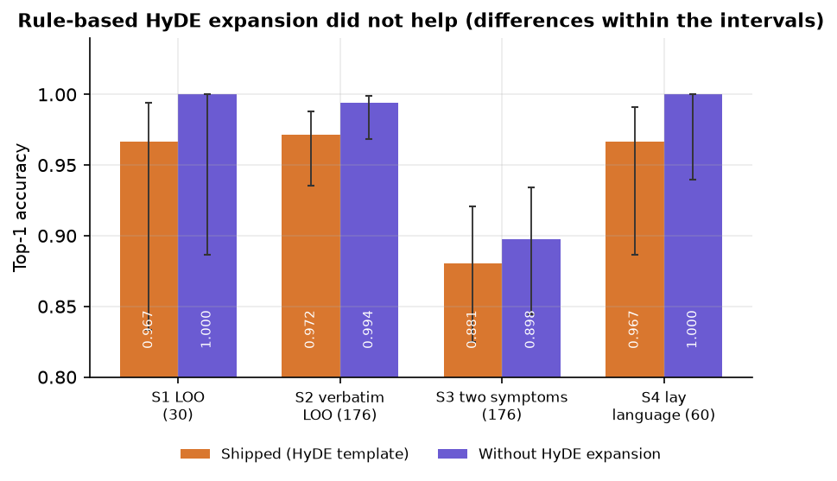
Figure 37: Effect of the HyDE-style expansion: the shipped pipeline with and without it on each query set.
Offline mode. When the sentence-embedding model cannot be downloaded the application falls back to TF-IDF vectors and skips reranking. That mode scores 81.7% on S4 and 90.3% on S3 (and 100.0% on verbatim S2): usable, and weaker than the full pipeline on paraphrased input (96.7%). The interface does not tell the user which mode is running.

8.5 The displayed relevance score
The match bar and the labels Strong, Moderate and Weak are computed by min-max normalising the cross-encoder scores of the 15 candidates, so the best candidate always receives 1.00 and a Strong label. The measurement confirms it: the top record had displayed relevance 1.00 in all 60 in-knowledge-base queries and in all 15 out-of-knowledge-base complaints, and all 15 of the latter were labelled Strong match (also through pipeline.answer: {'Strong match': 15}). The history screen shows 100% in every row for the same reason.
Table 47: Complaints with no matching condition in the knowledge base
Query | First record shown | Displayed | Raw rerank score
My tooth aches badly when I drink cold water | Common Cold | 100% Strong | -4.80
Sprained my ankle playing football, it is swollen and bruised | Anaphylaxis | 100% Strong | -5.99
Lower back pain after lifting heavy boxes | Appendicitis | 100% Strong | -5.69
My hair has been falling out in clumps | Depression | 100% Strong | -8.83
Knee pain when climbing stairs | Heart Attack | 100% Strong | -6.36
A bruise on my arm that is not healing | Heart Attack | 100% Strong | -6.13

The information needed to do better is present. The raw cross-encoder score of the top record averages 2.481 for in-knowledge-base queries (range -4.52 to 6.494) and -6.336 for out-of-knowledge-base ones (range -9.116 to -4.766); the area under the ROC curve for telling them apart is 1.0 with the raw rerank score and 0.9322 with the raw hybrid score. The normalisation throws it away. On this small set a threshold on the raw score would separate the groups perfectly; with only 15 out-of-knowledge-base queries that is encouraging but not a guarantee.
Figure 38: Raw cross-encoder score of the top record for in-knowledge-base and out-of-knowledge-base queries, against the constant displayed value of 100%.

8.6 Generated answer text
With the default configuration the generator returned the prompt, not an answer: 30 of 30 test queries (100%) produced text beginning with the instruction lines followed by the user's symptoms and the retrieved records. The cause is the installed library version: transformers 5.20.2 no longer provides the text2text-generation task (unavailable: KeyError), so the code falls back to the text-generation task, which for a T5 model returns its input. The answer is still labelled local-generator:google/flan-t5-small. Generation took 808 ms on average. The requirement file asks only for transformers>=4.38, so an older version would not show this behaviour; it was not tested here.
The evidence-based fallback, used when no generator can be loaded, builds the answer from the retrieved records in 0.031 ms. Every condition it names is one of the retrieved records (30 of 30 answers; true by construction). This gives structural grounding, since nothing outside the retrieved text can appear. It is not a synthesis: it lists the matched records and repeats their guidance sentence once per matching record (screens 07 and 11), it has no per-statement citation, and no human or model judgement of groundedness was carried out, so objective 4 is only partly met.

8.7 Safety layer
The rule layer has 10 emergency patterns and 6 caution keywords. It was tested with 40 emergency descriptions and 30 other texts written by the team.
Table 48: Emergency detection on the probe sets
Probe group | Texts | Result
Emergencies worded like the rules | 28 | 27 flagged emergency
Emergencies in everyday wording | 12 | 0 flagged emergency; 0 flagged caution; the rest passed as routine
Ordinary non-emergency texts | 20 | 0 false emergencies; 20 routine
Hard negatives (negation, history) | 10 | 6 false emergencies, 4 caution flags

Figure 39: Emergency detection: recall on literal and paraphrased wording, and false alarms on ordinary and hard-negative texts.
Overall recall is 67.5% (95% CI 52.0-79.9%) and precision 81.8%. The rules catch the wording they were written for and nothing else: "pressure in my chest and my left arm hurts", "I cannot catch my breath" and "I do not want to live anymore" all passed as routine. In the other direction a sentence that merely mentions a trigger ("I do not have difficulty breathing, only a blocked nose") raised an emergency alarm because negation and history are not understood. For a health tool, the missed paraphrases are the serious failure.
The answer filter removed a banned phrase in 6 of 14 test sentences, and in 6 of the 10 cases that use one of its five listed phrases: the replacement is case-sensitive, so "Take ibuprofen", "Dosage:" and "Prescribe" at the start of a sentence are detected but not replaced. Drug names outside the list (paracetamol, amoxicillin) pass through. The retrieved guidance texts contain no dosages, so the filter is a second line of defence that was never needed in the captured sessions.

8.8 Speed
Per-stage times for 30 queries with warm models are in Table 8.5. The cross-encoder dominates (555 ms on average for 15 pairs on the CPU); everything else except the query embedding (93 ms mean, with a few slow outliers) takes a few milliseconds. The stages were timed in separate passes, so they do not add up exactly to the totals. A whole pipeline.answer call takes 979 ms on average with the local generator (p95 1376 ms) and 484 ms with the fallback (p95 697 ms).
Table 49: Time per pipeline stage (milliseconds, 30 queries, warm models)
Stage | Mean | Median | 95th percentile
query expansion | 0.03 | 0.03 | 0.05
query embedding | 92.96 | 56.21 | 269.18
FAISS search | 0.19 | 0.13 | 0.46
BM25 search | 2.46 | 2.13 | 4.19
score fusion | 0.07 | 0.06 | 0.11
cross-encoder rerank (15 pairs) | 554.66 | 542.57 | 841.96
safety rules | 0.04 | 0.04 | 0.08

Figure 40: Mean time per pipeline stage and totals for the two generator modes.
Over HTTP on 127.0.0.1, POST /api/chat took 403 ms on average with the fallback generator (median 397, p95 569) and 766 ms with the Flan-T5 generator (median 737, p95 1077); sign-in takes about 249 ms because of bcrypt, listing the history about 32 ms and the health check about 8 ms. The first request after start-up must load the models, which took about a minute in the measurement script, so the application is best started once and kept running. A reply in well under two seconds is comfortable for a chat; no load or concurrency test was made.
Figure 41: HTTP latency of POST /api/chat with the fallback generator and with the default Flan-T5 generator.

8.9 Functional tests
The nine pytest tests passed (9 of 9, 34.09 s): query normalisation, emergency detection, the dosage filter, password hashing, fusion, the generator fallback, authentication with history isolation between users, request validation and a retrieval round trip. The end-to-end smoke test, which goes through the Vite proxy as a browser would, passed 22 of 22 checks (health, sign-in, session cookie, chat, evidence fields, emergency escalation, validation, history list, search, detail, delete, registration, duplicate-email rejection, private history of a new account, sign-out). The tests show that the wiring works; they do not measure clinical correctness.

8.10 Comparison with the base paper
The base paper Madhury and Ramesh (IJERST, 2026) [1] reports no figures: its results section describes "experimental observations" that the hybrid retrieval "consistently" returns relevant records and shows one chat example (constipation, stomach ache, high fever and swollen lymph nodes giving Typhoid). There is no accuracy, no recall, no latency and no stated dataset size, and its "Sequence-NQ transformer" is not specified further. A numerical comparison is therefore impossible, and the datasets differ in any case: the base paper's symptom-disease knowledge base is not described in measurable terms, and this project's is a synthetic 176-record table. What can be compared is what each system does.
Table 50: Qualitative comparison with the base paper
Aspect | Base paper [1] | This project (CareLens AI)
Retrieval | Sequence-NQ embeddings + FAISS | MiniLM embeddings + FAISS and BM25, fused 0.65/0.35
Reranking | Not described | Cross-encoder (MS MARCO MiniLM) on 15 candidates
Query expansion | Not described | Rule-based HyDE-style template (no measured benefit)
Generation | RAG answer generation | Flan-T5-small or deterministic evidence-based fallback
Safety | Not described | Emergency regex rules, caution keywords, answer filter, disclaimer
Application | Registration, login, chatbot, history | FastAPI + React app, bcrypt/JWT, private history with search, detail and delete
Longitudinal tracking | Stores history "to support future analysis" | Stores and lists consultations; no trend analysis
Evaluation | Qualitative observations, no figures | Five query sets, ablation, probes, latency, tests, with intervals
Data | Symptom-disease knowledge base (not quantified) | Synthetic, 176 records, 30 conditions

The honest summary is that this work adds components and a measurement the base paper does not describe, while neither work has been validated on real clinical data.

8.11 Sample inputs and outputs, success and failure analysis
Table 51: Sample queries and what the pipeline did (captured sessions and logged probes)
Input | Output | Verdict
I have high fever, headache and body pain since yesterday | Top record Influenza; fifth card Dengue (75%); routine | Correct; plausible differential
Burning when I pee, going to the toilet every few minutes and the urine looks cloudy | Urinary Tract Infection | Correct on everyday wording
I have severe chest pain and difficulty breathing | Emergency banner; top record Heart Attack | Correct and safe
I am pregnant and have mild nausea in the mornings | Caution banner; top record Gastritis | Caution correct; condition is a weak guess
I have congestion and runny nose | Allergic Rhinitis (true Common Cold) | Failure: shared symptoms
I have chills and headache | Malaria (true Influenza) | Failure: shared symptoms
Sprained my ankle playing football, it is swollen and bruised (out-of-knowledge-base) | Anaphylaxis, shown as 100% Strong match | Failure: no abstention

8.11.1 What works
• Condition retrieval on symptom text is accurate on this knowledge base: 97.2% on verbatim leave-one-out and 96.7% on lay language.
• Emergency wording that matches the rules is escalated prominently, and the permanent disclaimer is always present.
• The application is responsive on a CPU-only PC, keeps data private per user, runs offline with fallbacks, and passed 9 of 9 unit tests and 22 of 22 end-to-end checks.

8.11.2 What fails
• The local generator echoes its prompt in the tested environment, so the generative half of "RAG" is not working; answers come from a template.
• The relevance display cannot express uncertainty: everything is a Strong match, including complaints outside the knowledge base.
• Emergency rules miss all 12 paraphrased emergencies in the probe set and raise false alarms on negations.
• Evidence cards repeat near-identical records, so the user sees one condition five times instead of alternatives.
• Reported symptoms are not tracked over time: the history is a list, not a trend.

8.12 Limitations of the evaluation
• The knowledge base is synthetic and tiny; high scores reflect how it was built (short phrases, one text per condition), not medical competence.
• The lay-language, out-of-knowledge-base and safety probes were written by the authors, are small, and were not reviewed by clinicians.
• Leave-one-out leaves sibling records in the index; a stricter test would hold out whole record families or use an independent source.
• No human judgement of answer quality or groundedness, no user study, no load test, no accessibility audit.
• One machine and one library set; the generator behaviour depends on the installed transformers version.
• Latency stages were timed in separate passes on warm models; cold-start cost was measured once.

8.13 Objectives against outcomes
Table 52: Objectives of the project against what was measured
No. | Objective | Status | Evidence
1 | Build a curated medical knowledge base and index it for semantic retrieval | Achieved (synthetic data) | 176 records, 30 conditions, FAISS flat index and BM25 index; written by the team, not clinically curated.
2 | Accept natural-language symptoms and expand the query | Achieved | Free text accepted (3 to 2000 characters); expansion is a rule-based template and showed no measurable benefit.
3 | Hybrid retrieval with neural reranking | Achieved, measured | Hybrid + cross-encoder: top-1 96.7% on lay probes and 88.1% on two-symptom queries.
4 | Grounded responses that cite the retrieved source for every statement | Partly | Answers are built from retrieved records and shown with evidence cards (record id, symptoms, guidance), but there is no per-statement citation and the local generator echoes its prompt.
5 | Track reported symptoms over time to reveal progression and trends | Not achieved beyond storage | Consultations are saved, searchable, viewable and deletable; there is no trend, timeline or progression analysis.
6 | Evaluate retrieval relevance, groundedness and response time | Partly | Retrieval and response time measured; groundedness checked structurally only (no judge).

In short, the retrieval half of the system works and has been measured honestly; the generative half, the uncertainty display, the safety rules on paraphrased input and the longitudinal tracking promised by the base paper's gap statement are the parts that still need work before the tool could be used by real patients.

CHAPTER 9: CONCLUSION

9.1 Summary
SymptoTrackAI, implemented as the CareLens AI web application, lets a user describe symptoms in everyday language and returns grounded information about matching conditions. A FastAPI service normalises the text, expands it with a template, searches a 176-record knowledge base with FAISS and BM25, fuses the scores, reranks with a cross-encoder, builds an answer from the retrieved records, applies safety rules and stores the consultation in a private history. A React interface shows the answer, the evidence cards, the safety banners and the history. The whole system runs on one CPU-only PC.

9.2 Objectives achieved and key findings
Of the six objectives two are achieved, two are achieved with a stated qualification, one is partly met and one is not met beyond storage.
Table 53: Objectives against outcomes
No. | Status | Outcome
1 | Achieved (synthetic data) | 176 records, 30 conditions, FAISS and BM25 indexes
2 | Achieved | Free-text input with a rule-based expansion that gave no measurable benefit
3 | Achieved, measured | Top-1 96.7% on lay probes, 88.1% on two-symptom queries
4 | Partly | Answers built from retrieved records with evidence cards; no per-statement citation; generator echo
5 | Not achieved beyond storage | History saved, searched and deleted; no trends
6 | Partly | Retrieval and speed measured; groundedness checked structurally only

• The retrieval half works: 97.2% top-1 on verbatim leave-one-out, 96.7% on lay-language probes. The shipped 100% is an upper bound because the held-out record stays in the index.
• BM25 alone is a strong baseline on this synthetic data (88.3% on lay probes); the cross-encoder adds a little on paraphrase; the HyDE-style template adds nothing measurable.
• Three defects matter for a health tool: the default generator echoes its prompt (30 of 30), the relevance display says 100% even when nothing in the knowledge base matches, and the safety rules missed all 12 paraphrased emergencies.
• Against the base paper [1], which reports no figures, this project adds BM25 fusion, reranking, safety rules, an application with private history and a measurement; neither work is validated on real clinical data.
The most useful result of the evaluation is a negative one about the original evaluation. The shipped script reports 100% because it searches for records that are still in the index with their own symptom list as the query. Once the held-out record is removed the pipeline scores 96.7% on the same queries; with two random symptoms it scores 88.1%, and a team of four people writing everyday descriptions got 96.7%. None of these is a clinical accuracy, because the data are synthetic, but they are honest measures of how robust the retrieval is as queries move away from the stored text.
The ablation also shows where effort pays. The cross-encoder and the embedding model help on paraphrased input, and the TF-IDF fallback keeps the application usable offline (81.7% on lay probes). The HyDE-style template, which the project description lists as a core component, did not improve any set. We kept it in the shipped pipeline and report the result as measured.

9.3 Applications and known limitations
Applications: a teaching example of a hybrid RAG pipeline with its failure modes visible, a private first-look tool for symptom information once the knowledge base is replaced by reviewed content, and a base for a symptom-tracking product. Limitations: synthetic knowledge base, near-duplicate evidence, a relative relevance score, a wording-bound safety layer, no symptom trends, no user study. It is a prototype and must not be used for medical decisions.

9.4 What the project taught us
• A health assistant needs its failure modes measured before its accuracy: the missed paraphrased emergencies and the constant 100% matter more than another point of top-1.
• A pipeline with fallbacks can fail quietly: the echoing generator was reported as a success by the code, so a check on the output (not only on exceptions) is needed.
• A good-looking number needs its protocol read: the shipped 100% was correct arithmetic on a test that could not fail.
• Strong, simple baselines (BM25) are worth keeping in the comparison; they show which complexity pays for itself.

CHAPTER 10: FUTURE SCOPE
The future work below follows directly from the measured weaknesses: first repair what exists, then add what the objectives promised and the base paper's gap statement called for, then prepare for real use, and finally evaluate with people.

10.1 Improvements to what exists
1. Repair generation. Load the T5 model with the sequence-to-sequence classes directly, or pin transformers below version 5, and detect an echoed prompt (output equal to input) so the fallback is used; then judge the generated answers.
2. Show absolute confidence. Use the raw cross-encoder score or a calibrated version, add an abstain threshold and say "no good match" for out-of-knowledge-base complaints; the raw score already separates the groups in our probes.
3. Diversify evidence. Collapse records of the same condition so the five cards show different conditions, giving a real differential.
4. Make the safety layer meaning-aware. Add negation and history handling, many more paraphrases, a small classifier trained on reviewed examples, and a test set written with clinicians; fix the case-sensitive filter and extend it to drug names.
5. Per-statement citations. Number each statement with its record id so objective 4 is met literally.
These five items are small in code but large in effect. Repairing generation and the uncertainty display would change what a user sees on every screen, and a meaning-aware safety layer is the precondition for any real use. Each can be checked with the harness already in the repository by re-running scripts/measure_metrics.py and comparing the new numbers with those in Chapter 8.

10.2 Additional features
• A symptom-tracking module for objective 5: structured symptom entries with severity and onset, a timeline, trend charts and a gentle alert when symptoms worsen.
• Follow-up questions about duration, severity and age, to narrow ambiguous two-symptom queries.
• Multilingual input and output, starting with Telugu and Hindi, using a multilingual encoder.
• Export of a consultation summary that a user can hand to a doctor.
• An evaluation page that shows the honest metrics of this report instead of the upper-bound figures.
The tracking module is the most important addition. The base paper's gap statement and objective 5 call for revealing progression and trends, but the application stores each consultation as an isolated free-text event. A structured symptom log (symptom, severity, onset, date) would let the system draw a timeline, compare the latest entry with earlier ones and retrieve guidance with that context.

10.3 Scalability and deployment
• Replace the synthetic table with reviewed content from licensed or open medical sources, at thousands of records, with an approximate FAISS index and source attribution per record.
• Run the API behind a production server with a persistent database, a managed secret key and rate limiting; the Docker files are a start.
• Cache the query embedding and reuse the pipeline across workers; consider a quantised or smaller reranker to cut the reranking cost.

10.4 Further research
• A user study with patients and clinicians on trust, comprehension and safety of the answers and escalation messages.
• A benchmark of symptom-description queries with expert-labelled conditions, to measure accuracy honestly and to compare retrieval-augmented and plain-model assistants [26, 28].
• Study of hallucination and refusal behaviour when a generator is actually working [27], and of fairness across languages and demographic descriptions.

REFERENCES
[1] U. S. Madhury and M. Ramesh, "A hybrid retrieval-augmented generation framework for intelligent symptom monitoring and disease guidance," Int. J. Eng. Res. Sci. Technol., vol. 22, no. 3, pp. 702-707, 2026, doi: 10.62643/ijerst.2026.v22.n3.4170.
[2] "A retrieval-augmented generation framework for medical question answering: design, implementation, and evaluation of an AI-driven healthcare chatbot," Iconic Research and Engineering Journals, 2026. [Listed in the batch literature survey; authors, volume and pages could not be verified.]
[3] "A book-verified retrieval-augmented medical chatbot for reliable and explainable healthcare assistance," in Proc. 7th Int. Conf. Intelligent Communication Technologies and Virtual Mobile Networks (ICICV), 2026. [Listed in the batch literature survey; authors and pages could not be verified.]
[4] "Healthcare chatbot: AI-powered medical information assistant using retrieval-augmented generation," Int. J. Pharmacy with Medical Sciences, 2026. [Listed in the batch literature survey; authors, volume and pages could not be verified.]
[5] N. Son, I. Kang, I. Kim, K. Lee, S. Nam and D. Lee, "Development and evaluation of a retrieval-augmented generation-based electronic medical record chatbot system," Healthc. Inform. Res., vol. 31, no. 3, pp. 218-225, Jul. 2025, doi: 10.4258/hir.2025.31.3.218.
[6] N. Nananukul and M. Kejriwal, "ClinicBot: a guideline-grounded clinical chatbot with prioritized evidence RAG and verifiable citations," system demonstration, CAIS 2026, arXiv:2605.00846, 2026.
[7] S. Divya, V. Indumathi, S. Ishwarya, M. Priyasankari and S. K. Devi, "A self-diagnosis medical chatbot using artificial intelligence," J. Web Develop. Web Designing, vol. 3, no. 1, pp. 1-7, 2018.
[8] S. S. Kumar, S. T. Ahmed, A. S. Fathima, M. Nishabai and S. Sophia, "Medical chatbot assistance for primary clinical guidance using machine learning techniques," Procedia Comput. Sci., vol. 233, pp. 279-287, 2024.
[9] I.-C. Hsu and J.-D. Yu, "A medical chatbot using machine learning and natural language understanding," Multimedia Tools Appl., vol. 81, no. 17, pp. 23777-23799, Jul. 2022.
[10] A. Babu and S. B. Boddu, "BERT-based medical chatbot: enhancing healthcare communication through natural language understanding," Explor. Res. Clin. Social Pharmacy, vol. 13, Art. no. 100419, Mar. 2024.
[11] S. D. Bhavani Peri, S. Santhanalakshmi and R. Radha, "Chatbot to chat with medical books using retrieval-augmented generation model," in Proc. IEEE North Karnataka Subsection Flagship Int. Conf. (NKCon), Bagalkote, India, Sep. 2024, pp. 1-5, doi: 10.1109/NKCON62728.2024.10774900.
[12] Prathwini and Prathyakshini, "PreScienceMED: leveraging text classification for precise disease prediction," in Proc. IEEE Int. Conf. Distributed Computing, VLSI, Electrical Circuits and Robotics (DISCOVER), Mangalore, India, Oct. 2024, pp. 90-95, doi: 10.1109/DISCOVER62353.2024.10750775.
[13] Y. Natarajan, K. R. S. Preethaa, S. Pandian, S. U. Geetha and S. Senthilkumar, "Enhancing medical information retrieval with a language model," in Proc. Int. Conf. Cognitive Robotics and Intelligent Systems (ICC-ROBINS), Coimbatore, India, Apr. 2024, pp. 437-441, doi: 10.1109/ICCROBINS60238.2024.10533903.
[14] S. H. Alqaidi, S. M. Albugami, W. S. Alzahrani, S. Badri and A. Wali, "Network-integrated medical chatbot for enhanced healthcare services," Telematics Informat. Rep., vol. 15, Art. no. 100153, Sep. 2024.
[15] P. Lewis et al., "Retrieval-augmented generation for knowledge-intensive NLP tasks," in Proc. Adv. Neural Inf. Process. Syst. (NeurIPS), vol. 33, 2020, pp. 9459-9474.
[16] V. Karpukhin et al., "Dense passage retrieval for open-domain question answering," in Proc. Conf. Empirical Methods Natural Language Process. (EMNLP), 2020, pp. 6769-6781.
[17] J. Johnson, M. Douze and H. Jegou, "Billion-scale similarity search with GPUs," IEEE Trans. Big Data, vol. 7, no. 3, pp. 535-547, Jul. 2021.
[18] N. Reimers and I. Gurevych, "Sentence-BERT: sentence embeddings using Siamese BERT-networks," in Proc. EMNLP-IJCNLP, 2019, pp. 3982-3992.
[19] S. Robertson and H. Zaragoza, "The probabilistic relevance framework: BM25 and beyond," Found. Trends Inf. Retr., vol. 3, no. 4, pp. 333-389, 2009.
[20] L. Gao, X. Ma, J. Lin and J. Callan, "Precise zero-shot dense retrieval without relevance labels," in Proc. 61st Annu. Meeting Assoc. Comput. Linguistics (ACL), 2023, pp. 1762-1777.
[21] R. Nogueira and K. Cho, "Passage re-ranking with BERT," arXiv:1901.04085, 2019.
[22] P. Bajaj et al., "MS MARCO: a human generated machine reading comprehension dataset," arXiv:1611.09268, 2016.
[23] H. W. Chung et al., "Scaling instruction-finetuned language models," J. Mach. Learn. Res., vol. 25, no. 70, pp. 1-53, 2024.
[24] W. Wang, F. Wei, L. Dong, H. Bao, N. Yang and M. Zhou, "MiniLM: deep self-attention distillation for task-agnostic compression of pre-trained transformers," in Proc. Adv. Neural Inf. Process. Syst. (NeurIPS), vol. 33, 2020, pp. 5776-5788.
[25] G. V. Cormack, C. L. A. Clarke and S. Buettcher, "Reciprocal rank fusion outperforms Condorcet and individual rank learning methods," in Proc. 32nd Int. ACM SIGIR Conf. Research and Development in Information Retrieval, 2009, pp. 758-759.
[26] G. Xiong, Q. Jin, Z. Lu and A. Zhang, "Benchmarking retrieval-augmented generation for medicine," in Findings Assoc. Comput. Linguistics: ACL 2024, 2024, pp. 6233-6251.
[27] Z. Ji et al., "Survey of hallucination in natural language generation," ACM Comput. Surveys, vol. 55, no. 12, Art. no. 248, 2023.
[28] K. Singhal et al., "Large language models encode clinical knowledge," Nature, vol. 620, no. 7972, pp. 172-180, 2023.
[29] T. Wolf et al., "Transformers: state-of-the-art natural language processing," in Proc. EMNLP: System Demonstrations, 2020, pp. 38-45.
[30] F. Pedregosa et al., "Scikit-learn: machine learning in Python," J. Mach. Learn. Res., vol. 12, pp. 2825-2830, 2011.
[31] C. D. Manning, P. Raghavan and H. Schutze, Introduction to Information Retrieval. Cambridge, U.K.: Cambridge Univ. Press, 2008.
[32] N. Provos and D. Mazieres, "A future-adaptable password scheme," in Proc. USENIX Annu. Tech. Conf., FREENIX Track, 1999, pp. 81-91.
[33] M. Jones, J. Bradley and N. Sakimura, "JSON Web Token (JWT)," IETF RFC 7519, May 2015.
[34] E. B. Wilson, "Probable inference, the law of succession, and statistical inference," J. Amer. Statist. Assoc., vol. 22, no. 158, pp. 209-212, 1927.
[35] S. Ramirez, "FastAPI," software, 2018. [Online]. Available: https://fastapi.tiangolo.com

APPENDIX A: IMPORTANT CODE
The listings are copied from the repository (8.ProjectCode) in the state in which the results of this report were measured. Comments and docstrings are kept as they are; each listing is a whole function or class.

A.1 Query expansion (`app/rag/query_expansion.py`)
def expand_query_hyde(raw_query: str) -> dict:
"""Return {'normalized': str, 'hypothetical': str, 'combined': str}."""
norm = normalize_query(raw_query)
# Extract mention-like fragments (split on commas/periods/and)
frags = [f.strip() for f in re.split(r"[,.]| and | with ", norm) if f.strip()]
frags = [f for f in frags if len(f) > 1][:8]
core = ", ".join(frags) if frags else norm
hypothetical = (
f"Medical symptom presentation involving {core}. "
"Patient-reported symptoms with possible associated systemic features, "
"onset information and relevant clinical observations for matching medical information."
)
combined = f"{norm} {hypothetical}"
return {"normalized": norm, "hypothetical": hypothetical, "combined": combined}

A.2 Hybrid score fusion (`app/rag/hybrid_retriever.py`)
def fuse(sem_hits, lex_hits, w_sem: float = 0.65, w_lex: float = 0.35, k: int = 15):
"""sem_hits / lex_hits: list of (score, record, idx). Returns ranked list of dicts."""
sem_scores = {idx: s for s, _, idx in sem_hits}
lex_scores = {idx: s for s, _, idx in lex_hits}
rec_by_idx = {}
for _, r, idx in list(sem_hits) + list(lex_hits):
rec_by_idx[idx] = r
all_idx = list(rec_by_idx.keys())
sv = _minmax([sem_scores.get(i, 0.0) for i in all_idx])
lv = _minmax([lex_scores.get(i, 0.0) for i in all_idx])
fused = []
for i, a, b in zip(all_idx, sv, lv):
fused.append({"idx": i, "record": rec_by_idx[i],
"sem": sem_scores.get(i, 0.0), "lex": lex_scores.get(i, 0.0),
"hybrid": w_sem * a + w_lex * b})
fused.sort(key=lambda d: d["hybrid"], reverse=True)
return fused[:k]

A.3 Cross-encoder reranking (`app/rag/reranker.py`)
def rerank(self, query: str, candidates: list[dict], top_k: int = 5):
if not candidates:
return []
if self.available and self.model is not None:
try:
pairs = [(query, c["record"].get("retrieval_text", "")) for c in candidates]
scores = self.model.predict(pairs)
for c, s in zip(candidates, scores):
c["rerank"] = float(s)
candidates = sorted(candidates, key=lambda d: d["rerank"], reverse=True)
except Exception as e:
print(f"[reranker] predict failed: {e}")
for c in candidates:
c["rerank"] = float(c.get("hybrid", 0.0))
else:
for c in candidates:
c["rerank"] = float(c.get("hybrid", 0.0))
# normalize rerank to 0..1 for display
vals = [c["rerank"] for c in candidates]
lo, hi = min(vals), max(vals)
for c in candidates:
c["relevance"] = 1.0 if hi - lo < 1e-9 else (c["rerank"] - lo) / (hi - lo)
return candidates[:top_k]

A.4 Safety rules (`app/rag/safety.py`)
"""Software safety rule layer (not a clinical triage model)."""
import re

EMERGENCY_PATTERNS = [
(r"severe\s+chest\s+pain|crushing\s+chest|chest\s+pressure", "Severe chest pain can be an emergency."),
(r"difficulty\s+breathing|shortness\s+of\s+breath|can.?t\s+breathe|struggling\s+to\s+breathe", "Difficulty breathing can be an emergency."),
(r"severe\s+bleeding|heavy\s+bleeding|uncontrolled\s+bleed", "Severe bleeding needs urgent care."),
(r"loss\s+of\s+consciousness|passed\s+out|fainted|unconscious", "Loss of consciousness needs urgent evaluation."),
(r"slurred\s+speech|face\s+droop|one\s+side\s+(weak|numb)|stroke", "Stroke-like symptoms need emergency care."),
(r"severe\s+allergic|anaphylaxis|throat\s+closing|swollen\s+(lips|tongue|face).*breath", "Severe allergic reaction can be an emergency."),
(r"suicid|self.?harm|kill\s+myself|end\s+my\s+life", "Self-harm thoughts need immediate support."),
(r"sudden\s+(severe\s+headache|vision\s+loss|numbness|weakness|confusion)", "Sudden severe neurological symptoms need emergency care."),
(r"seizure|convulsion", "Seizures need urgent evaluation."),
(r"severe\s+abdominal\s+pain|rigid\s+abdomen", "Severe abdominal pain needs urgent evaluation."),
]

DISCLAIMER = ("CareLens AI provides preliminary health information and is not a medical diagnosis. "
"If symptoms are severe, rapidly worsening, or you believe you may be experiencing "
"an emergency, seek immediate professional medical care.")

def check_safety(query: str) -> dict:
q = (query or "").lower()
for pattern, advice in EMERGENCY_PATTERNS:
if re.search(pattern, q):
return {
"flag": "emergency",
"message": (f"Emergency safety notice: {advice} Please seek urgent/emergency medical care "
"right away (local emergency number or nearest emergency department). " + DISCLAIMER)
}
# high-risk single keywords that merit caution banner
cautious = ["chest pain", "breathing", "bleeding", "pregnant", "infant", "newborn"]
if any(k in q for k in cautious):
return {"flag": "caution",
"message": ("Caution: your message mentions potentially serious symptoms. "
"Consider contacting a healthcare professional promptly. " + DISCLAIMER)}
return {"flag": "routine", "message": DISCLAIMER}

def apply_safety_filter(answer: str) -> str:
banned = ["take ibuprofen", "take antibiotics", "dosage", "prescribe", "mg twice daily"]
text = answer
for b in banned:
if b.lower() in text.lower():
text = text.replace(b, "[removed: specific medication instruction]")
return text

A.5 Answer generation with fallback (`app/rag/generator.py`)
def fallback_answer(self, query: str, evidence: list[dict]) -> str:
if not evidence:
return ("I could not find closely matching information for those symptoms in the local "
"medical knowledge base. " + DISCLAIMER)
parts = []
for i, c in enumerate(evidence, 1):
r = c["record"]
parts.append(f"{i}. {r.get('disease','Unknown')} — commonly associated with: {r.get('symptoms','')}.")
conds = "; ".join(parts)
guide_bits = []
for c in evidence[:3]:
g = c["record"].get("guidance", "").strip()
if g:
guide_bits.append(g)
guides = " ".join(guide_bits)
return (
f"Your symptoms most closely match information associated with: {evidence[0]['record'].get('disease','')}. "
f"This is a preliminary information result, not a diagnosis. "
f"Possible conditions suggested by matching medical information include: {conds} "
f"Relevant health guidance from the matched records: {guides} "
"If symptoms are severe, rapidly worsening, or you are worried, seek professional medical care promptly. "
+ DISCLAIMER
)

def generate(self, query: str, evidence: list[dict]) -> tuple[str, str]:
"""Returns (answer, generated_by)."""
if self.available and self.pipe is not None:
try:
out = self.pipe(self._prompt(query, evidence), max_new_tokens=220, do_sample=False)
text = out[0]["generated_text"].strip() if out else ""
if not text:
raise RuntimeError("empty generation")
# safety post-check: strip any definitive-diagnosis phrasing
text = text.replace("You have ", "Information most closely associated with ")
if "not a diagnosis" not in text.lower():
text += " This information is not a diagnosis; consult a qualified healthcare professional."
return text, f"local-generator:{self.model_name}"
except Exception as e:
print(f"[generator] generation failed: {e}")
return self.fallback_answer(query, evidence), "evidence-fallback"

A.6 The chat endpoint (`app/routes/chat.py`)
@router.post("/chat")
def chat(payload: ChatRequest, user=Depends(require_user), db: Session = Depends(get_db)):
q = (payload.query or "").strip()
if not q:
raise HTTPException(status_code=400, detail="Please describe your symptoms.")
if len(q) > settings.MAX_QUERY_CHARS:
raise HTTPException(status_code=400, detail=f"Input too long (max {settings.MAX_QUERY_CHARS} characters).")
try:
from app.rag.pipeline import get_pipeline
pipe = get_pipeline()
result = pipe.answer(q)
except FileNotFoundError as e:
raise HTTPException(status_code=503, detail=f"Medical knowledge base not ready: {e}")
except Exception as e:
print(f"[chat] pipeline error: {e}")
raise HTTPException(status_code=500, detail="The assistant is temporarily unavailable. Please try again.")
try:
c = Consultation(
user_id=user.id,
symptom_query=q,
generated_response=result["answer"],
top_condition=result.get("top_condition", ""),
retrieved_evidence=json.dumps(result.get("evidence", [])),
retrieval_score=float(result.get("retrieval_score", 0.0)),
safety_flag=result.get("safety_flag", "routine"),
)
db.add(c)
db.commit()
db.refresh(c)
except Exception as e:
db.rollback()
print(f"[chat] db error: {e}")
raise HTTPException(status_code=500, detail="Could not save consultation.")
ev = [{"record_id": e["record_id"], "disease": e["disease"], "symptoms": e["symptoms"],
"description": e["description"], "guidance": e["guidance"], "severity": e["severity"],
"red_flags": e["red_flags"], "relevance": e["relevance"]} for e in result["evidence"]]
return {
"answer": result["answer"],
"top_condition": result["top_condition"],
"evidence": ev,
"safety_flag": result["safety_flag"],
"safety_message": result["safety_message"],
"relevance_label": result["relevance_label"],
"consultation_id": c.id,
"created_at": c.created_at.isoformat() if c.created_at else "",
"generated_by": result["generated_by"],
}

APPENDIX B: INSTALLATION AND USER GUIDE

B.1 Requirements
• A Windows 10 or 11 PC (built and measured on an 12th Gen Intel Core i5-12500 (6 cores / 12 threads), no GPU, 15.7 GB, no GPU), Python 3.11 (3.10 or newer works), Node.js 18 or newer and a current browser (Chrome or Edge).
• About 4 GB of free disk space and an internet connection for the first start, when the three models (MiniLM, the cross-encoder and Flan-T5-small) are downloaded once from Hugging Face. Afterwards the application also works offline through its fallbacks.
• Docker Desktop only for the Docker method.

B.2 Method A: automatic start (`run.bat`)
1. Open the project folder (the one containing run.bat) in File Explorer and double-click run.bat.
2. The window checks Python and Node.js, creates .venv on the first run, installs requirements.txt and the frontend packages, builds the knowledge base (scripts/prepare_data.py) and the indexes (scripts/build_index.py) if missing, and seeds the demo account (scripts/seed_demo.py).
3. Two windows open: CareLens API (port 8412) and CareLens Web (port 5412). The browser opens at http://localhost:5412.
4. To stop, close the two server windows.

B.3 Method B: Docker
docker compose up --build

Docker builds the React app and starts two containers: the API on port 8412 and an nginx server on port 5412 that serves the app and forwards /api to the API. The data folder is mounted, so history survives restarts.

B.4 Method C: manual start (two terminals)
python -m venv .venv
.venv\Scripts\activate.bat
pip install -r requirements.txt
python scripts\prepare_data.py
python scripts\build_index.py
python scripts\seed_demo.py
python -m uvicorn app.main:app --host 127.0.0.1 --port 8412

:: second terminal
cd frontend
npm install
npm run dev

B.5 Using the application
1. Open http://localhost:5412, choose the demo login (demo@carelens.ai / Demo@1234) or create an account (password of 6 to 128 characters).
2. On the Symptom assistant screen type your symptoms in everyday words (3 to 2000 characters) and press Enter, or tap an example chip. Shift+Enter inserts a new line.
3. Read the banner first: red means emergency wording was detected, amber means a caution keyword. Then read the answer, the top condition and the evidence cards (symptoms, description, guidance, severity, red flags).
4. The answer is saved automatically. Open History to search by symptom or condition, open a consultation, or delete it after confirming.
5. About & metrics shows the pipeline and the evaluation figures shipped with the application (an upper bound; see Chapter 8). The sun/moon button switches the theme; Sign out ends the session.
6. The information is preliminary and is not a diagnosis; in an emergency call the local emergency number.

B.6 Tests and measurement scripts
Table 54: Scripts used for the tests and the measurements in this report
Command (from the project folder, inside .venv) | Purpose
python -m pytest tests -v | 9 unit and API tests
python scripts/smoke_test.py | 22 end-to-end checks through the frontend proxy (app running)
python scripts/evaluate.py | The shipped evaluation (writes results/metrics.json; its protocol keeps the held-out record in the index)
python scripts/measure_metrics.py | Ablation, query sets, relevance, generator, safety and latency measurements (writes docs/metrics/metrics.json)
python scripts/measure_latency.py <label> | HTTP latency of the running API
python scripts/capture_docs_screens.py | Captures the screens in docs/screenshots/ (needs pip install playwright; add --echo for the default-generator screen)

B.7 Configuration
Table 55: Settings read from environment variables
Variable | Default | Meaning
CARELENS_HOST / CARELENS_PORT | 127.0.0.1 / 8000 (run.bat sets 8412 through .env) | Address of the API
CARELENS_DB_PATH | data/carelens.db | SQLite file
CARELENS_SECRET_KEY | a development value | Token signing key; change it for any shared use
CARELENS_TOKEN_EXPIRE_MIN | 1440 | Token life in minutes
CARELENS_EMBEDDING_MODEL | sentence-transformers/all-MiniLM-L6-v2 | Sentence-embedding model
CARELENS_RERANKER_MODEL | cross-encoder/ms-marco-MiniLM-L-6-v2 | Cross-encoder
CARELENS_GENERATOR_MODEL | google/flan-t5-small | Local generator; an unavailable id selects the evidence-based fallback
CARELENS_TOP_K / CARELENS_CANDIDATE_K | 5 / 15 | Evidence cards shown / candidate pool
CARELENS_HYBRID_SEM / CARELENS_HYBRID_LEX | 0.65 / 0.35 | Fusion weights
BACKEND_PORT / FRONTEND_PORT (.env) | 8412 / 5412 | Ports used by run.bat and the Vite proxy

B.8 Troubleshooting
• Python or Node not found: reinstall with "Add to PATH" ticked and reopen the terminal.
• Port in use: change BACKEND_PORT and FRONTEND_PORT in .env (and CARELENS_PORT), or close the program using 8412 or 5412.
• Slow first start or model download failure: the models download once; with no network the application falls back to TF-IDF retrieval and evidence-based answers (weaker on paraphrased input).
• The answer text is the prompt itself: the default generator is affected by transformers 5; start the backend with CARELENS_GENERATOR_MODEL set to an unavailable id to use the evidence-based fallback, or install a 4.x version.
• Docker not running: start Docker Desktop and wait until it reports Running.

APPENDIX C: ADDITIONAL SCREENS
These screens complete the set of captures described in Chapter 8: theme variants, registration, the search result, the delete confirmation, the phone-width layouts and the not-found page. All were captured from the running application on 2026-10-22.
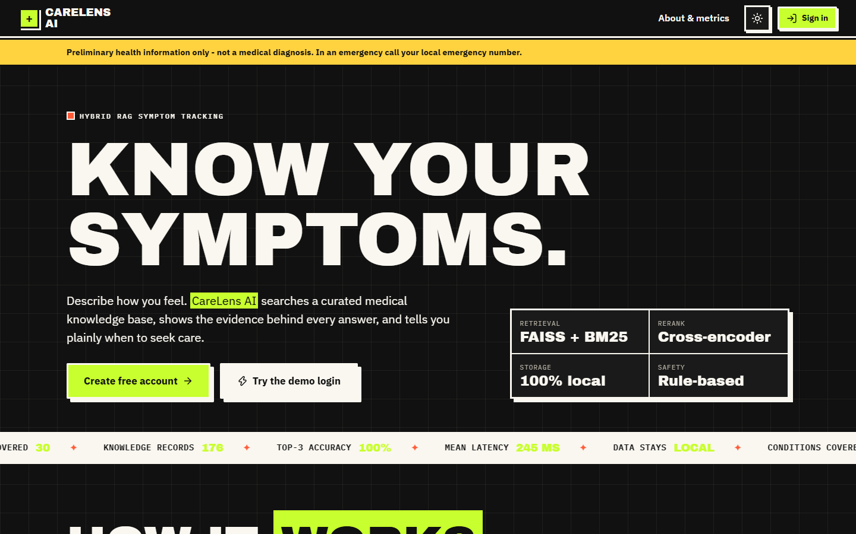  Figure 42: Landing page, dark theme. | 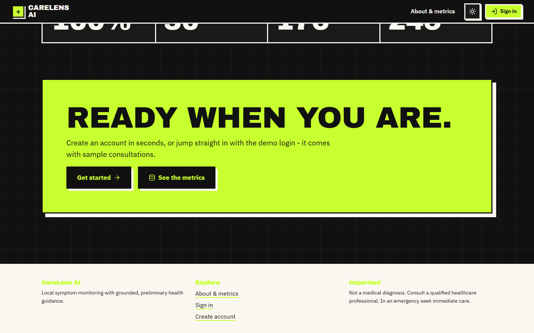  Figure 43: Bottom of the landing page (dark theme).

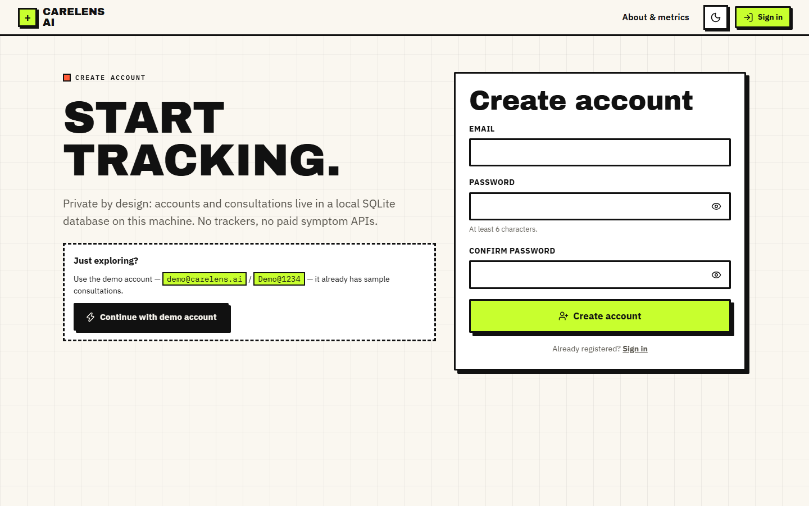  Figure 44: Create-account form (email and a password of 6 to 128 characters). | 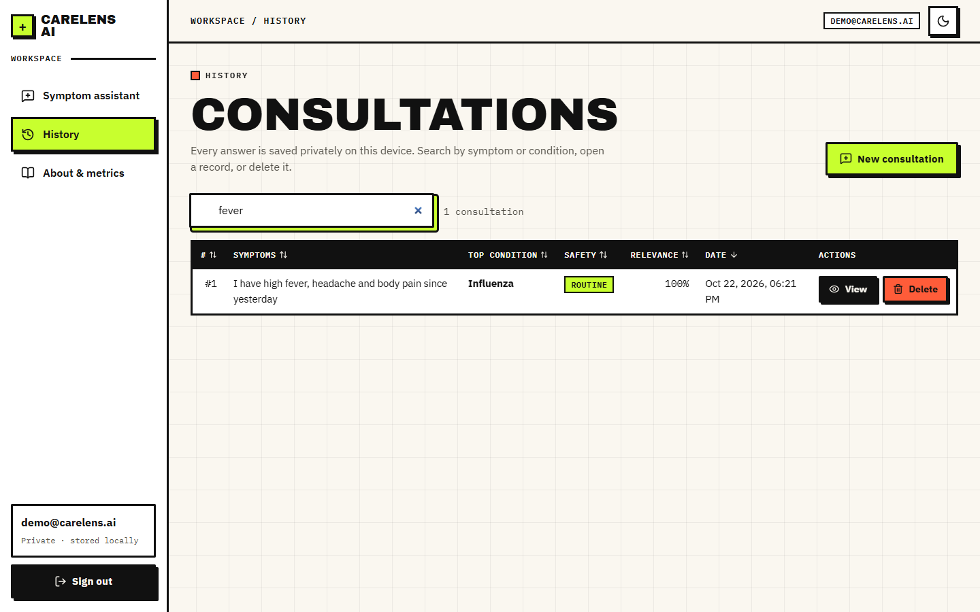  Figure 45: History filtered by the search term "fever": one consultation remains.

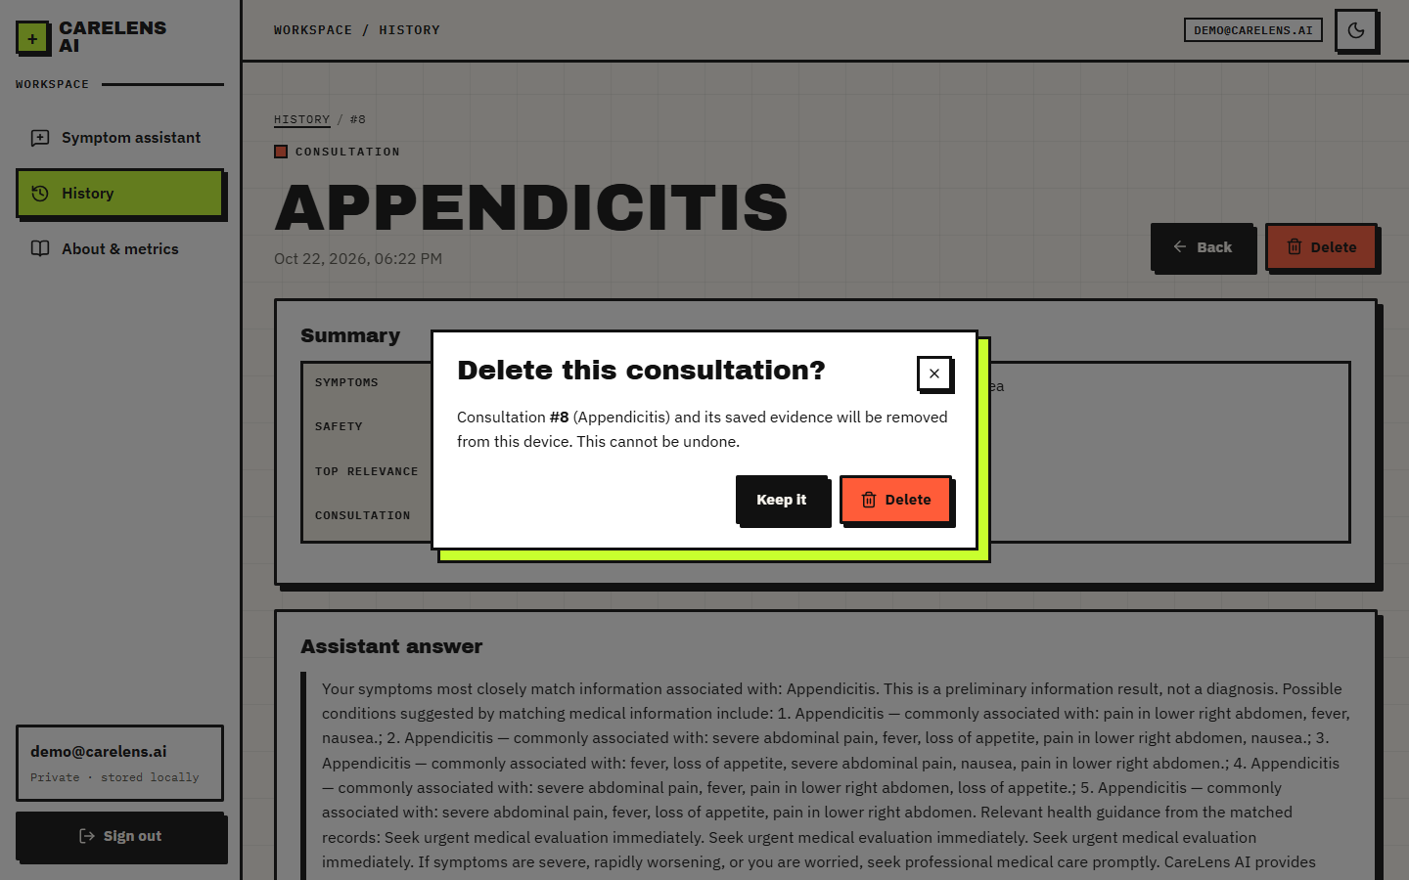  Figure 46: Confirmation dialog before a consultation is deleted. | 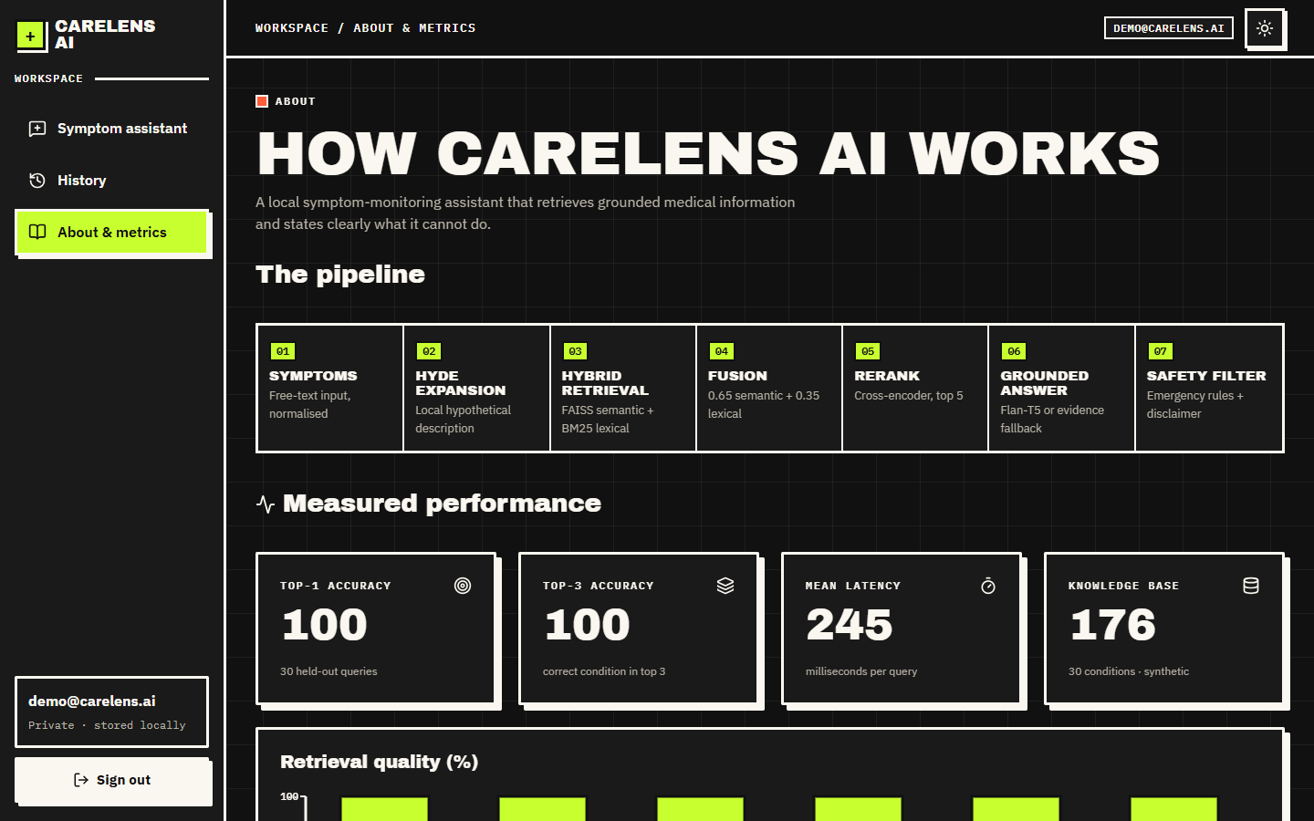  Figure 47: About page, dark theme.

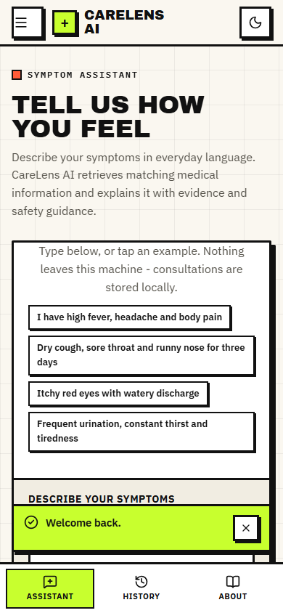  Figure 48: Symptom assistant at phone width (390 pixels). | 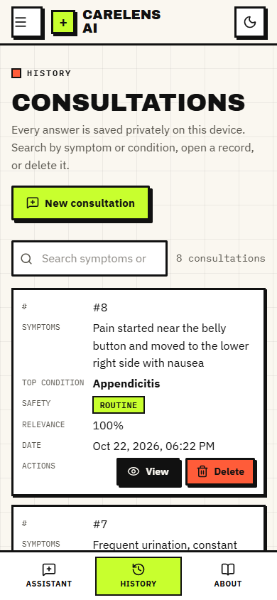  Figure 49: History as cards at phone width.

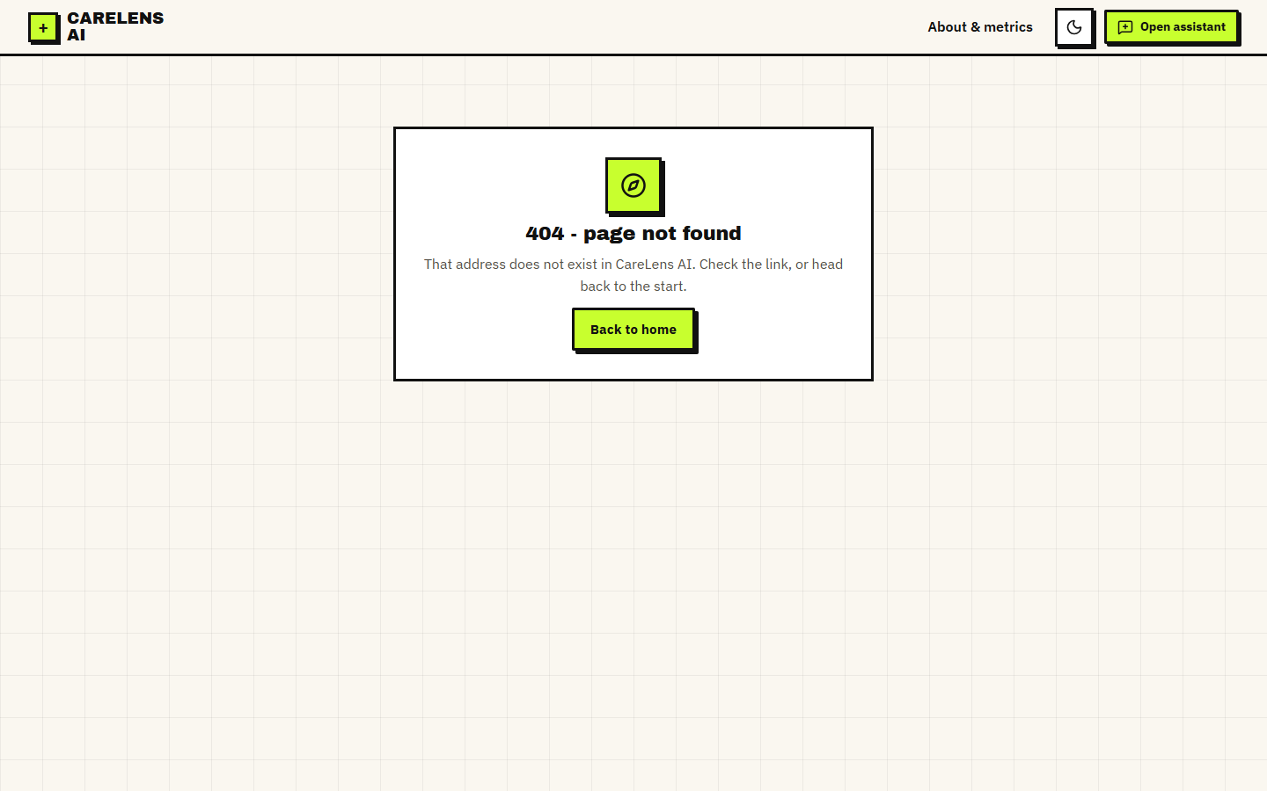
Figure 50: Unknown route: the 404 screen.

